Grigg Whakapapa

Roots in Thanet of

the Grigg Family in New Zealand
Draft, April 2010, minor revisions Feb 2019
(When better historical DNA data is available I will get this finished)
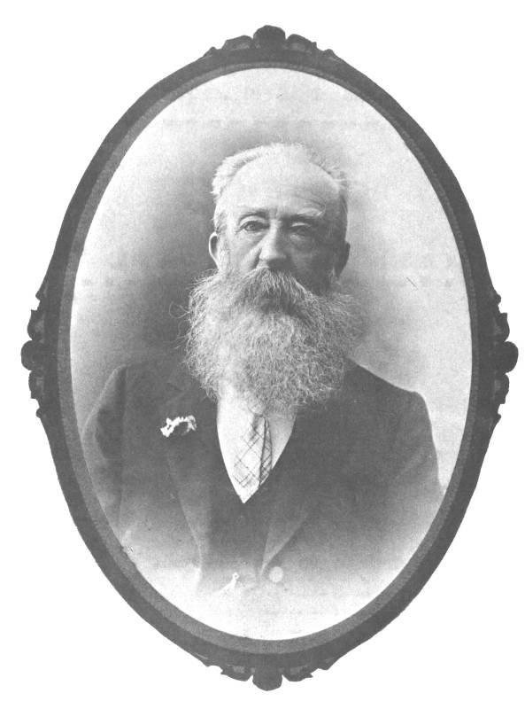
Figure 1: Picture of John Grigg, astronomer (original hangs in our garage).

By Viv Grigg, PhD, son of John Grigg, the scientist, son of Handel the educationalist, son of Albert Edward, son of John Grigg, Fellow of the Royal Astronomical Society, musician, son of James, son of William Grigg, son of William Griggs, the miller from Acol, son of John Griggs, descendent of Thomas Griggs of Birchington, Isle of Thanet, descendent of John Griggs and the blacksmiths of the ancient princely Jutish town, Finglesham, Kent, son of William Grygge of Sholden, Kent (c1424) descendent of Thomas Grygge (c1350), who held lands in Kent and Sussex, 17 generations ago, descendent of the Portuguese Celts, Swedish Jutes and Danish Saxons.

Introduction
This is the story of an ancient clan of Grigg, Griggs, Grygge, decendents from Celts and Jutish princes, blacksmiths and millers, who migrated to the Isle of Thanet in Kent. In the 1860’s they then migrated to New Zealand and lived lives of service doing a little good here and there. The story focuses around the ancestors of the John Grigg, F.R.A.S., who migrated to New Zealand in 1863 as one of the Albertlanders, desiring to found a Christian city, and became an astronomer of some note, a musician, and a “humble follower of the Master”. Matthew Grigg did a study on his ancestors back to William Grigg.

John Grigg, my father, extended this forward to the descendents of John Grigg, F.R.A.S. This current work goes back nearly 600 years and 17 generations, extending ten generations behind what Matthew Grigg documented to Thomas Grygg born c1350 who migrated to the formerly Jutish town of Finglesham, centre of Jutish princely culture. It discovers the mill where his descendants lived and multiplied profusely for generations in Birchington, Isle of Thanet, Kent, then scattered across the empire during the time of the enclosures (when the English Lords fenced in common land preventing the peasants from grazing their sheep), till none are left in Kent.

Ancient Roots
The Celts migrated up through Portugal around 500 BC. The Gryggs of Thanet (Men of Kent vs the Griggs of further West, the Kentish Men) are largely Celtic in origin, but perhaps also descendants of the Jutes who invaded Kent, becoming blacksmiths and millers.

How do we know this? Through several sources. One is a mapping of name distributions in the 1891 census (Appendix 1) that shows the name Grigg (in Kent and along the Eastern Thames), Grigg (in Cornwall), Griggs (spread in other Southern and Eastern England), Gregg (in northern England), Greig (in the lowlands of Scotland) and MacGregor or Greer (in the highlands of Scotland), Gryg (in Ireland). When put all together define a consistent spread of Grigg family names, with emphasis in the more strongly Celtic corners of the UK.

The second line of reasoning comes from DNA testing which shows that Celtic blood lines remain in 70-90% of almost all English counties and 50-75% of Southern England, so the Celts were not forced out, but remained and others intermarried (Appendix 2). Since we were of a town centre of Jutish royalty we are slightly less Celtic.

A lineage of equality and leadership of protest?

The original inhabitants of what is now known as England were the Celts who in turn were invaded by the Romans invaders who were known as Britons. After the withdrawal of the Roman forces about the beginning of the fifth century, the South Britons were no longer able to withstand the attacks of the Scots and Picts. They applied for assistance from the Roman General Aetius, but he was too much involved in the struggle with Attila to attend to their petitions. In desperation the Britons sought the aid of the Saxons; and according to Anglo-Saxon narratives, three ships containing 1600 men were dispatched to their help under the command of the brothers Hengest and Horan. These Saxons were assigned the Isle of Thanet for habitation, and from there marched against the northern foe, obtaining complete victory. The date assigned to these events by the later Anglo-Saxon Chronicles is 449 A.D.

The Chronicles also states that the Saxons, finding the land desirable, turned their arms against the Britons, and reinforced by new bands, the Jutes and Angles, conquered first Kent and ultimately the larger part of the island. These Saxons, Jutes and Angles were Teutonic tribesmen coming from the country about the mouths of the Elbe and Weser Rivers in ancient Germany. This struggle continued for about 150 years and at the end of that time, most of the South of Briton was in the hands of these Teutonic tribes. This conquered territory was then divided into small states. These conquerors did not exterminate the Celts but being mostly ,ale intermarried thus the bloodline remains 83% Celtic/British.

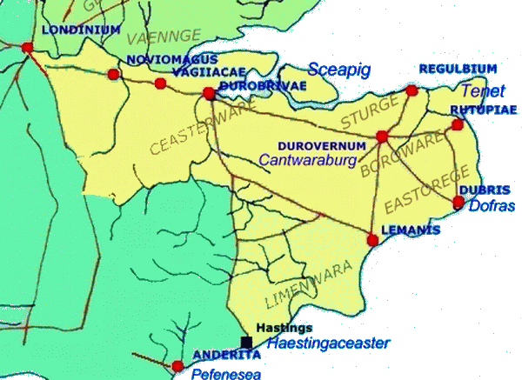

Figure 4: : Place names at the time of the Jute invasion.

DNA
Lastly I found a tiny number of very unusual clans in the southern part of England. Two are from sub-Saharan Africa, three from Syria or Jordan. These exotic sequences are found only in England, with one exception, and among people with no knowledge of, or family connection with, those distant parts of the world. I think they might be descendants of the Roman slaves, whose lines have kept going through unbroken generations of women. If this was the genetic legacy of the Romans, they have left only the slightest traces on the female side (pg. 283).

This might explain both the North African and Nigerian ancestry. (Perhaps this also is on my maternal side of Peters and Monks, perhaps somewhere there is a link to North Africa from a notorious sea captain that occasionally featured in my mother’s stories).

Where did the name Grigg Come From?
There is some common information on the web as to the derivation of the name, “Gregory, the name of ten early popes is derived from Gregor, “watchman.” Both GREGORY and GREGOR are found in England and the pet forms GREIG, GREGG and GRIGGS have produced family names with these spellings. The Scottish name is MacGregor, In Scotland the family name is sometimes shortened to GREER. GREGOIRE is the French family name. GREGORSKI is Polish….”

In this Island (the name doesn't ever seem to have taken in Ireland), all the evidence shows that our ancestors at first preferred their native names to any foreign imports. Outside religious institutions "Gregory" was rarely conferred. It seems frequently to have been assumed by Bishops who deemed it appropriate with regard to their status as "Guardian of their Diocesan Flock" thus "Gregorius Duncheldensis episcopus" (1150) and "Gregorius episcopus de Ros" (1171) are found in Scotland. Otherwise there is no mention of any "Gregory" before the Conquest. The earliest record dates from 1143, where, in Lincolnshire reference is made to a "Gregory" as the father of "William". But after the 11th Century, and especially during the 13th and 14th Centuries it enjoyed widespread popularity, especially in the North. This fact is demonstrated through the innumerable surnames it generated - and of course, the "family" or "pet" versions such as "Greg" and "Grigg" went on to create forms such as "Gregson" and "Griggs". According to a Victorian clergyman who researched the name, "Gregson" was so prolific in north Lancashire as almost to become a regional name. In Scotland was found "Greig" as well as (naturally) "MacGregor" and an extreme form of spelling occurs with "Grix" - of which there is a listing locally for Brailsford,
Then the name simply fell out of favour and has never recovered. It all began with Henry VIII (1509-1547) who severed England from Rome and began the religious upheavals which followed. The name "Gregory" had such strong Papal associations that it was most decidedly avoided. Furthermore, it had attracted to itself certain incidentals which rendered it rather unacceptable. For example, from the beginning of the 1600's to 1649 Gregory Brandon and his son were the public Hangmen and Executioners. It was "Young Brandon" who executed Charles I. The expression "the Gregory Tree" was for a long while a current euphemism for the Gallows!

Around the 14th century, various commonly used names became surnames. This would indicate no significant correlation between the various branches of the Grigg family except where traceable to that date. There is a DNA correlation of Griggs surnames in Kent back to the 13th C. DNA testing shows no significant correlation between Macgregor and the Cornish Grigg, and no significant correlation between the Kent and Cornish Grigg, but some close correlations between the Kent and Staffordshire Grigg (Halesowen, Worcestershire, UK).

Sykes finds little Roman descendants in England, so we are not Roman, even though we likely inherited the name of Gryg from “Gregory”, indicating our 1300’s ancestor may have been a former monk moving out of the monastery, and being given a land grant from Canterbury...

Kentish History

Prehistoric

1400-600 BC
Settlement sites from the periods of the Middle and Later Bronze Age and the Iron Age are being discovered all over the Isle of Thanet. From the evidence and the vast hoards of tools and weapons found here, it looks as if the Isle of Thanet was a populous and wealthy place throughout this time.

600 BC
The use of iron came to Thanet around this time, when like most of Britain it was probably inhabited by Celtic tribes, linguistic ancestors of modern Welsh, Irish and Scots Gaelic speakers. A small field pattern is clearly shown in the Iron Age Village at Dumpton Gap and South Cliff Parade, Broadstairs. Other Celtic fields have been seen from crop marks at Bartlett's near St Nicholas and Gore End Farm, Birchington.

500 BC
The oldest known plough marks in Thanet date from this time in the Belgic Iron Age at a site at Lord of the Manor above Pegwell Bay. An Iron Age pot found in Cliftonville contained rye seeds and one grain of wheat, showing that cereal crops were under cultivation on the island.

400 BC
Until this time Thanet's central plateau was probably heavily wooded, but clearing now began due to the availability of iron axe heads.

325 BC
The first account we have of Thanet is by Pytheas, an astronomer and geographer from the Greek colony of Massilia (Marseilles), who sailed around Britain around this time. He described 'Albion' (Britain) as 'mostly flat, overgrown with forests, thickly populated, the people tall and not so yellow haired as the Celts on the continent'. They lived in humble houses of wood, thatched with reeds, grew corn and stored thew ears in roofed granges and used chariots. Pytheas reported rounding "Kantion corner" (the Kent promontory - or the Isle of Thanet) from where the Continent was visible. This is the first reference to the name of a people from which derive the names of both Kent and Canterbury. These few sentences about Britain are the nearest we are likely to get to an eyewitness description of Thanet before the Romans.

Romano-British Ceint
The 7th Century British historian, Bede, writes:
Ex his omnibus longe sunt humanissimi qui Cantium incolunt, quae regio est maritima omnis, neque multum a Gallica differunt consuetudine. Interiores plerique frumenta non serunt, sed lacte et carne vivunt pellibusque sunt vestiti. Omnes vero se Britanni vitro inficiunt, quod caeruleum efficit colorem, atque hoc horridiores sunt in pugna aspectu; capilloque sunt promisso atque omni parte corporis rasa praeter caput et labrum superius.
(Of all the Britons the inhabitants of Kent, an entirely maritime district, are by far the most civilised, differing but a little from the Gallic manner of life. Of the inlanders most do not sow corn, but live on milk and flesh and clothe themselves in skins. All the Britons, indeed, dye themselves with woad, which produces a blue colour, and makes their appearance in battle more terrible. They wear long hair, and shave every part of the body save the head and the upper lip.)
After Caesar's attempt to conquer Britain failed the Romans did not visit that part of the world until the Emperor Claudius invaded Britain from Gaul in 43 AD and in a short time incorporated Britain into the Roman Empire.
The Kentish coastline was known as the Saxon Shore and was guarded by a series of very effective fortresses. After the evacuation of the last Roman legions from Britain a number of Jutish ships made landfall on the shores of Britain. The British ruling council was offering them payment in return for federati service defending the realm in the north from the incursions of Picts and Scots. According to legend they were promised provisions and offered the island of Ynys Ruym - now known as Thanet - in perpetuity to use as a base for their operations. It is recorded in the Anglo-Saxon Chronicles that their leader, Hengist, advised:
Take my advice and you will never fear conquest from any man or any people, for my people are strong. I will invite my son and his cousin to fight against the Irish [the Scoti], for they are fine warriors.
Apparently the Jutes assaulted the enemy and brought much needed relief to the beleaguered Romano-British communities of the north. It is further said that the British king Vortigern married Rowena, the daughter of Hengist with the Cantiaci civitas (Kent) as the bride-gift.

Jutish Cantware
The first securely datable event in the kingdom is the arrival of Augustine with 40 monks in 597. Because Kent was the first kingdom in England to be established by the Germanic invaders it was able to become relatively powerful in the early Anglo-Saxon period.
Kent seems to have had its greatest power under Æthelbert at the beginning of the 7th century: Æthelbert was recognized as Bretwalda First among the Kings) until his death in 616, and was the first Anglo-Saxon king to accept Christianity, as well as the first to introduce a written code of laws in 616. After his reign, however, the power of Kent began to decline: by the middle of the century, it seems to have been dominated by more powerful Anglo-Saxon kingdoms.
After this, Kent fell into a state of disorder, fragmentation and increasing obscurity. From 785 until 796, Kent was ruled directly by Mercia. Mercian authority was replaced by that of Wessex in 825, following the latter's victory at the Battle of Ellandun.
In 892, when all southern England was united under Alfred the Great, Kent was on the brink of disaster. A hundred years earlier pagan Vikings had begun their raids on these shores—they first attacked Lindisfarne on the coast of Northumbria killing the monks and devastating the Abbey. They then made successive raids further south until in the year 878 the formidable Alfred defeated them, later drawing up a treaty allowing them to settle in East Anglia and the North East. However, countrymen from their Danish homeland were still on the move and by the late 880s Haesten, a highly experienced warrior-leader, had mustered huge forces in northern France having besieged Paris and taken Brittany.
Up to 350 Viking ships sailed from Boulogne to the south coast of Kent in 892. A massive army of between five and ten thousand men with their women, children and horses came up the now long-lost Limen estuary (the east-west route of the Royal Military Canal in reclaimed Romney Marsh) and attacked a Saxon fort near lonely St Rumwold's church, Bonnington, killing all inside. They then moved on and over the next year built their own giant fortress at Appledore. On hearing of this, resident Danes in East Anglia and elsewhere broke their promises to Alfred and rose up to join in. At first they made lightning raids out of Appledore (one razing a large settlement, Seleberhtes Cert, to the ground - now present day Great Chart near Ashford) later the whole army moved further inland and engaged in numerous battles with the English, but after four years they gave up. They were the forebears of the Normans who returned in triumph less than two centuries later.

The Jutes
The Jutes, Iuti, or Iutae were a Germanic people who, according to Bede, were one of the three most powerful Germanic peoples of the time. They are believed to have originated from Jutland (called Iutum in Latin) in modern Denmark, Southern Schleswig (South Jutland) and part of the East Frisian coast.
While Bede places the homeland of the Jutes on the other side of the Angles relative to the Saxons, they have nonetheless been identified with people called the Eucii (or Saxones Eucii) who were evidently associated with the Saxons and dependents of the Franks in 536. A map of Tacitus' portrays a people called the Eudoses living in the north of Jutland and these may have been the later Iutae. Still others have preferred the identification with the Eotenas (ēotenas) involved in the Frisian conflict with the Danes as described in the Finnesburg episode in the poem Beowulf (lines 1068–1159). Others have interpreted the ēotenas as jotuns ("ettins" in English), meaning giants, or as a kenning for "enemies". Yet another possible identification is with the obscure tribe called the Euthiones and probably associated with the Saxons. They are mentioned in a poem by Venantius Fortunatus (583) as being under the suzerainty of Chilperic I of the Franks. Even if Jutes were present to the south of the Saxons in the Rhineland or near the Frisians, this does not omit the possibility that they themselves were migrants from Jutland.
Another modern hypothesis (the so-called "Jutish hypothesis"), accepted by the Oxford English Dictionary, states that the Jutes are identical with the Geats, a people who once lived in southern Sweden. In primary sources the Geats are referred to as Eotas, Iótas, Iútan, and Geátas. However, in both Widsith and Beowulf, the Eotenas in the Finn passage are neatly distinguished from the Geatas. It is possible that the Jutes are a related people to the Geats and a Gothic people as it is mentioned in the Gutasaga that some inhabitants of Gotland left for mainland Europe (the Wielbark site in Poland is evidence of a Scandinavian migration).
The Jutes, along with the Angles, Saxons, and small number of Frisians, were amongst the Germanic tribes who sailed across the North Sea to raid and eventually invade Great Britain from the late fourth century onwards, either displacing, absorbing, or destroying the native Celtic peoples there. According to Bede, they ended up settling in Kent (where they became known as the Cantuarii), Hampshire (in Wessex), and the Isle of Wight (where they became known as the Uictuarii).
It is commonplace to detect their influences in Kent (for example, the practice of partible inheritance known as gavelkind). Bede is the only historical evidence and he clearly implies that this was so, in 686 CE. The culture of the Jutes of Kent is usually regarded as more advanced than that of the Saxons or Angles and early on shows signs of Roman, Frankish, and Christian influence.

Conversion of the Men of Kent
Æthelberht (c. 560 – February 24, 616) was King of Kent from about 580 or 590 until his death. In his Ecclesiastical History of the English People, the monk Bede lists Aethelberht as the third king to hold imperium over other Anglo-Saxon kingdoms. In the late 9th century Anglo-Saxon Chronicle Æthelberht is referred to as a bretwalda, or "Britain-ruler". He was the first English king to convert to Christianity.
He married Bertha, daughter of Charibert, king of the Franks, thus building an alliance with the most powerful state in Western Europe at that time; the marriage probably took place before Æthelberht came to the throne. The influence of Bertha may have led to Pope Gregory I’s decision to send Augustine as a missionary from Rome.
Gregory, ruler of Kent purchased young English Saxon slaves and took them to Rome where he planned to educate them for the mission of evangelizing their Pagan countrymen on return to Britain in 590 AD.
Augustine landed on the Isle of Thanet in east Kent in 597. Shortly thereafter, Æthelberht was converted to Christianity, churches were established and wider-scale conversion to Christianity began. Æthelberht provided the new church with land in Canterbury, at what came to be known as St Augustine's Abbey, thus establishing one of the foundation-stones of what ultimately became the Anglican church.
Æthelberht’s code of laws for Kent, the earliest written code in any Germanic language, instituted a complex system of fines. Kent was rich, with strong trade ties to the continent, and it may be that Æthelberht instituted royal control of trade. Coinage began circulating in Kent during his reign for the first time since the Anglo-Saxon invasion.
Æthelberht was later canonised for his role in establishing Christianity among the Anglo-Saxons. His feast day was originally February 24, but was changed to February 25.

Resistance to the Saxons
Under Alfred the Great, order was established in the county of Kent, and the Isle of Thanet was constituted the Hundred of Ringaloe. Birchington became part of the Manor of Monkton (not to be confused with Monkton in Pembrokeshire, where there is another Grigg clan) under the Archbishop of Canterbury. Acol is between Monkton and Birchington.

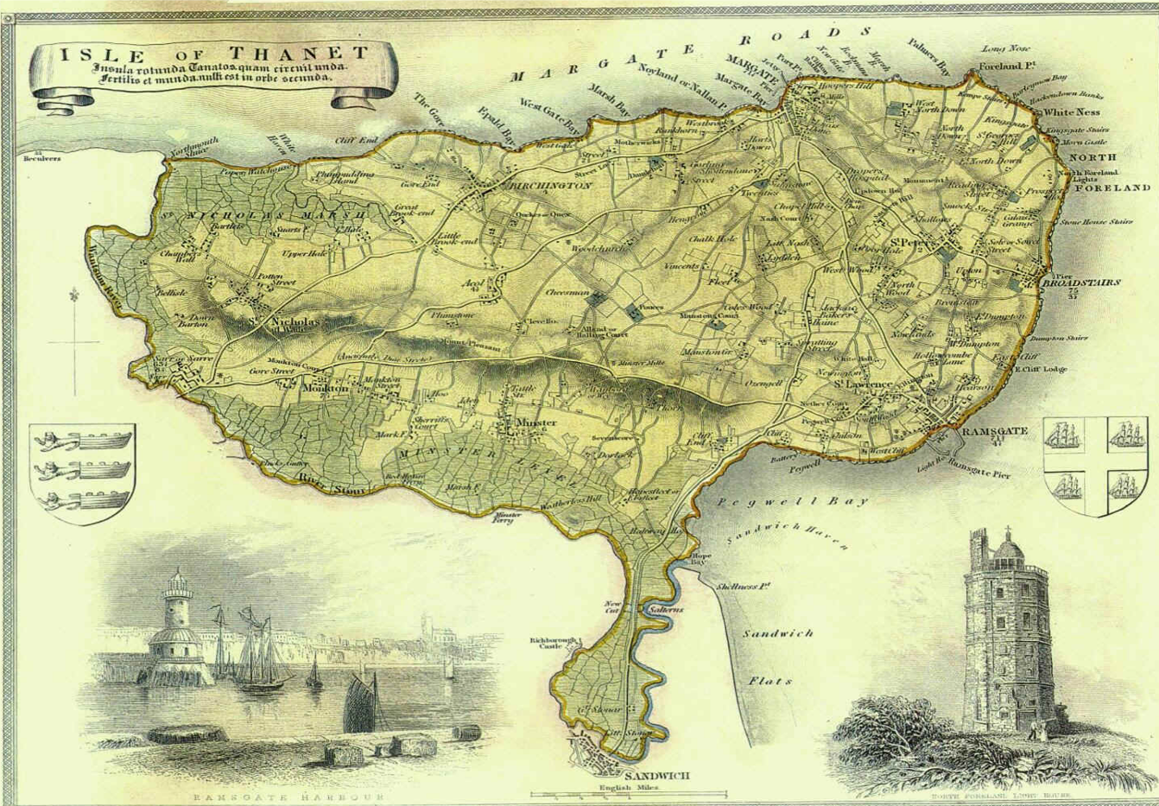
Figure 5: Historical Map of Thanet of Kent

Records from the 12th and 13th C
There are Grygge in multiple parts of England in the 1300’s. There is a Henry Grygge hanging out with some knights in Essex in 1307. A Robert Grigges of Martham in Norfolk was forced to abjure according to Foxes Book of Martyrs between 1428 and 1431.

Canterbury: The earliest Kent reference to a Grigg is to a Richard Grigge paying for the wine and dancers to entertain the mayor in 1218 at Canterbury..

London landholders in Kent: Which Londoners are connected to Kent is unclear. “On 11 June 1371, Henry Chaucer a vintner is one of the mainpernors of Alan Grygge, accused by Nicholas Mollere of having spread the false news that aliens might trade in the city of London as freely as freemen etc. Afterwards, Alan being judged guiltless….” There is a Robert Grygge, clerke in 1389 at Westminster. And a Geoffrey Grygg, merchant of London, in 1386 involved in a dispute in the shipping trade.
It also appears from the following that Thomas Grygge in the mid 1300’s had a son Richard Grygge and these possessed lands in Kent and Sussex. I am presuming these were our forebears.
“The Calender of Patent Rolls (CPR) show a grant of the King to his servant Thomas Brenchesle of the custody of the king's parks of Dothwelle and Crowhurst in Sussex. - 29 May 1408 Quitclaim from Thomas Brenchesle of Brenchesle, brother of William Brenchesle, knigt to Joan, widow of William, and Thomas Wallere of all his rights in the manor of Frant and in all other lands in Kent and Sussex which the late William Brenchesle and others held by grant of Richard, son of Thomas Grygge. (DYK/15).”
This Thomas Grygge was also of Frant. Frant is a village and civil parish in the Wealden District of East Sussex, England. It is located on the Kentish border, about five miles (8 km) south of Tunbridge Wells. Richard Grygge or his son of the same name is perhaps the member of Parliament sometime between 1422 and 1504.,
The following London-Sussex Grigg are probably not connected to our family. The youngest son of a Devon Grege, Michael Grigg married Rechord Prouse, the daughter of a prominent family of tailors/drapers of Tiverton, Devon in London in 1581. To his second son, Robert, he left the Manor of Becklings, in Snape, Suffolk. This clan rose to prominence in London, then escaped to the colonies.
Suffolk Griggs: Robert, born 1598, became a cleric, married Margaret Reeve of Suffolk, settled at Houghton Conquest, Bedfordshire and had six children. Both he and his wife were dead by 1645 leaving the children orphans.³³ His sons are Michael, born 1630 and Robert, 1634. Michael, Robert’s son, married Dorothy Gosnold of Otley,³⁵ Suffolk, daughter of a family of Gosnolds prominent in the early exploration of Virginia.³⁶ They settled at Bealings Parva, Suffolk and had 11 children, and again Robert, born 1662, ³⁷ and Michael, born 1660, feature as the names of the earliest born sons. Michael, the father died at Little Bealings, Suffolk in 1669. Michael, his son, went on to take his Doctorate in Divinity at Cambridge, married Barbara Williams in 1688 and became the rector of Upwell, Norfolk in 1691. He died in that parish in 1698.

This line appears to disappear at this time. The rest of the London family appear to have escaped the Puritans by shipping to Virginia. There is no record after 1657 in London.
Kent-Sussex Connections: Rado Grygg and likely son, Nico Grigg were taxed in the rape of Ewes in 1332 and the rape of Bramber 1296 in Sussex. Three Gryg are recorded in the 1332 taxation of Sussex: in the Hundr' de la Manewod. Villat' de Sidlesham (near Portsmouth), Johe Gryg taxed 4 9s. and in Villat' de Seleseye, Walto Gryg taxed 10s. In the Hundr' de Boseham, Villat' de Chudeham. Rico Gryg taxed 9s. In 1405, a Ter Gryg paid 6d rent at Marshalls Farm, Kirdford, Sussex. Roger Gryg is involved in land transfers in 1428 to 1433 in Tichurst, Sussex. John Griggs who was born c 1436 in Somerton, Suffolk County, England. In Muskett's Suffolk Memorial Families, John is the first listed in this book showing d.27 April 1497, Suffolk County. He had a son, William Griggs, b.c.1471, Stansfield England, Suffolk.

The 1500’s
London in 1500’s: John Grygs made lace in London in 1595. A Robert Grygge died prior to 1560 but held lands in Southwarke, London. There are a Francis and a William Grigge in the Algate ward paying three pounds in the London subsidiary role in 1582. There is a William Grygge in London of some means mentioned in the Liber Albus. A Willyam Grygges, perhaps of Snodgras, rode for the Kings army against the Puritans in Kent. London Griggs include Henry’s, Michaels, Richard, and Johns. In 1648, a John Barbor alias Grigge bought extensive property in London.

Kent Lineage pre-15th Century
The first mention of someone with the surname of Griggs in East Kent dates from 1325 in which a 'John Grygges' is listed as a burgess (towns person) of Queenborough, Isle of Sheppey (Queenborough Statute Book CKS-QB/AZ/1).
The lay subsidy of Kent for 1334/5 includes several heads of household with Grigge variant surnames. The majority are located in the Hundred of Folkestone (this is the port south of Dover), with just one household in Brenchley hundred (between Canterbury and London). It is noted that the 1334/5 data is unlikely to include every household. It is estimated due to poverty this lay subsidy contained less than half the heads of households. (An Historical Atlas of Kent, Phillimore).
Robt Grigge, Brenchley Hundred, paying 2s 0d
Wm. Grigge, Folkestone Hundred paying 4s 6d
Jn. Grigge Folkestone Hundred paying 5s 8d
Wm. Griggs, Folkestone Hundred paying 4s 3d.
John Gryg and William Grygg were named as archbishop’s tenants in 1365.
At the time of the 1334/5 subsidies, the population of Kent has been estimated as about 125,000 (ibid). There was then a drastic drop in population during the black death epidemics (1349-1350). By the time of the Poll Tax returns of 1377, the population is estimated to have returned to about 90,000 (ibid). The 1377 poll tax returns include the following individuals (Carolyn Fenwicks transcripts of Poll Tax returns).
THOMA GRIGGE Canterbury, 8d
HENRICO GRIGGE Canterbury, 8d
The 1381 returns (ibid) contain the following, somewhat more detailed entries:
JOHANNE UX HENRIC GRIGGE DE ROMNE FILA TRIX Canterbury 8d
THOMAS GRIGGE CHANDER WILLEMUS SADLER JOHANNE GRIGE SERVIANT SUI Canterbury 8d
We know a little more about Thomas Grigge from the 1381 returns. He is listed several times in 'Intrantes of Canterbury 1392-1592'. He is listed in the years 1396-1413, usually at Burgate, Canterbury and is recorded as a Cobler.
These poll taxes were deeply unpopular and lead to the peasants revolt of 1381, which, contained mostly rebels from Essex and Kent. The leader – Wat Tyler being from Kent (both Dartford and Maidstone claim to be his home town). However, what is known is that a lot of the 'rebels' were ordinary folk from Kent and Essex. In a poem by Gower (a contemporary of Chaucer) entitled 'Vox Clamantis' some of the leaders are mentioned by name. The poem itself was written in Latin and is over 10,000 lines long. [Among the leaders names is a Grigge].

The Gryggs of Finglesham, Deal, near Dover, Kent
Griggs (vs Grigg) is a Southeast name in the UK. Although it is possible that all the Kent Griggs merge into one eventually, genealogists are still trying to work it all out. Tony Grigg appears to have the largest database and most extensive research and has not found a connection! Thus, there is no proven linkage between the London, Folkestone and Finglesham Gryggs, but there is reasonable speculation. Tony concludes there are four main families in Kent.

1. The earliest clear reference to an ancestor of the Birchington Grigg clan, is that found in 1424 to a William Grygge of Cottingham, listed as the recipient of land in Fynglsham near Sholden, Kent, (near Deal, next port north of Dover) in the tenure of St Augustine Abbey. Cottington, Ickham is 5 miles from Canterbury. Finglesham means “home of a prince”, indicating a Jutish administrative area.

2. John Grygge b 1430 in Finglesham, Kent. “John Grygge, of Fyngelsham, in 1484, was buried in the chancel of this church, where the sepulchre of our Lord was placed on the day of Easter.” Married to Cecily. The church was NorthBourne and Sholden was a chapel.,

He was father of:
3.1 A William Grygge of Mongeham, who was granted rights to the wreck of the sea when it occurs in 1445. Tony Griggs indicates his will in 1497.
3.2. There is a Richard Grygge who witnessed a land grant in Dover in 1448. He became mayor of Dover for two years round that time. “This Richard had a daughter by the name of Marion who married John Bratyll. This information comes from a Chancery dispute at the national archives over some land in Staplehurst, Kent.”
3.3 There is Robert Grygge who may have preceded him in this post.

Likely sons of Richard or William Grygge
4.1.William Griggs b c 1450 in Great Mongeham, Kent, U.K.
There is a Tom Grygg who worked on the Great Gun of Dover in 1469
4.2 Thomas Griggs b c1470 will 1514 m Elizabeth will 1514, parents of
  - 5.1 James
  - 5.2 Edward
  - 5.3 Leonard
  - 5.4 Womfred²²
4.3 Richard Griggs b c1480, m Elizabeth will 1508
  - 5.5 father of Richard Griggs b c 1500
  - 5.6 Thomas Griggs b c 1500
    - 6.1 father of Thomas Richard Griggs. b c1520
      - 7.1 likely father of Thomas and
      - 7.2 Hubbeard b c 1550, named in brother Thomas’ will, m Katherine 27 Jan 1579 Great Mongeham, b 1601 Whitfield, servant of Thomas Foorde.
        - 8.1 Probably father of Thomas Griggs in Ham.

The following progression is Robert Wiseby’s chart (with additional data from my own research), based on Fred Grigg’s book, which I have not checked against all sources (particularly Tony Griggs’ chart), but seems reasonable though not entirely accurate, against the ones I have.

2. John Griggs b: 1430 Fingelsham
3 William Griggs b: 1450 Great Moneham
4 Richard Griggs b: 1480
+ Unknown
5 Thomas Griggs b: 1500
+ Elizabeth
6 Thomas Richard Griggs
+ Unknown
7 Richard Griggs b: 1560
+ Jone Fow
8 Thomas Griggs b: 1589
+ Dorothy
9 Darnell Griggs b: 1609
9 Thomas Griggs b: 1611 d: 1612
9 John Griggs b: 1613 d: 1615
9 Ann Griggs b: 1615
9 Elizabeth Griggs b: 1617 d: 1638
9 James Griggs b: 1619
+ Susannah Wood b: 1613 d: 1701
10 Thomas Griggs b: 1652 Birchington
+ Martha Cook b:1651d:1718 m23Dec1677
11 Thomas Griggs b: 1678
11 Mary Griggs b: 1680
11 Elizabeth Griggs b: 1685
11 James Griggs b: 1687
11 John Griggs b: 1688
11 Richard Griggs b: 1691
11 Martha Griggs b: 1693
11 William Griggs b: 1695
+ Mary Strode
12 James Griggs b: 1720
12 William Griggs b: 1720 d: 1784
12 Henry Griggs b: 1722
12 Stephen Griggs b: 1723
12 Thomas Griggs b: 1726
12 Sarah Griggs b: 1728
12 John Griggs b: 1732 d: 1819
12 Thomas Griggs b: 1733
12 George Griggs b: 1735
+ Elizabeth Bartlet
12 Catherine Griggs b: 1737
12 Edward Griggs b: 1699
+ Martha Coleman
10 Edward Griggs b: 1699
+ Martha Coleman
9 Thomas Griggs b: 1619
9 Isabell Griggs b: 1621
9 William Griggs b: 1626
9 John Griggs b: 1629
+ Sussannah Woods b: 1613 d: 1701

Finglesham and the Riots of 1450-51
In 1451, after disturbances in Eastry, 'John Tayllour' a 'taillour' of Finglesham was charged with treason. This was the third rebellion in just over a year, and it came about for a number of reasons. In the late 1440s Kent had declined; trade was badly disrupted by an increase in piracy and the war in France had led to the loss of the territory of Normandy. Sandwich suffered a drop in exports of wool and cloth as well as a fall in wine imports. So, it is not surprising to find that cloth workers formed a significant proportion of the insurgents in the mid-1400s. Henry Vl's administration was unpopular, and local officials abused their power. Furthermore, the county was under the very real threat of attack from the French, who had burnt Rye and Winchelsea in 1448. On 14th April 1450, a commission of array was sent out to muster men against a possible French attack, and a command given to set up warning beacons.

Great Mongeham
Great Mongeham is a village and civil parish in East Kent, on the outskirts of Deal. Its name is derived from Mundelingham or village of Mundel It was first recorded as Mundelingham in 761, and Mundlingham in 833. The Domesday book gives it as Muningeham, and is supposed to originate from 'the HAM of Mundel's people' where HAM meant homestead. Mundel itself is a derivative of Munda which is Saxon in origin. An alternative interpretation is that the name means "Mundel's homestead", from the Olde English pre 7th Century personal name "Mundel", a diminutive form of any of the various compound names with "mund", protection, as the first element, and ham, homestead.
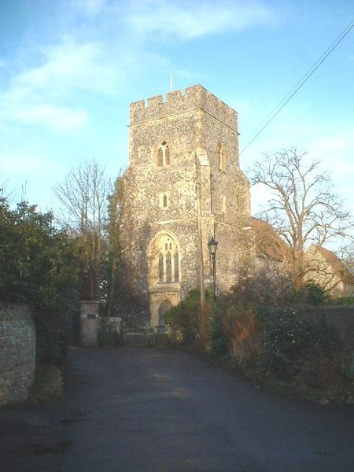
Parts of Great Mongeham's church, St Martin's, date back to the 13th century.
Great Mongeham may have been a settlement as long ago as the Bronze Age. When the site for the new primary school was being dug in February 1949 the body of a man and two fragments of food vessels were found. The man was in the crouched burial position used in the Bronze Age and one of the fragments was dated to about 1000 BC.
There certainly was a settlement here in 761 AD. In that year King Eadbert of Kent gave some land to St Augustine's Abbey in Canterbury. This included the village, which was then called Mundelingeham. By 1195 it was written as Munigeham. It had become Mongeham by 1610.
The village church has a complicated history. The original building probably dates from Saxon times but there are claims that it goes back to AD 470. By 1665 the church was in a state of disrepair. One third of the parishioners belonged to religious sects and did not attend service. The church was restored in 1851.

History of Deal

To understand anything of the history of Deal one must first appreciate the importance of the Downs, the stretch of water immediately facing us, which for 2000 years of recorded history was, and remains, amongst the busiest in the world. We are still in the first 150 years of the supremacy of the power-driven vessel; before this, movement depended entirely on wind and tide. The same wind which brought a ship up-Channel and round the South Foreland prevented her getting round the North Foreland and into the North Sea or London River, and vice versa.

Hence the Downs was as often as not, a compulsory anchorage; mention of 400 or 500 vessels lying at anchor was common; 800, on one occasion, have been recorded!

When the Romans arrived, they made use of the waterway lying between Thanet and the mainland as an alternative to rounding the dangerous North Foreland. This waterway "The Wantsum Channel" also formed a safe haven protected from the worst of the weather and from enemies by the garrisons of Reculver and Richborough at either end.

By the middle of the fifteenth century "The Downs" had become an important anchorage. Sailing ships, requiring to round the North Foreland in both directions, needed to await favourable winds before they could continue their journey and the Downs afforded protection against wind and weather. Since the right conditions to continue were sometimes slow in arriving, shipping "lying to" might number several hundred. No doubt a few boatmen living in shacks on the shingle bank were beginning to take advantage of the regularly occurring situation.

At the dissolution of the monasteries, Henry VIII built his three castles to defend the coast and anchorage. From this time, building on the shingle bank was accelerated, sometimes interfering with the "plying of the ordenance" from the castles. Deal's importance as a Port grew from this period.

The building of Deal, Walmer and Sandown Castles by Henry VIII afforded a new haven to shipping. The Downs had truly become a safe refuge, protected from wind weather and enemies alike. Time was ripe for the Channel "lay-by" to acquire a "Service Station". Soon, the Captain of Deal Castle was complaining that his line of sight for the ordinance was being obscured by the number of houses being built on the foreshore. The ships waiting for a change of wind needed fresh provisions. Boatmen skilled in launching from a shingle beach into rough seas were a necessity. Deal was coming into its own.

During the rule of the Stuarts, the King's Buildings were expanded and filled the space between South St. and Deal Castle. All trades that supported the technical side of ship maintenance came to the town. The supply of provisions to waiting ships provided the impetus for a rapid expansion in the intensity of local agriculture. Constant wars with our continental neighbours and the expansion of the East & West India trade fuelled the fires of commerce. More and more boats suitable for use off the steep shingle bank were required. Fitted for speed, strength and seaworthiness, salvage, rescue and supply duties (also a bit of smuggling), their design was developed from experience and they were built in the town by a skilled core of craftsmen. The largest were the Luggers, up to 30 tons, followed by Cat-boats and gradually decreasing in size down through Galley Punts and Galleys to the smallest, the lowly paddle punts and skiffs.

By 1600 the population had risen to 2,000 and at one time, in Naval ships and Merchantmen, upwards of 35,000 men were estimated to be stationed in the Downs. No wonder ship to shore trade was becoming brisk. Here indeed was the reason for Deal's existence. Most of the trade once passing through Sandwich had dried up and the Port of Deal was considered to rank with Rochester, Portsmouth and Plymouth in importance. The Town of Deal was granted its own Royal Charter in 1699 and with self government established the Port's expansion continued. By the time of the Napoleonic Wars, military establishments were well developed in the town: Barracks for troops, Naval & Military hospitals, the Naval Yard and Telegraph.

Related Kentish Clans
Mongeham: John Griggs (b ca 1430) in Finglesham Kent, died 1484. (PRC32/3/6 Finglesham, Northbourne). Also William Grigg of Great Mongeham, near Deal, which is south of Dover (b c1450, d 1497 (PRC17/6/336)). The spread of Griggs, the Men of Kent (as against the Kentish men of the West known as East Kent) appears to occur from here. A Henry Grigge married a Merrye Grott in 1609 in Shepherdswell, Kent (3 miles from Mongeham, near Deal).

In Sholden, the family became blacksmiths (not sure of all the relationships, but there is in this record a mention of our ancestors in Birchington, so probably we are descendent):
Griggs, Richard born ca 1480:
Griggs, Thomas ca 1480
- Grigg (s), James ca 1500: died Sandwich (4 miles north) 1546 (1546 PRC32/21/34)
- Griggis, Thomas ca 1500; died, Sandwich, 1541 (PRC3/10/10).
  - Griggs, Thomas or Richard ca1530;
  - Griggs, Thomas ca 1550;
  - Griggs, Richard ca 1560;
  - Griggs, James ca 1570
    - Griggs, Thomas ca 1589 d 1632
    - Griggs, James 1591 Birchington.

The Abbey was part of an exchange between Henry VIII and Bishop Cranmer in 1540.
There are Grigg in Headcorn, Ashford, Kent, (Farther East of Canterbury), in fact a lane/village is to this day named Grigg. It is not clear these are all related from the same area. Robert Gryggs died in Headcorn 1465; William Grygge died in Headcorn in 1473; A descendent, Roger Grygye died in Headcorn, 1541. Geoffrey Grigge died in Hothfield (1 mile away) in 1505 (PRC17/10/31); Edmund Grigge died in Headcorn, 1559 1560 (PRC17/32/40a); John Grigge died 1563 1564 (PRC17/38/108a).

London: There are Griggs, Grigg, Gryg from Kent but recorded in London, The earliest seems to be Richard Grigge in 1218 in Records of Early English of Canterbury, f8 “On wine spent on St John s Day by Richard Grigge, Mathew Hygon, John Cole, and others at John Cole s house lOd”. On 18 Mar 1524, a Richard Grigg (Grygge) entered Oxford to study his BA. He is assessed 100 marks in 1541. William Grigg m Anne Gregorye, widow, late of Chalton c. Kent, 26 Jan 1585/6, One rose to be an alderman, William Grigges was the landlord of the White Hart on the corner of High Street and Robin Hood Lane. On his death the inn and the ground which he held with it passed in 1785 to his two sons, Thomas and Charles.

Sheppey: The first mention of someone with the surname of Griggs in East Kent dates from 1459 in which a 'John Grygges' is listed as a burgess (towns person) of Queenborough (Queenborough Statute book CKS-QB/AZ/1), on the Isle of Sheppey; later a William Grigg died in 1526 in Minster on the Isle of Sheppey (PRC17/17/101 PRC3), an Oliver Grigg died in 1535 in Minster in Sheppey (PRC17/20/128); and Richard Griggs m Elizabeth Cutbush, 3 Aug 1703 in Minster in Sheppey. Presumably these were related to the Deal Grygges clan.

Dover: Around 1450, Richard Grygge was the mayor of Dover for two years. One suspects he was descendent of the Deal clan. Many mentions of him are made in the White and Black Books of the cinque ports during this period. He earned his role through his exploits: “Richard Grygge, who some twenty years later was elected mayor, was awarded £5 by the king for exposing " himself to great danger at sea, going to Calais to ...”

ISSUE ROLL EASTER 10 HENRY VI May.
To Richard Grygge who lately exposed himself to great danger at sea in a certain boat proceeding from the port of Dover to the town of Calais to ascertain and obtain a true knowledge of the arrival of the Lord the King in his town aforesaid and returning from thence to the town of Dover in the same boat to inform the Duke of Gloucester the said King's uncle and other Lords of his Council then at Canterbury of the arrival of the said King in his town aforesaid In money paid to him &tc to be had of the King's gift as a reward. By writ £5.

(Is this the same one who studied in London?). We believe that this Richard had a daughter by the name of Marion who married John Bratyll. This information comes from a Chancery dispute at the national archives over some land in Staplehurst, Kent. (Though there is no further Grygg connection to Staplehurst).

There is a John Henry Griggs, b Nov 1665 in Dover, presumably descendent.
- son John, b. 1712, d. Their son John Griggs was b 8 Jun 1712 m Mary as these are buried next to these, or 1754 m Elizabeth d 1747..
  - Son, christened Robert GRIGGS on 29 Aug 1742 in St. Mary's in Dover. Robert Griggs and Susanna PASCALL were married in St. Mary's in Dover, Kent, England 27 Apr 1763.

An early will at Canterbury Cathedral is John Grygg of Alkham, (1476 PRC17/3/52). (Alkham is five miles west of Dover).

In 1424 a Robertus Gregg is recorded as being ordained at Canterbury in the registers of Henrici Chichele, who was archbishop of Canterbury from 1414 to 1443. In marriages at Canterbury, James Grigg m Margaret Wyld, 21 Sep 1705, in St.Andrews, Canterbury, and perhaps a son, Henry Grigg m Jane Scoales, 4 Oct 1727, at St Martins, Canterbury. Also a William Grigge married an Elizabeth Chidduck on Oct 12, 1663 at St Martins, Canterbury. I presume these were from Canterbury, but could have been anywhere in Kent and the latter a generation before our Thomas would have married. Marriages at Canterbury were often those between county lines or elopement.

The following is Fred Grigg’s summary of the above.

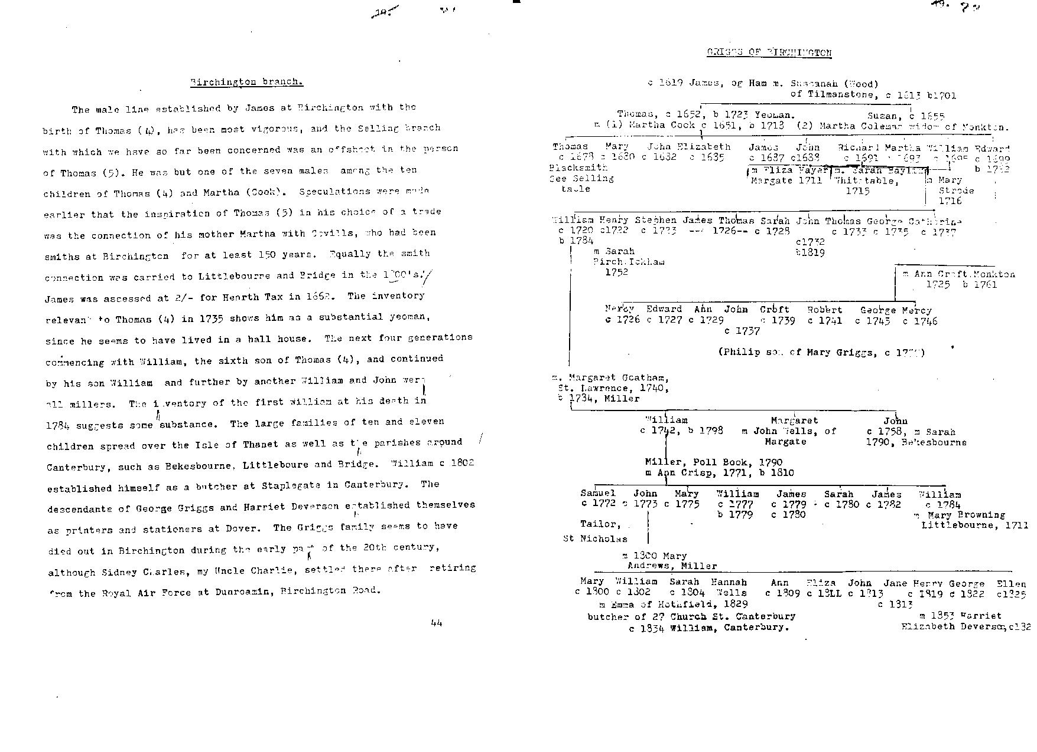


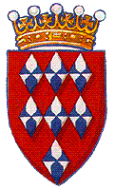
From the 17th C: The Mystery Line Between Huberts and William Griggs(0)

We inherited a Breeches Bible, published in 1610, still in our possession (with Anthony Grigg, Wellington), in which there are some family inscriptions, beginning with the Huberts in the 1500’s? It is presumed that this was inherited with Grigg’s mill and farm in Birchington, Isle of Thanet, Kent.

Here are some possibilities but nothing concrete.
The Arms of Hubert de Burgh.

Option 1: Hubert de Burgh (c.1175-1243), a younger son from a family of Norfolk gentry, entered the service of King John in the 1190s. His reputation was made by his obstinate defence of the castle of Chinon in 1205. Appointed seneschal of Poitou in 1212 he held that province against French attack. Recalled to England in he was appointed Justiciar at the height of the Magna Carta crisis and remained in that office, with overall responsibility for the administration of England, until 1232.
He was one of the great Constables of Dover Castle. From his first appointment until he finally vacated the office was a period of thirty years, 1202-1232, but from 1203-1215 four other men filled the office for short periods. During his first period of tenure in 1203 he founded the Maison Dieu in the town.
Hubert played a decisive part in the war against France of 1215-17. He defended Dover Castle against Prince Louis of France, who invaded England to help the barons in their fight against King John. In 1216, the French laid siege to the Castle with a large army and great siege engines that could hurl rocks against the walls. Hubert only had 150 men to defend the castle with. Part of the outer curtain wall of the castle was undermined by the French and collapsed. But Hubert and his heroic defenders were able to plug the breach and fight off the attackers. With the death of King John, and the accession of his infant son Henry III, the French withdrew.
The French returned in August 1217 with a fleet of eighty great ships and many smaller vessels. They were met, off the Goodwin Sands, by Hubert with only forty ships at his command. But, unlike the French he understood the difficult Channel currents. He sank some of the French ships, ramming them with the iron tipped bows of his galleys. With his own vessels to windward of the remaining French ships he threw quicklime to burn his enemy and the French commander was captured. This defeat finally ended Louis’s hopes of becoming King of England.
From 1219 onwards Hubert was the most influential figure in Henry III’s minority government. In 1221 he married, as his third wife, Margaret, sister of King Alexander II of Scotland, and four years later was created Earl of Kent. In 1232 his long-time rival for royal favour, Peter des Roches, finally persuaded Henry to dismiss and imprison him. He made a dramatic escape from prison in 1233 and was reconciled to the king next year, but never recovered his former influence. In Dover Hubert de Burgh will be remembered as the heroic defender of Dover Castle and the founder of the Maison Dieu.

Option 2: Edward Hubert came over from France with the Huegenots and became Lord of Kent.
Option 3: But it is more likely that we were intermarried with a Hubert in Deal, Sholden, Kent prior to moving to Acol/Birchenton. There is a doctor John Hubert in Sholden, Deal in 1619. I would surmise that James Grigg b ca 1570 married one of this Hubert clan and their son James Griggs was born 1591 in Birchington, the first to be born in Birchington (records at Deal need researching).

Option 4: There is also an Earldom in Pembroke.

The castle of Dunster, Lordshp of C---hampton given to Sir Edward Hubert is mentioned as the first Earl of Pembroke by King Edward IV (some time after 1471). His wife, Elizabeth, was daughter of Sir William Courtney.

Was he an ancestor, and are we thus related to the miller Grigg’s of Pembrokeshire, or did the Bible simply come with the mill down to the Griggs? Or did it belong to the church at Acol that fell down? Did the Huberts ask the Griggs to transfer their milling knowledge from Kent to Prembrokeshire. If so when? (see appendix 5).

There is also a will from a Nathan Hubert, yoeman of Woodchurch in 1618.

After the Huberts, there is Line of Nash’s in the Breeches Bible. Who were they? There was a Nash Court traded by the Quex’s., Family tradition surmises that the mill was inherited through marriage to a Nash and that the Nash family had married into the Huberts.

Earliest Known Birchington Ancestor
Our family tradition is that we owned a mill in Birchington on the Isle of Thanet in Kent, back before 1666. I have been able to identify ancestors in Birchington, 130 years earlier. We know there was a mill and land there in 1666 known as Grigg’s Piece at the corner of Quex Park, 100 yards North East of Sparrow Castle Farm (Gray, 11).

Since our ancestor is recorded as a Griggs in a 1786 newspaper report, our ancestors are more likely to be Griggs, and prior to that, Grygg or Gryggs. There seem to be several clans in Kent that are probably related several generations back, but those in Birchington, Acol, and most in Margate, Ramsgate, in the Isle of Thanet appear to me to be descended from Thomas Griggs of Acol, Birchington (b c1645).

Generation 0: The earliest Birchington Grigg that I can clearly identify is James Griggs, born ca 1591 in Birchington, Kent, brother of Thomas and son of James, or Thomas or most likely Richard Griggs and Jane Fow of Sholden, Kent, near Deal (He does not show on the family tree above, indicating some discrepancy).

Generation 1: His sons are as yet unidentified. (Either James or one of these likely married a Nash??, hence the line in the family Bible?)

Generation 2: Thomas Griggs (b c1645), presumably his grandson, m Martha Cook, 23 Dec 1677 in Birchington, Isle of Thanet in Kent, UK.,

- Generation 3.2: Their son, John (0) Griggs was baptised 1691 in Birchington, will in 1758, died 1775 (PRC17/99/278a), possibly married to Sarah in 1747.
- Generation 3.1:He is probably brother of our William (0) Griggs,, likely born c 1695, likely m Mary Strode c1735, died in Birchington in 1784, and likely was buried in Thanet somewhere (this is not the William Griggs buried in Dover in 1774 from the other family as dates are different) . With certainty, I have been able to clearly trace our ancestors to this William(0) Griggs of Birchington, on the Isle of Thanet in Kent, (c 1710 - died 1799), m _____ , through stumbling on the following unusual story, which confirms the tradition of our owning a flour mill for some extensive time, perhaps back to 1666, as the family possessed a scale back to that time from the mill.

About two years since he died at Birchington in the Isle of Thanet, Mr William GRIGGS, many years Master of a Windmill at that place. On his death bed he informed his son, who is now master of the said Mill, that he had buried a quantity of money in the house he then lived in, at Birchington. The son, after his fathers decease, searched after the money, but could not discover where it was. The house was let to another person, who has lived in it ever since, till within a quarter of a year, when he quitted it. The house being now empty, the son of the said Miller, determined on a second search, when under the pavement in the kitchen he found a clock (crock in the Ipswich version) containing a bag with 735 guineas. The son has given half this sum to his sisters children, who are left without a father or mother, their parents being dead some time.

Who was the family: brothers, sister, sisters children, parents?
- Generation 3.1 John Grigg, wife Ann, mentioned in the will
- Generation 3.2: James Grigg , likely brother of John, brother of William, baptised 1712 at St Nicholas at Wade nearby
  - With son, John Grigg(1) of Manston (next village towards Ramsgate) b 1733, d 1819 in Margate, m Jane b 1742 d 1792 (both buried in Ramsgate).
- Generation 3.3: Edward Grigg is another likely brother of John Griggs, brother of William (Born c 1710), died in 1767 at St Peter in Thanet Married Ann, 2 Sep 1733. (Is this a different clan or most likely a brother?). Children were:
- Edward Griggs - Born 13 Oct 1731, St Nicholas at Wade.
- Richard Grigg was born 2 Sep 1733 at St.Nicholas at Wade
- Sarah Grigg (b 4 May 1735), at Nicholas at Wade.
- Gen 3.4 His sister, and her husband died before 1784 and left children, surnames unknown (from the newspaper article).
- Gen 3.6 Phillip Grigg is another likely brother of John Griggs (bc1715) married Hester Bookey (or Booker?) on 23 July 1740,
  - Esther Grigg was born 20 Oct , 1750, daughter,
  - Stephen Grigg, 9 Feb 1752, St.Nicholas at Wade (likely the shipwright in Margate in 1763), though this is more likely a descendent from those who lived in Margate.
    - Father of Charles Grigg m Mary
    - Father of Stephen Grigg, mariner, father of Sarah Ann
  - Philip Grigg bapt 15 Aug 1742 at St.Nicholas at Wade m Eliz Randall, 18 Oct 1770 at St.Nicholas in W Kent. Children:
    - In the Canterbury records, Phillip Grigg was born 6 July 1768
    - and Stephen Grigg, on 15 Oct, 1761 (Shipwright in Margate?)
    - John Griggs, (b 1771) m Sarah Wooten (according to Neville Grigg in footnote above)
      - John Grigg b 1795, m Sussanah Holmes
        - James Grigg, b 1812, m Jemimah Brown in 1827 (http://www.teanook.ca/family/tree/fam/fam00023.htm)
  - Sarah Grigg, 8 May 1757, St Nicholas at Wade. (There is a Sarah Griggs of Kent deported to Australia on the convict ship Neptune, in 1788, with a sentence of 7 years).
- There is a Henry Grigge, who married Merry Grott in Shepherdswell on the 8th June, 1609. Two generations later, John Griggs of St Peters, Thanet married, 5 July 1747, Sibella Barfestron Dixon in Shepherdswell, Kent, (This may be coincidence or may indicate an ongoing relationship between the Birchinton and Shepherdswell clans of Grigg, and since Henry Grigge precedes our Thomas, we may wonder if Thomas migrated from Shepherdswell). A William Grigg married a Jane Gibbons in 1798 in Shepherdswell. This is unlikely to be his son (as Grigg, not Griggs, but it’s a possiblility).
- There are other unconnected descendants:
- John Grigg, married Sarah
  - with child, John, in 1812 in St Nicholas at Wade.
  - Thomas (b1806) of St Nicholas at Wade. Children:
- Jane, Daughter 1839, 12 in 1851 census
- Eliza, Daughter 1841, 10
- Louisa, Daughter 1843, 8
- Martha, Daughter 1847, 4
- William Brice, Son in Law, 21 born Canterbury, Shepherd (married to which daughter? Sarah?)
- Sarah
- Two others
- George Grigg at Margate, who walked out on his wife, and in 1858 was running Kent Inn, Cambden Rd, Ramsgate.

History of Birchington, Monkton, Ville of Wood and Acol
Birchington was first recorded in 1240 as Birchenton, a name derived from the Old English words 'bircen tun', meaning a farm where birch trees grow. Archaeological evidence has shown the area was inhabited before the existence of the village: Roman and prehistoric artefacts have been discovered in the area, and Minnis Bay was once the site of an Iron Age settlement.
Archives show the village's All Saints Church dates to around 1350. In the early 15th century, Quex Park manor house—named after the park's second owner, John Quek—was built just south of the village. The ownership of the manor passed to various families until 1770 when it was acquired by the present owners, the Powell family. In the late 17th century, the house was visited by King William III. In 1565, a report on the coast of Thanet by the commissioners of Queen Elizabeth I stated that Birchington had 42 houses.
In the 19th century, the village coastline was frequented by smugglers, leading to skirmishes between them and excise officers. Several of the older houses in the village contain cellars and bricked up tunnels, once used for storing contraband.
Birchington, Monkton and Vil of Wood (Woodchurch, corruptly pronounced by the inhabitants as Willowwood (Hasted)) shared common Church of England churchmen, and the Crispes who lived in Quex Park came to own much of Woodchurch as well.
The 1801 census recorded the Birchington village's population as 537. It had grown by 100 over the previous century but virtually no families with the same names were there at the end of the 1800’s as had been there in the beginning of the 1700’s indicating considerable migration in and out, perhaps because it was on one of the routes to the sea. It was under the control of Dover, one of the Cinque ports. The village was a farming community until the late 19th century, when it began to develop into a coastal resort.
The Wesleyan Methodists, Baptists and Primitive Methodists all had a chapel in the village in 1847. Since the Griggs don’t feature in the church leadership, one presumes they were Baptist by this point. The Free School is a small wooden building where 45 children are taught. Thus out of 540 odd people, one would presume that most were non-conformist.

Known Ancestral Line
To continue our family line, Generation 3.1. William Griggs of Birchington, in the Isle of Thanet in Kent, (c 1715 - died 1784). William (0) wife is likely Sarah Grigg, buried in Margate and daughter of Stephen and Elizabeth Swinford, besides whom she is buried. She would have been born around 1720 d 1782? – need to find Birchington records).
Generation 4.William Grigg (1) (c 1740 – 1799) the son mentioned, is the Grandfather of John Grigg of Thames, likely wife Ann (Appendix 3) (or Elizabeth (1749-1837), less likely). The Grigg-s is a slight name change between generations. One presumes from this point on they were called Grigg not Griggs. He was miller, of the Ville of Wood (or Acol), with considerable property. From Matt Findlay’s work we know he had four sons.
5.1. Samuel Grigg who died elderly, a widower with no family, was a grocer at St Nicholas at Wade in the 1858 directory.
5.2. John Grigg born about 1780 in Acol, Kent, married c 30 Jun 1811 in Birchington, Kent, Mary Andrews (b about 1780 in Minster, Thanet). Children:
- They had one daughter Eliza Grigg b c30 Jun 1811 in Acol, Birchington, Kent.
- His sons were William (1803-), married Emma (1811-) , a butcher and lived at Canterbury (1851 Census). On 14 & 15 April, 1814 indenture of mill and houses from John Grigg to William Grigg of Titchfield St., Oxford Road, Middlesex, plumber & glazier. [Was this his son, at age 11? Or do I have the wrong birthdate].
  - Whose son was William(3) (b 1835). He had no children.
- Henry, a licensed victualler in London.
- George, an invalid chairmaker in Ramsgate.
- John, lived in London, occupation unknown.
  - but a son of his, named John, came to New Zealand serving under Von Tempsky’s regiment, fighting against the Maori.
- Other daughters.
5.3. William Grigg (2) (b c1770), who had no male issue, .
5.4. James Grigg (b Birchington, 10 Oct 1782, died London, 5 Nov 1851), our ancestor, Chief Clerk and Financial Manager of Wells and Co, House Furnishers in Regent Street, London, who married twice.
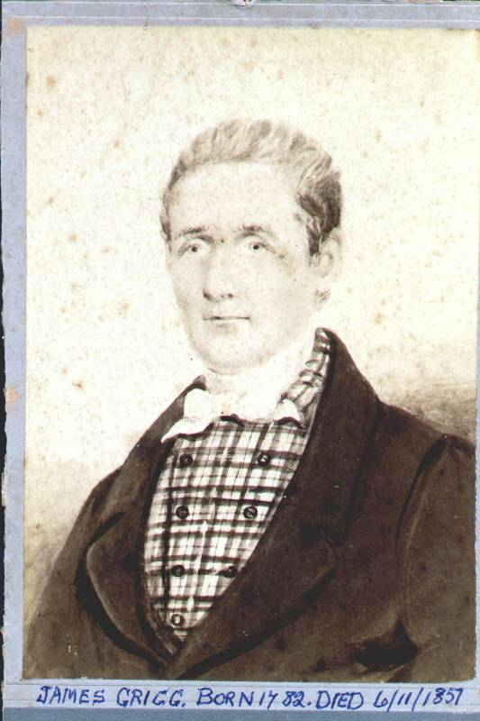

First married to ______ (c1820), likely in London, after he had sold the houses and farm and moved to London. They had ten sons and two daughters, who if he remained in Birchington likely scattered to Ramsgate, Margate and Dover then to London or overseas (If he moved early to London, likely the following links are incorrect).
6.4.1 one of whom
7.4.1.1 had a son called William(4)
- 7.4.1.1.1 who had a son called William(5) James living in 30 Leyton Park Rd, Sussex in 1910.
6.4.2 one of his sons was Edward Griggs who married Mary of Acol and had:
7.4.2.1 daughter Ann Grigg (1823)
7.4.2.2 William Smith Grigg(b 12 Nov,1826)
6.4.2.3 Louisa Ann Grigg (5 April,1829) married William Miller (10 Feb 1849, St Lawrence). It was witnessed by Jane Griggs, presumably the aunty above.
6.4.2.4. John Edward (1831)
6.4.3 likely Edmund Griggs, m Patty Impett, his Son, John Griggs b 1824 m Jane Sayer b c1829 in Birchington.
6.4.5 plus seven other sons, who likely migrated to the colonies.
6.4.7.his two daughters are likely Sarah
6.4.8 and Esther, who witnessed his second marriage to Ruth

[There is an interesting poem by Wordsworth about the Men of Kent around this time (http://youtu.be/PwuXR_RJzBk )]
James (at 54) married his second wife, Ruth Jones, a widow, at the Parish Church of St Mary, Lambeth, Surrey, 23 Feb, 1836, attested by Sarah Grigg and Esther Grigg. She was the daughter of John Martin of Southwick, London, a saddler from Strauraer, Scotland. Her previous marrage was to R.M. Jones, with whom she had one daughter, also Ruth, who died at 10 years. James died 6 Nov 1851. Ruth died in 1853. By this time he was an independent and she a Baptist.
Gen 6: His son by this marriage, John Grigg, F.R.A.S was born London on 4th June 1838, in London, married (13 Sept 1858) Emma daughter of Thomas Legge Mitchell. The founder of the Grigg family in New Zealand, John Grigg who migrated from London, was the son of this James, who was the fourth son of William Grigg, a miller from the Ville of Wood (Appendix 3), who inherited golden guineas hidden in a crock under a flagstone of the mill from his father William Griggs.
When his father died in 1851, he and his mother moved to Greenwich, where she started a school with his assistance. She died in 1853, so he had to take on a clerical job at age 15 with his father’s old firm. He then left it for experience in the music trade.

He married Emma in Sept 1858, in the 1861 census, John 22 and wife Emma, 24 lived at Marylebone, London, with son John H (Handel), 1 yo born at Marylebone and an adopted son Frerick H, 5 yo born in Lambeth Surrey.

“A prominent member [of the Auckland Baptist Tabernacle in Willougby Street] was Mr John Grigg, famous as an astronomer, useful as a musician and lowly as a disciple of the Master”

Emma died in childbirth. In July,1883 he bought 250 shares in The Lucky Hit Goldmining Company. He is noted there as the music seller and in another article as the same viz a viz the furniture seller. As a choir master he put together an amazing amount of work but the attached shows an interesting conflict with the leader of the orchestra in 1889.
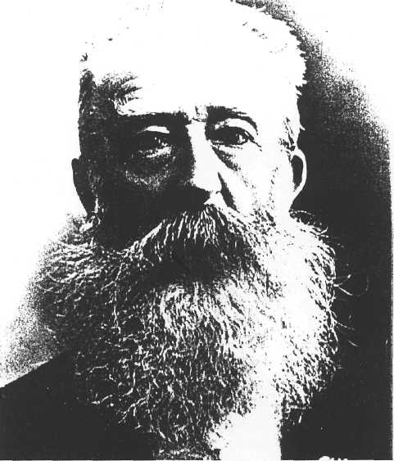
There he established a furnishing business, and later he added a music shop to this, and taught singing.
Grigg married a second time in 1871, but his new wife died during a miscarriage in 1874. He wed a third time in 1887. In all, Grigg's three wives bore him six sons and three daughters, and he and his first wife also adopted a son.
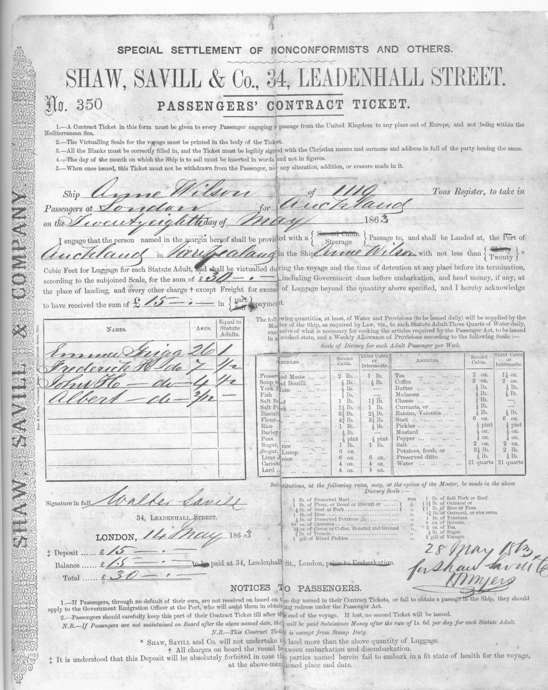

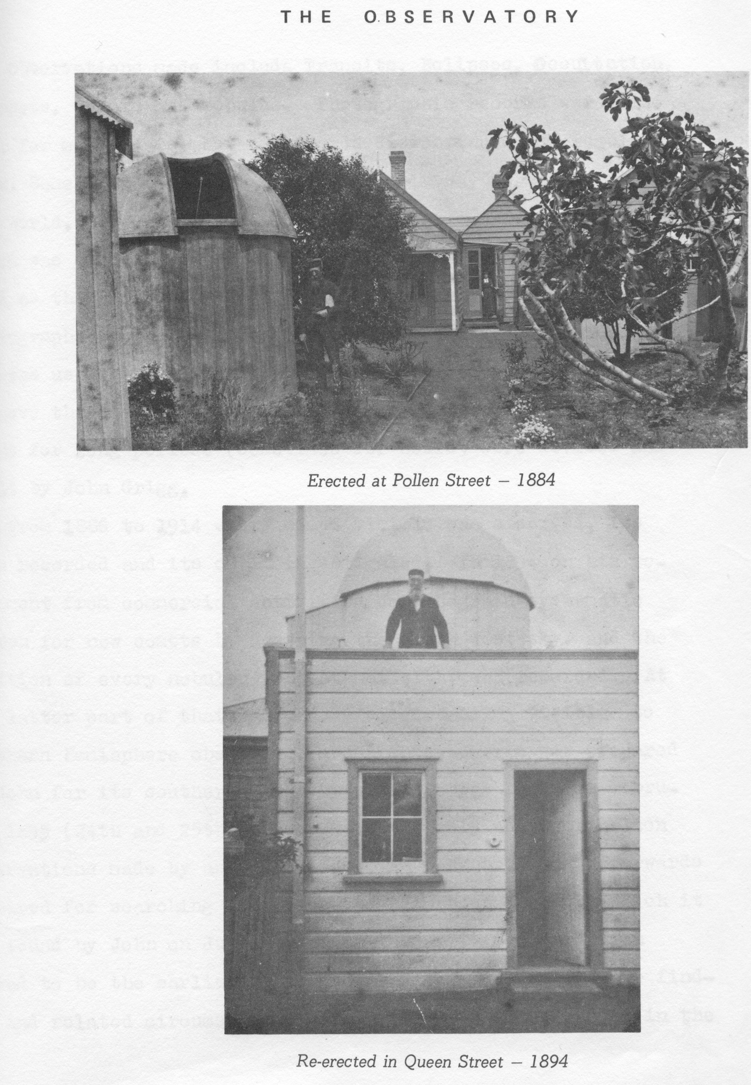
The rest of the Grigg Family descendents in New Zealand and Australia are recorded in John Grigg’s summary, up to 1990.

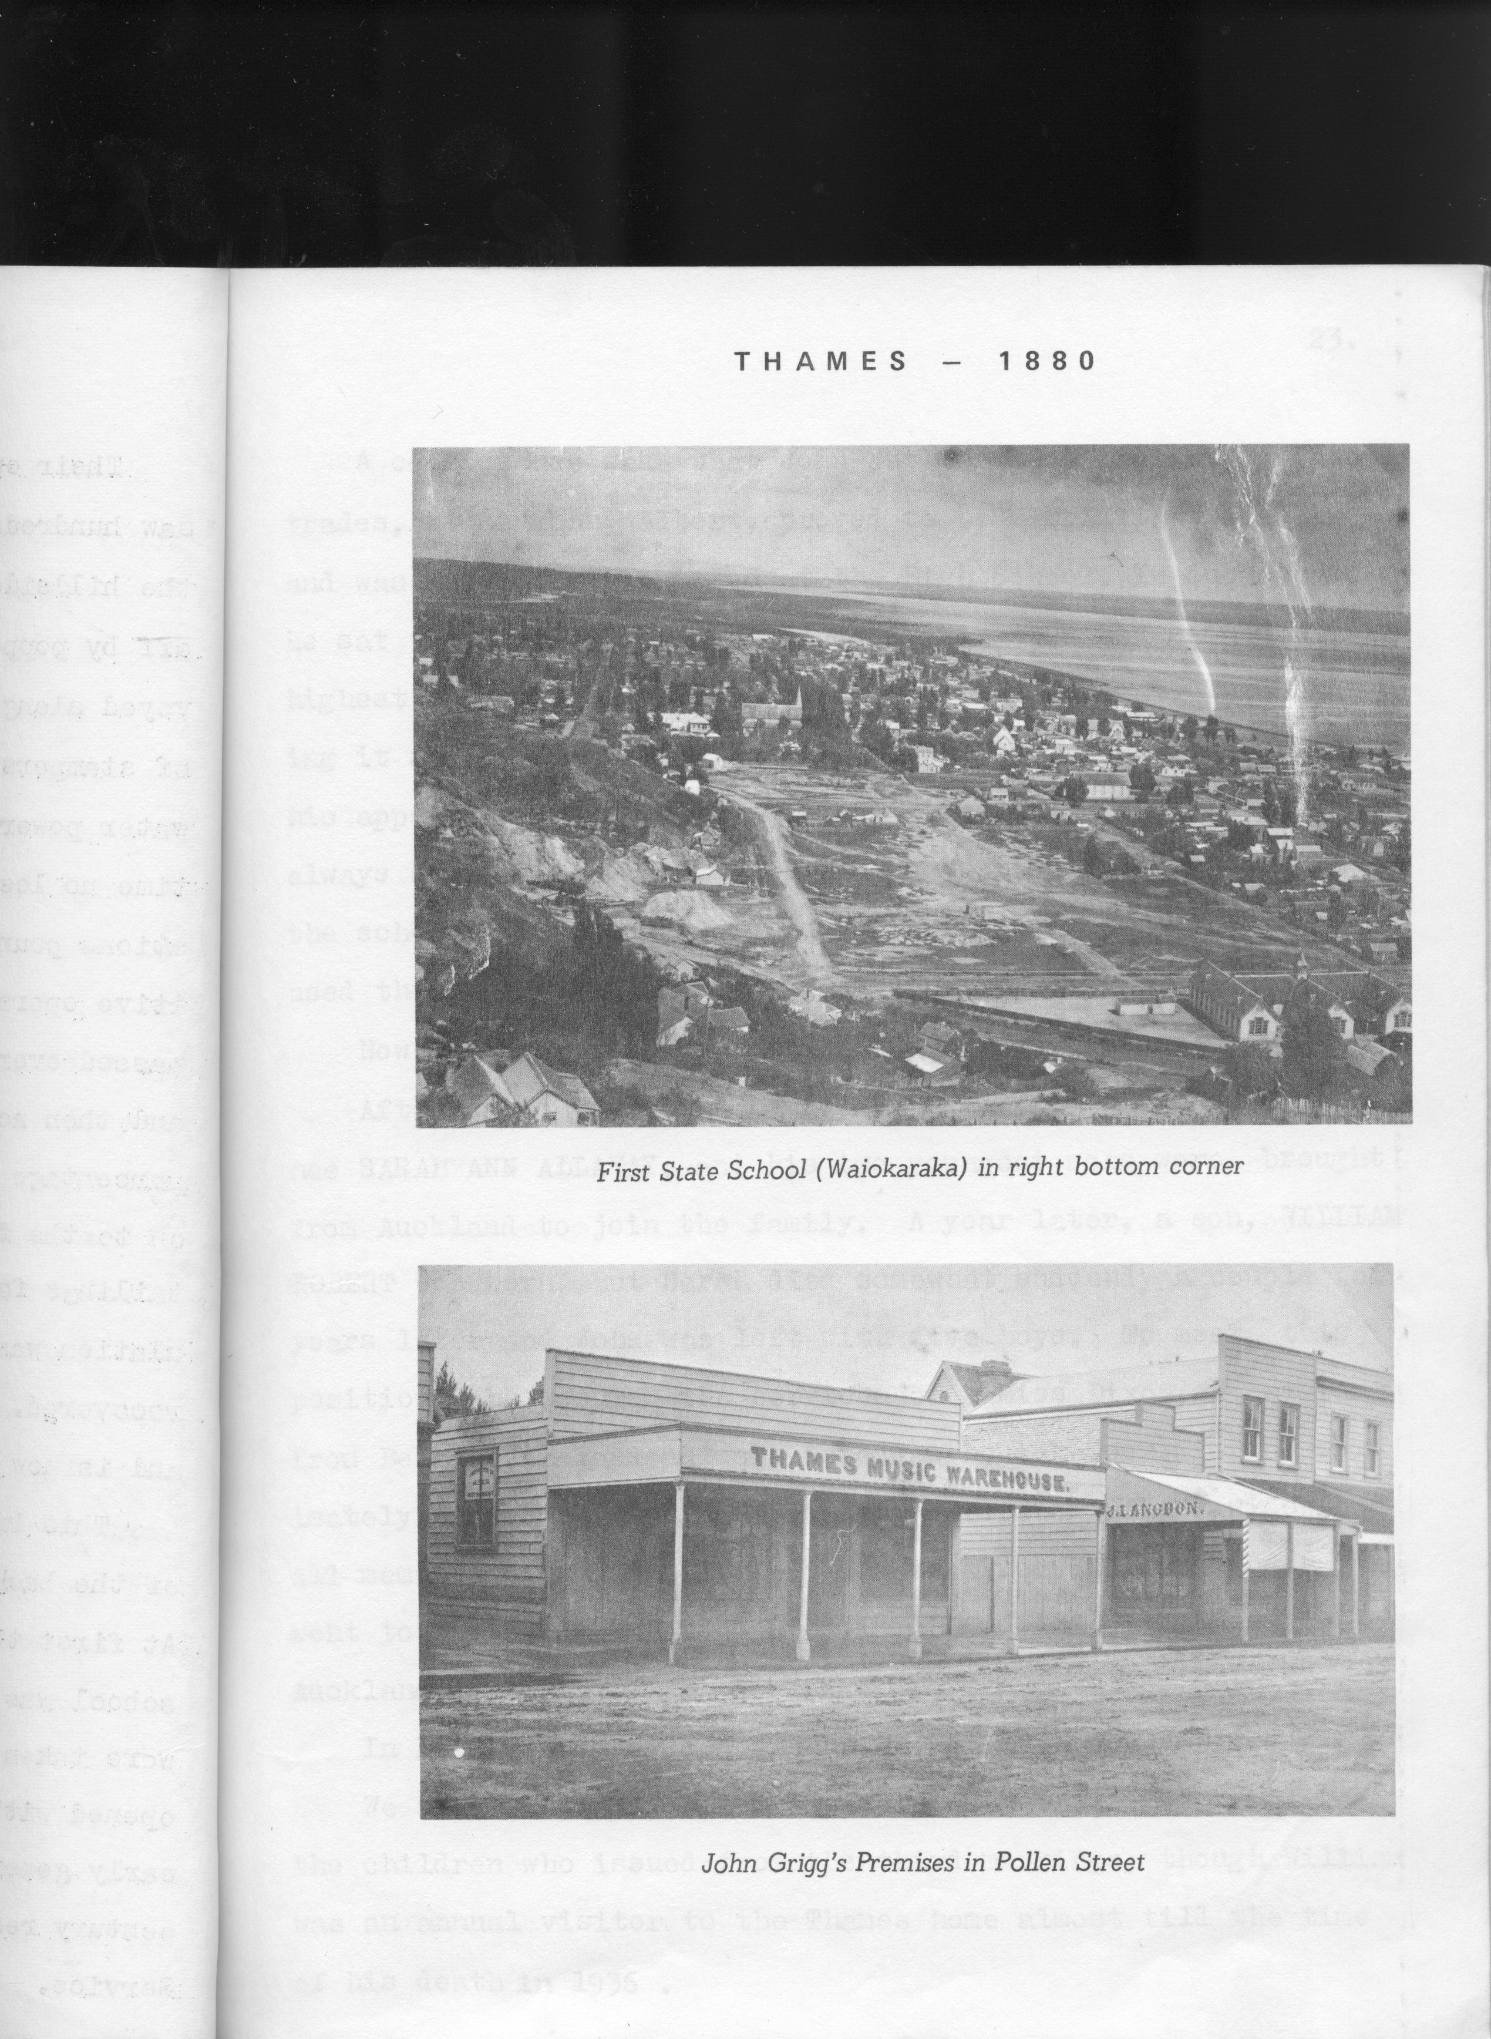

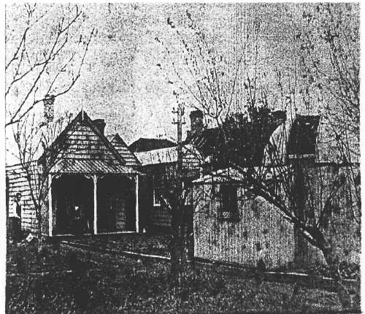
Further descendants of generations 7 to 10 up to 1990 can be found in my father’s manuscript or that of Matthew Grigg.

And the Future of the Grigg Clan?
Well, next stop the moon, as we already have a crater named after us, (actually after John Grigg F.R.A.S).
Al

Appendices

Woodchurch? Acol?
William Griggs is mentioned as a miller at Monkton, and note on the old map below that Acol - where many of the Grigg’s are noted as being from - is not the same as Woodchurch, so presume that the Birchington church registrar indicates he owned land in both places, but that the mill was at Acol. Matt Grigg indicates that the family had owned a farm and mill. The notes in appendix 3 indicate him buying several houses in the village of Birchington in 1774. These were bequeathed to two sons in 1797. The record below indicates this as being Samuel and John and wife Ann (most likely William’s wife), and he was still from the Vill of Wood (=Acol), while the fourth son, James, our ancestor, inherited money. By 1810, the houses in Birchington were mortgaged and sold. The following describes the changing names:
South-eastward from, and adjoining to Birchington, lies the ville or parish of Wood, otherwise Woodchurch, corruptly called by the people Willow-wood, for Villa-wood, taking its name from its being antiently almost all a wood.
It is, as Birchington, a limb of the town and port of Dover, and under the government of the same deputy, and assessed, with Birchington, to the land-tax, though antiently it was taxed by itself. This town of Wood, in queen Elizabeth's reign, paid more to the tenth and fifteenth, than was paid at that time by the town of Monkton; and yet in the return made by archbishop Parker, in pursuance of a letter from the privy council, it is said there were no housholds in this parish; the meaning of which probably was, that this parish, being chiefly woodland, there were no farm-houses in it, but only cottages.
The high road from Sarre to Margate separates Wood from Birchington; about a quarter of a mile or a little more from which, southward, are the ruins of Wood, or Woodchurch chapel; near it there is but one house, the rest of the houses being near a mile from it, at a ville, antiently called the Millburgh, and now Acholt, which is about the same distance from Birchington, where there is a fair held at Acholt, on May 30, yearly, for pedlary and toys. For this reason it is likely this chapel was so far suffered to go to decay, as at length to fall down; however this may be, it has been long since demolished, only part of the walls being left; its yard, containing about half an acre, surrounded by the original walls of it, converted to a lay fee. The building must have been of a considerable size, as the foundation measures eightyfour feet in length, and fifty-six in breadth; there is a mount of eight or ten feet high in the middle of the area of the church, which evidently appears to be the ruins of the tower. There is a farm-house adjoining the inclosure, which is about a quarter of a mile from the great road leading from Canterbury to Margate. The inhabitants of this parish are assessed towards the repair of the church or chapel of Birchington, though it still maintains its own poor. (fn. 1)
The chapel of Wood was dedicated to St. Nicholas, it was exempt from the jurisdiction of the archdeacon, and was standing and used as a place of worship in the year 1563. The vicar of Monkton, to which church this was a dependent chapel, was bound by the endowment of his vicarage, to find a chaplain, to celebrate in this chapel on Sundays, and every Wednesday and Friday, and to officiate in it duly, in divine services, as is more particularly described in it; for which duty he paid him 3l. 14s. 4d. yearly.
Wikipedia: Acol (formerly Acholt) is a hamlet in the English county of Kent. Located about 1½ miles south of Birchington, close to the Western end of the runway at Manston Airport, it is one of the smallest communities in Kent.
A village called Acholt was recorded at Sparrow Castle, or Kemp's Corner - the Junction between Shottenden Road (B2049), and Manston Road (B2050), in 1270. The name derives from the Old English, ac meaning oak and holt meaning wood. This indicates the original proximity of the village to a small area of oak trees. Most of the inhabitants perished at the start of the Black Death in 1347, and when the village was burnt down to stop contamination, the decision was made to move the settlement to its current position. The new village's first name was Millbrough, and then variously Ville in the Oaks, Ville in the Woods or Ville of Woods. Later the name became Acoll and finally Acol.
The Ville in the Woods first appears on Thomas of Elmham's map of the Isle of Thanet, Circa 1412 (now housed at Trinity Hall, Cambridge).

The Missing Mill

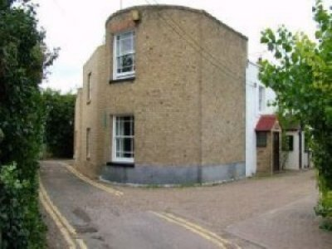
Where was the mill? Was it here actually in Birchington, where they seemed to buy a set of row houses, in Mill Rd? In a 1666 map [in Gray] there are about 50 houses but no mill is shown, perhaps because the map does not go far enough, but it is known that in 1666, there was a mill at the corner of Quex Park in Birchington, 100 yards North East of Sparrow Castle Farm and as shown as Grigg’s Piece. “The next maps of 1774 clearly show Griggs Mill, sometimes known as Griggs Piece” (p12). The fields with the mill are also clearly shown. “Two houses stood which stood with the mill. On November 7th, 1787, Sun Fire Insurance Policy No 537003 valued the two houses at 100 pounds.” (Find this piece of insurance to see William Griggs involvement?)
The original mill house is still standing. The mill was on top of this house then was shifted to the back of the land and raised (down drive from this mill house). (Copy the photos from Grey).
Barrett mentions a mill at Beach Hill in Birchington in 1688. The map doesn’t show it but this is on the road to Acol, so presumably the same. The Griggs mill was not the Quex mill according to Grey. “W Coles Finch states that Griggs Mill was moved during the early 1800’s and became the famous Hudson’s Mill.” There is likely evidence of what happened in the Hudson Mill history that in fact the mill was moved from the top of the mill house to the end of the current drive.
It is likely one of the following from Mills in Kent (these are on the maps dated below), most likely the number 3 as there is a connection to the Hudsons. However, since it was only moved from the mill house to the end of the road it is more likely the first mill seen in 1596. (Were we the owners then or were the Huberts or someone else owners)?
- Birchington Post 1596 1695 1719 1596 1719
- Birchington Dentdelion Mill 1610 1695 1610 1695
- Birchington Quex Park Mill, Birchington Mill 1736 1769 1819 1736 Possibly moved to Birchington (Hudson's Mill)
- Birchington Grove End Mill 1769 1769 1769
- Birchington Seed Mill 1819 1819 1819
- Birchington Hudson's Mill Smock 1819 1858 1819 Demolished c.1900.

The following is another story that predates even these, of interest but probably not relevant:
A WINDMILL IN KENT
The year is 1198. The place is Monkton, England -- a town on an island off the coast of Kent. It isn't far from Canterbury Cathedral, where Thomas à Becket was murdered 28 years before. English monks have a monastery there. They've set up a water wheel to grind grain.
Now hi-tech comes to Kent. Windmills were the new power source. They'd appeared about 20 years before. They outperformed water wheels. Now they were sprouting everywhere.
A man named William Wade got into the act. He built a windmill near the monastery. The problem was, he built on land his uncle had sold to the monastery back in Becket's time. Wade had always disputed the sale. He figured the land was still his.
The monastery had been slipping. It'd once had 140 monks. Now there were fewer than 100. When the windmill went in next door the monks were furious. They were far more angry about the competitive technology than they were about encroachment on their land.
So they took William to court. By now, the Norman administration had created legal logjams that rival the ones we see today. First the monks went to the local manorial court. Then the case got bumped up to the Royal Court.
The Royal Court found against William. They ordered him to tear down his mill. About this time King Richard was assasinated. So William crossed the English Channel and went to King John in Normandy. He offered the King ten marks to confirm his right to operate the mill. This was a small potatoes transaction, and the King said, "OK."
The monks were patient. They opened another suit charging that William had deceived King John. He hadn't mentioned the judgment pending against him. By the year 1203, a priory court in Canterbury found against William again. This time he agreed to tear down his mill and return the land to the monks.
But he didn't do it. By the year 1205, the case was back in King John's court. And there William finally lost his case -- and his windmill -- after six long years of litigation.
Of course, not long after all this foofaraw the Monkton monks themselves began building windmills. In fact, while the fuss was going on, a group of nuns near Canterbury had already begun building their own windmill. They needed it to grind grain for their cloister and their hospital.
The Quex mill is also noted in records. They were different according to Gray. Perhaps that is why the Griggs do not feature in church activities, where Quex were prominent. They were in competition.

Impoverishment that Forced Migration
Why did the Griggs disappear from Birchington in the early 1800’s?
The aftermath of the Napoleonic War was a cruel time for small farmers and farm workers. Starvation wages, low prices and crippling taxes drove many to desperation and caused social upheavals on the land. At first sight, Cobbett was most impressed:
"When I got upon the corn land in the Isle of Thanet, I got into a garden indeed." He avoide Margate as being "full of Stockjobbing Cockholds at this time of year..." He breakfasted at a little Hamlet (Acol) "But could get no corn for my Horse, and no Bacon for myself." Regarding the local conditions, Cobbett was moved to comment, "The Labourers houses, all along, through this Island are beggarly in the extreme. The People dirty, poor-looking, ragged, but particularly dirty. It is impossible to have an idea of anything more miserable than the state of the Labourers in this part of the country".
In reality, the condition of the labourers throughout Kent at the time were deteriorating to the point where unrest brought about the start of the Swing Riots in 1833-4. At the same time, many labourers left Kent, often with the grateful assistance of their parish councils who did not want to keep supporting them, to take up new lives in the colonies.
The Swing Riots were a widespread uprising by the rural workers of the south and east in 1830. The rioters, largely impoverished and landless agricultural labourers, sought to halt reductions in their wages and to put a stop to the introduction of the new threshing machines that threatened their livelihoods. They reinforced their demands not only with riots in which objects of perceived oppression such as workhouses and tithe barns were destroyed, but also with more surreptitious rick-burning, the destruction of threshing machines and cattle-maiming. The movement paralleled its urban-industrial counterpart, the Luddite disturbances. The first threshing machine was destroyed on Saturday night, August 28th, 1830. By the third week of October, over one hundred threshing machines had been destroyed in East Kent. In geography, arable land is a form of agricultural land use, meaning land that can be (and is) used for growing crops. ...
The thrashing machine, or, in modern spelling, threshing machine (or simply thresher), was a machine first invented by Scottish mechanical engineer Andrew Meikle for use in agriculture. ... The Luddites were a social movement of English textile artisans in the early nineteenth century who protested often by destroying textile machines against the changes produced by the Industrial Revolution, which they felt threatened their livelihood. ...
The Swing Riots had many immediate causes, but were overwhelmingly the result of the progressive impoverishment and dispossession of the English agricultural workforce over the previous fifty years, leading up to 1830. The anger of the rioters was directed at three targets that were seen as the prime source of their misery: The Tithe system, the Poor Law guardians, and the rich tenant farmers who had been progressively lowering wages while introducing agricultural machinery.

John Grigg, F.R.A.S. by John Grigg, my father

THE ANCESTORS and DESCENDANTS
OF THE PIONEER SETTLER
JOHN GRIGG F.R.A.S.
OF THAMES, N.Z.
(1836 - 1920)

Compiled by his oldest
great-grandson
JOHN LAWRENCE GRIGG Auckland

1. INTRODUCTION
If we exclude the descendants of FREDERICK HENRY GRIGG, the adopted son of JOHN GRIGG, I am the oldest great-grandson in his family. I have taken on myself the task of updating our genealogy for the benefit of later generations.

About 20 years ago, my father's half-uncle, MATTHEW HENDERSON GRIGG compiled a record of the family, which he entitled "JOHN GRIGG F.R.A.S. of THAMES N.Z.". This and entries in a historic family Bible which I now hold provide the basis for this extended compilation.

A family tree is simply a catalogue of names and dates unless information is available to give a verbal picture of the lives of the entries. These notes aim to "flesh out" my heritage. My aim is to record for my children and grandchildren, who are now scattered as far apart as Melbourne and Philadelphia, some background to their ancestry, and to suggest what motivated various phases of the lives of our ancestors.

2. BEGINNINGS
The earliest records associated with our branch of the GRIGG family are handwritten entries in a Family Bible brought to New Zealand in 1863 by JOHN GRIGG.

This Bible, the Geneva translation, often known as the "breeches" Bible is currently in my possession. Although the translation was made in Geneva by exiled English protestants in the time of Queen Mary, this copy was printed in London in 1610. It contains the Old and New Testaments and the books of the Apocrypha.

I was told that the Bible had been. through a flood in Thames, N.Z. Each page was carefully sponged free of mud. A few pages have been damaged, and many pages are discoloured, but are still legible. After this flood the volume was rebound in leather.

Genealogies usually proceed through male lines, but the entries in our Family Bible concern families named HUBERT and NASH, and it would seem probable, although not documented, that a HUBERT daughter married a NASH, and a daughter of the NASH line married WILLIAM GRIGG about the time of the French Revolution.

The earliest name referred to in the Bible is EDWARD HUBERT, described as "Esquire" of "Grasorne" in north-eastern Kent. JOHN GRIGG and his son MATTHEW GRIGG regarded him as a founder of the family. He had a son, also named EDWARD of "Much Baddon". The recorded members of the HUBERT family lived during the reigns of James I, Charles I and the Commonwealth period. They were described as land-owners and flour-millers. "Grasorne" and "Much Baddon" are presumably the names of estates or villages.

One can speculate how these ancestors dressed - the boys possibly as in Gainsborough's paintings, the "Red Boy" and the "Blue Boy", and the ladies as in Yeates' painting "And when did you last see your Father?".
The connection between the HUBERT and NASH families is probably through a daughter. ELIZABETH HUBERT was of an age to be the wife of WILLIAM NASH. Likewise, a century later, either ELINOR or ANN NASH could have been the mother of WILLIAM GRIGG.

The NASH family entries show us the frailty of human life in the early 18th century. The first wife of WILLIAM NASH, MARY, died aged 22 after bearing two children. Her second boy lived only five days. WILLIAM'S second wife, JENNET, also died young shortly after the birth of her third child, MARY.

The attached genealogies cover the data in the Bible recorded for these two families.
3. 1800-1863.
The first mention of the name GRIGG comes with WILLIAM GRIGG (1) who died about 1800. His estate was divided among his four sons. Details are sketchy, but SAMUEL probably received the mill, and JOHN (1) the farm estate, while WILLIAM (2) and JAMES received money. (I have numbered entries to distinguish persons of the same name).

SAMUEL GRIGG lived in later years at St Nicholas on the Isle of Thanet which is the region of Kent cut off by the now silted up River Stour. He was a widower without family and died at an advanced age.

The second son, JOHN (1) had a large family, four of whom were boys:
WILLIAM (3) was a butcher in Canterbury and died without issue.
HENRY, was a licensed victualler in London.
GEORGE, was an invalid-chair maker in Ramsgate which became a fashionable watering-place about this time.
JOHN (2), lived in London but his occupation is unknown. He had a son who came to New Zealand in the 1860's and served with von Tempsky's "Forest Rangers" in wars against the Maoris.

The third son, WILLIAM (2), died with no male descendants.

The fourth son, JAMES, my great-great-grandfather, was twice married. He had a large family of 12 children by his first wife, about which MATTHEW GRIGG knew nothing, except that there was a son, WILLIAM (4) who had a son WILLIAM JAMES living in Sussex in 1910. I have not tried to trace these lines of the family.

JAMES' second wife, nee RUTH MARTIN, had previously been married to R.M.JONES who died just before the birth of their daughter RUTH JONES. RUTH, the daughter, died when she was 10 years old.

JAMES GRIGG was Chief Clerk and Financial Manager for the firm of Wells & Co. in London, who were house furnishers. JAMES and RUTH had one son JOHN (3) born in 1836, my great-grandfather, who was the founder of the family now spread throughout New Zealand and Australia.

JOHN (3) was well educated by the standards of the mid-19th century. He was an only child and was sent to one school where he received a musical and scientific education, then to another where he did secondary subjects. After his father's death in 1851 he assisted his mother who ran a private school in Greenwich. He was greatly intrigued by the concrete strip at the Royal Observatory in Greenwwich which marks the U degree meridian. This early proximity to astronomers no doubt led to his later interest in astronomy, culminating in his discovery of several comets, and the award of a Fellowship of the Royal Astronomical Society.

When his mother's health deteriorated, JOHN had to find work. He worked first as a clerk in a merchant's office, but when RUTH died in 1853, Wells and Co. for whom his father had worked, offered him employment. After some time with them he left for the music trade, which brought him into touch with musical circles in London, especially the West London Choral Society. He was a member of the choir which performed Handel's "Messiah" before Queen Victoria at the Crystal Palace in 1855.

Left alone in London at an early age, JOHN matured rapidly. He returned to the furniture trade, setting up his own business at 47 Baker St., later moving to premises further along Oxford St.

In 1858 JOHN married EMMA MITCHELL, daughter of Mr Thomas Legge Mitchell, described on their marriage certificate as a "Missioner to the Poor". They adopted a child, FREDERICK HENRY, then aged two. Their own first child JOHN HANDEL (1) was born in 1859, their second, a daughter also named RUTH was born in 1861 but died the same year. Their third child, ALBERT EDWARD, my grandfather, was born in 1863.

4. TO THE COLONIES.
JOHN, EMMA, and children FREDERICK HENRY, JOHN HANDEL and ALBERT EDWARD sailed from England for a new life in the Colony of New Zealand on the ship "Anne Wilson" (not "Annie Wilson" as Matthew states), 1100 tons register, on 28-05-1863.

The voyage was via the Cape of Good Hope, but they did not call at Capetown and the only lands they saw from London to Auckland were Madeira and Tasmania.

JOHN emigrated as one of a group, the "Albertlanders", organised by Non-Conformists somewhat after the pattern of the "Pilgrim Fathers" to North America in the 17th century. His father JAMES had described himself as an "Independent" and his mother RUTH as a "Baptist". Both were very sincere Christians and JOHN followed their beliefs.

Arriving in New Zealand, JOHN found the colonists at war with the Maoris in the Waikato. He inspected the land allotted to him at Albertland on the Kaipara Harbour, but could see no future in it, so joined the militia for a time. The family lived in barracks on "Barrack Hill" (now Albert Park) in Auckland, and there another son was born to JOHN and EMMA, named HAYDN, in line with musical tradition. However, EMMA died in 1867, when only about 30 years old.

In 1867 gold was discovered on the Coromandel Peninsula and JOHN joined in the "rush". He took FREDERICK and JOHN HANDEL (1) with him, but left the younger boys ALBERT EDWARD and HAYDN in the care of a home for children set up by Bishop Selwyn.

But JOHN was not interested in digging for gold. His experience in the furniture and music trades led him instead into supplying the needs of the miners and foresters in the area. He built a store and factory on Pollen St. midway between the miner's settlement of Grahamstown and the logging settlement of Shortland.

JOHN married for the second time in 1871, his bride being Miss SARAH ANN ALLAWAY. They then brought the two youngest boys from Auckland to reunite the family.

SARAH and JOHN had a son WILLIAM (4), born in 1872, but SARAH died suddenly in 1874 and JOHN was again left alone with four growing boys. To care for them he employed a housekeeper, Miss Dixon, an emigrant from Belfast who "mothered" the family for about 10 years.

5. THE LATER YEARS OF' JOHN GRIGG
By about 1885 all the boys had left home. FREDERICK, ALBERT EDWARD and HAYDN ultimately went to Australia and JOHN HANDEL (1) to the Waikato, while WILLIAM (4) moved to Auckland and Kaitaia. JOHN left alone in Thames married for a third time in 1886. His bride was MARY JANE RENNIE HENDERSON. She bore him four children. MARY RENNIE GRIGG died when she was only a few weeks old, but STELLA, MATTHEW HENDERSON and FELIX JOHN THEODORE all grew up in Thames. The third family thus had little contact with the children of the first and second marriages, who had little incentive or occasion to visit Thames by this time.

As he grew older JOHN turned more and more to his interests in music, astronomy and the Baptist Church. The family moved to a new home in Green St., Thames and the telescope went too.

One interesting item about JOHN GRIGG is that he composed a song, "My Own New Zealand Home" which for a time appeared likely to become our National Anthem. It was sung by a choir at the opening of the Thames Branch railway line in 1898, but has now been forgotten, although copies exist.

JOHN was a foundation member of the Thames Baptist Church, which commenced as a fellowship in 1869, and was an original member church of the N.Z.Baptist Union. He was for many years a deacon, trustee, choirmaster and organist.

FREDERICK HENRY GRIGG: Adopted at the age of 2, FREDERICK grew up in Thames, being educated at private schools. He learned the baking trade in Auckland but went to Australia when about 21 and gradually lost contact with the family. He worked as a baker for some time and then as a public servant associated with dredging operations on the Clarence River in New South Wales.

Many of his descendents are listed in the genealogy, but I have not added any further generations than in MATTHEW's tabulations.

JOHN HANDEL (1): Born in London, the oldest child of JOHN and EMMA, he came to New Zealand aged 4. He grew up in Thames, loving outdoor life. He went to sea at 15, but at his father's request gave it up and worked in the bakery, boot and shoe trades. Later he joined the Telegraph Dept. as a telegraphist at Cambridge and Wellington. The continuous concentration and hard work involved led to him contracting Bright's disease. He died at Thames at age 25.

For a time, JOHN HANDEL and his brother ALBERT EDWARD toured the North Island as "entertainers", with a "magic lantern" show they called "An Exhibition of Phantasmagoria", but JOHN HANDEL's health deteriorated and he died at Thames on 21-12-1884.

6. A.E.GRIGG, MY GRANDFATHER.
ALBERT EDWARD GRIGG, was born in London and was only two years old when brought to New Zealand. When his mother EMMA died in 1867 he was placed in Bishop Selwyn's Home for Motherless Children until his father remarried in 1871. He was educated in Thames and was a brilliant scholar, passing the Civil Service Entrance Examination in first place for the Colony of New Zealand.

He was offered a position in the Survey Department, but his father would not let him leave home, so he trained as a pupil teacher. He was not very happy in this job, and resigned after two years to travel with his brother JOHN HANDEL (1) and his "Phantasmagoria" magic lantern show.

When this partnership was dissolved, ALBERT entered the grocery trade in Auckland. He joined the Ponsonby Baptist Church, becoming the organist. Here he met the GUEST family, recently arrived from England, Mr & Mrs Guest, five sons and five daughters, a family descended from French Huguenot emigres.

ALBERT became engaged to LAURA ALBERTA GUEST, but a short time later, the Guest family, including LAURA, moved to Melbourne, Victoria, to escape the effects of the depression in New Zealand during the 1880's. ALBERT followed the family to Melbourne soon afterwards and married LAURA on 10th May 1891.

ALBERT resumed his teaching career in country schools. Enoch's Point mining camp, Upper and Middle Indigo, Mildura and Bahgallah are some of the places where he taught. The couple had three children during their time at Indigo Creek - HILDA MARY (b.1-05-1892), JOHN HANDEL (2) (b.30-06-1893, and ALBERT JAMES (b.24-12-1895). A third son, EDWARD WILLIAM, was born on 21-12-1903 at Bahgallah. He suffered from the heat during Australia's hot summers, so in 1906 ALBERT EDWARD decided to bring his family back to New Zealand.

This change was quite traumatic for the three older children who had no desire to leave the land of their birth, despite the appeal of JOHN GRIGG'S patriotic song.

Back in New Zealand, ALBERT EDWARD obtained teaching posts at Ngunguru and then at Kauri-o-hore near Whangarei. The children were then able to attend Whangarei High School, travelling in by a local train. It was here that ALBERT JAMES lost both his legs below the knee when he slipped under a moving carriage.

Later, LAURA and ALBERT moved to another sole-teachership at Gordon, near Te Aroha, and then to Leigh where ALBERT was a well respected member of the community, which was then much more isolated than it is today. He finally retired in 1928 to a small farm he had bought above Matheson's bay, and lived in retirement until his death on 24-08-1940 in Auckland.

LAURA and ALBERT shared fully in the life or the Leigh community. ALBERT frequently conducted church services in nearby farming communities where the regular circuit preacher visited only once a month. After his death, LAURA stayed with HANDEL in Wellington until HILDA retired from school teaching. HILDA then cared for her at Te Papapa during her last years. LAURA died in 1946 and was buried alongside ALBERT in Waikaraka Cemetery, Onehunga.

7. JOHN HANDEL GRIGG (2).
From this point in our story I will concentrate principally on my own family.

My father was named after his deceased uncle, but was always known as HANDEL. He was born in Indigo Creek in Western Victoria, 20 miles from Albury on the Murray River. Because ALBERT EDWARD taught at two part time one-teacher schools, HANDEL attended school only on Mondays, Wednesdays and Fridays.

HANDEL has told how he used to sit on the school-house roof extinguishing sparks from the all too frequent bush fires. School was closed when temperatures rose over 40 deg.C.

Later, the family moved to Mildura where his schooling was more regular. There he often did seasonal work in vineyards, picking grapes for drying on trays in the sun to make raisins and sultanas.

On their return to New Zealand in 1906, HANDEL attended Whangarei High School, getting his Civil Service Entrance qualification, and qualifying for University Entrance. He was offered a post as a clerk in the Education Department, and accepted this (1910). He was employed in this Department for 40 years, rising to be chief executive of the Examination Branch, responsible for the organising of the Public Service Entrance and School Certificate examinations, teacher gradings and promotions, and all the clerical backup required by the professional staff. He finally retired from this position in 1950.

As a young man HANDEL was very active, having lived an outdoor life in Australia. He played Rugby football for the Oriental and University clubs in Wellington, social tennis with the Vivian St. Baptist Church young people, and enjoyed competitive walking. He regularly walked to work from Karori.

With 3 or 4 other young public servants he lived in a rented house in the suburb of Northland, within 10 minutes brisk walk of the historic wooden Government Building where he worked. They employed a housekeeper to care for them. HANDEL attended Victoria University College (then part of the University of New Zealand), studying Arts subjects, Maths, Latin and English. However the First World War disrupted his plans for completing his degree.

In 1913, compulsory military training was introduced by the Government, and HANDEL joined an artillery unit. On the outbreak of World War I, he was mobilised into the Coast Defence Regiment at Fort Dorset at the entrance to Wellington harbour, manning the 6 inch guns then installed.

He became a sergeant and excelled in gunlaying. After the German Fleet was eliminated from the Pacific Ocean, chiefly after battles with British vessels in the Falklands Islands area, HANDEL was transferred to the NZEF. He trained as a machine gun specialist on Vickers guns in the 21st Specialist Unit. He enlisted in 1916. In July 1916 he sailed with them for England and France, but was hospitalised in Torbay, England with a severe attack of cerebro-spinal meningitis. So he was spared the trauma of the later battles of the Somme and Paschaendale. He was invalided home in early 1918.

Because he had seen no active fighting HANDEL did not associate with Returned Servicemen's activities, but he always attended ANZAC day services in Karori, and wore his service ribbon when in the Home Guard during World War II.

Shortly before the outbreak of World War I, HANDEL became engaged to ANNIE DORIS CATHIE, daughter of Charles Cathie, a clothing manufacturer in Wellington. The Cathie family (11 children) lived in Karori on a small farmlet, and attended the Vivian St. Baptist Church. After his return from the war HANDEL and ANNIE DORIS were married on the lawn at this Karori property, known as "Inveresk", on 27-12-1918.

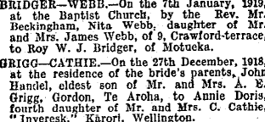

HANDEL bought a house at 1 Mallam St., Karori with his rehabilitation grant and this house was their home all their married life. Some rooms were added about1923 to accommodate their growing family.

HANDEL and DORIS had three children, JOHN LAWRENCE (b.14-03-1921), DOREEN LILIAN (b.9-02-1924) and DESMOND MILROY (b.21-11-1927).

The family were active in the Wellington Baptist Church (then in Vivian St.) where HANDEL was a choir member, and sometimes organist. The lack of Sunday morning tramcars meant a long walk for the family to church, luckily mostly down hill. Church would be followed by lunch with the CATHIE grandparents who had moved to Brougham St. on Mt Victoria. After afternoon Sunday school there was a tram ride home from Courtenay Place, costing 2d for children, 5d for adults.

As we children grew older, the time came when it seemed opportune to commence a Baptist work in Karori. There were a number of Baptist families in the district but not all elected to leave Vivian St-although those with children were glad to do so.

Karori Baptist Church commenced with about 40 members in 1935. Meetings were at first held in the supper room of the Masonic Lodge in Standen St., but a building fund and a search for a suitable site for a church were soon under way.

Handel was an inaugural deacon, organist and Sunday School superintendent, and also acted as secretary or treasurer when called on. In later years he was an elder.

Apart from his family, work, and church, HANDEL's main interests were his garden, and singing in the Wellington Harmonic Society Choir, led by H. Temple White. This was a regular Thursday night appointment he would never miss.

HANDEL completed 40 years service with the Education Department in 1950. In 1954 - 1955 he and ANNIE DORIS made a prolonged trip by sea to Britain, spending over a year there visiting Cathie relations in Scotland and spending the winter on the South Coast of England. Most of their travelling was done in a Ford "Cortina" they bought. This car was then shipped back to New Zealand and and was thus imported duty tree.

In later retirement, HANDEL enjoyed a quiet life, his church, his music and his family.

He died suddenly on 18-11-1975 after a fall. His ashes are interred in the Soldiers' Cemetery in Karori.

While I have concentrated on HANDEL in this chapter, my mother played her part in caring for us. She was rather ill after the birth of DESMOND, requiring removal of a kidney, so we had home-help at times. ANNIE DORIS was active in the BWMU and WCTU movements, being for many years business manager for the "White Ribbon" temperance magazine.

After her father Charles Cathie died, ANNIE DORIS inherited some money, which she used to buy a seaside cottage at Plimmerton, where we spent many holidays and often stayed there during February after school resumed. HANDEL, busy with school exam results, could not usually get annual leave in January, but was able to travel in and out to work by suburban trains, at first over the hill via Johnsonville, then beneath it by the Tawa tunnels, which cut the time from 1hr 15 mins to 40 mins. He enjoyed his evening swim after work, and watching the sun set behind Marlborough Sounds across Cook Strait. Rowing our dinghy round the various coves and beaches from Paremata and Titahi Bay to Maori bay and fishing off "the reefs" was another relaxing exercise for HANDEL.
Although the Plimmerton cottage lacked amenities, it was an enjoyable place to stay for short times, being just over the road from a small sandy swimming beach, where the sea could range from calm to ferocious breakers when a nor-wester blew in.

In later years ANNIE DORIS suffered a stroke and was paralysed on one side. She died on 24-06-1984 in her 91st year, and was buried in the Karori Cemetery.

8. JOHN LAWRENCE GRIGG.
Born in Wellington (14-03-1921), I attended Karori school (1926-1932), and Wellington College (1933-1938) where I passed the matriculation exam (the fore-runner of today's University Entrance Exam.) in 1936. I had two sixth form years studying for the Bursary/scholarship exam. as I had to wait until I was 18 to be eligible to enter University.

I was determined on a career in chemistry and began studies at Victoria University College in 1939 for a science degree, taking Maths 1, Physics 1 and Chemistry 1 in my first year. I had been unable to study chemistry at Wellington College, so I found Chem. 1 difficult. Rev Ayson Clifford, our minister at Karori Baptist Church, gave me some private coaching, but I failed Chem.1 theory so had to repeat the lecture course in my second year.

After one year as a fulltime student, I took a position as a technician with the Chemistry Section of the Dept. of Agriculture, getting time off for University lectures and doing the practical work in the evenings. I worked in the fat research section at first, but in mid-1940 during a reorganisation, I was transferred to the Soils Section which had a laboratory in a large house in Kelburn. This made it very convenient for me while studying at the University.

World War 2 started in September 1939 when I was 18. It did not affect me directly at first, although some staff members volunteered for the First Echelon of the 2NZEF. I continued my studies at Victoria doing two subjects each year, and graduating B.Sc. in 1941.

I was selected in a ballot for Territorial Service in December 1941 and trained at Waiouru from Jan - April 1942 when our unit returned to civilian life with weekly training parades. Because I Was a Government scientist I was exempt from call-up for service overseas and remained with Dept. of Agriculture at the laboratory in Kelburn where I became the Official Analyst under the Fertiliser Act.

When the Japanese advanced into the Solomon Islands, our territorial battalion was mobilised in January 1943 as part of the 6th Brigade based to defend the Wairarapa, but in March I was released on special leave to continue my degree studies.

Through 1942 and 1943 I worked by day and studied for my M.Sc. degree, spending many evenings in the University laboratories and library. My thesis study on the analysis of Taranaki ironsands for titanium and vanadium was accepted, but developments in analytical chemistry have left it outdated and obsolete. Nevertheless, Taranaki ironsands are now a major source of iron and titanium for New Zealand industry.

I was called up again in 1945 for overseas service, training as a gunlayer on the 25-pounder medium field gun. The end of the war in Europe and the gradual roll back of the Japanese in the Pacific reduced the need for more artillery reinforcements, so I was never sent away.

I was retained in the Camp Patrol at Trentham while the war wound down, being finally released about April 1946. As soil research in the Dept. of Agriculture had been reorganised and the Kelburn staff had moved to new accomodation in Hamilton, I moved there to take up my job again.

I was quite happy to make this move, as I knew several families in Hamilton Baptist Church. I joined in church activities, Bible class, choir, tennis club, and soon felt at home, although somewhat on the outside of things.

Later in 1946 I met JOYCE OWEN AIKEN, known everywhere as JOY. Our friendship grew and in January 1947 we became engaged. We were married in the Hamilton Baptist Church on 10-05-1947 by Rev, F.H.Carter.

JOY was born in Cambridge on 15-02-1922, about six weeks after her father, OWEN AIKEN had been killed in a railway crossing accident on the Cambridge branch line on New Years day. Her mother, WINNIEFRED EMMA AIKEN (nee MONK) and grandmother HARRIET MONK were also injured in the smash.

JOY and her mother lived with her grandparents in Cambridge or with her father's parents at Kimbolton until her mother married TOM GRAHAM. They then lived in Hamilton East and finally in Whitiora, Hamilton.

JOY attended Hamilton East and Whitiora primary schools, and Fraser Memorial Technical College, where she studued typing. She worked in an insurance office in Hamilton during the war years, then in H. & J. Courts and in Dalgety & Co. (stock abd station agents).
Housing was very scarce after the war and we rented several places after we were married, but we eventually bought an old house in Fow St. In 1959 we built a house in Peacockes Rd., now Normandy Ave, in Melville.

We adopted a little girl, HEATHER GILLIAN GRIGG who was born on 25-08-1944. Our first son, BRUCE OWEN JOHN was born on 25-02-1948. Then we had VIVIAN LAWRENCE born 26-12-1950, and ANTHONY RONALD born 29-04-1952.

In 1955, restrictions on promotion in MAF led me to apply for a position with NSW Dept. of Agriculture at Wagga Wagga, so we moved to Australia and spent three happy years in the Riverina, although they were not without incident. HEATHER suffered appendicitis, and Joy required major surgery.

I ultimately decided there was not much scope for soil testing in the Southern Wheat Belt, and our thoughts turned back to New Zealand where our parents were ageing. MAF offered me a position running the South Island Section of the Soil Testing Service at Winchmore Irrigation Research Station, which I accepted on the condition that I would be able to engage in research work as well. We returned to Ashburton, the nearest centre to Winchmore in August 1958. Eventually we bought an old house near the town centre with 5 bedrooms and a sunporch where the growing family could spread themselves.

In 1960 the Soil Testing Section was transferred to Invermay Research Centre near Mosgiel and my duties expanded. I was responsible at first to the Director, Farm Advisor Division, but later became a Section Leader under the Director, Invermay, which allowed for closer cooperation with the agronomy staff.

We lived at first in a former Air Force house at Taieri, but when HEATHER went nursing, and the boys were involved in activities in Dunedin, and getting to University age, we moved there, first living in Bayfield, then Roslyn and Mornington. During the last four years before I retired and after all the family had left home, we returned to Mosgiel to live.

I retired from Invermay in 1982, having worked for 42 years, in the field of scientific agriculture. I don't think I made any world shattering break-throughs, but I consider my studies into the molybdenum status of N.Z. soils was worth several million dollars to the N.Z. economy.

From the time we returned to New Zealand from AUSTRALIA, and with the family all at school, JOY was able to work, at first in merchandise stores, but also for the P.S.A., and for the Survey School and the Home Science School at University of Otago.

Together we have encouraged our children to develop their talents, although we tried not to force our will on them unduly, except to see they acted responsibly in and out of school. They chose their own careers, so now we have BRUCE with a string of degrees, BSc (Otago), MS (Hawaii), PhD (Penn.); VIV with a BE (Elect.) from Canterbury University and M.A. (Miss.) from Fuller Theological Seminary, PhD (Theology) from Auckland University; and TONY BA (Hons), PhD from Otago. HEATHER did most of her nursing training, but resigned to get married.

On retiring, we moved to Auckland to be nearer to HEATHER and to JOY's mother and sister. We bought a 2-bedroom unit in Te Atatu South and then a larger unit in Glendene. We joined Henderson Baptist Church.

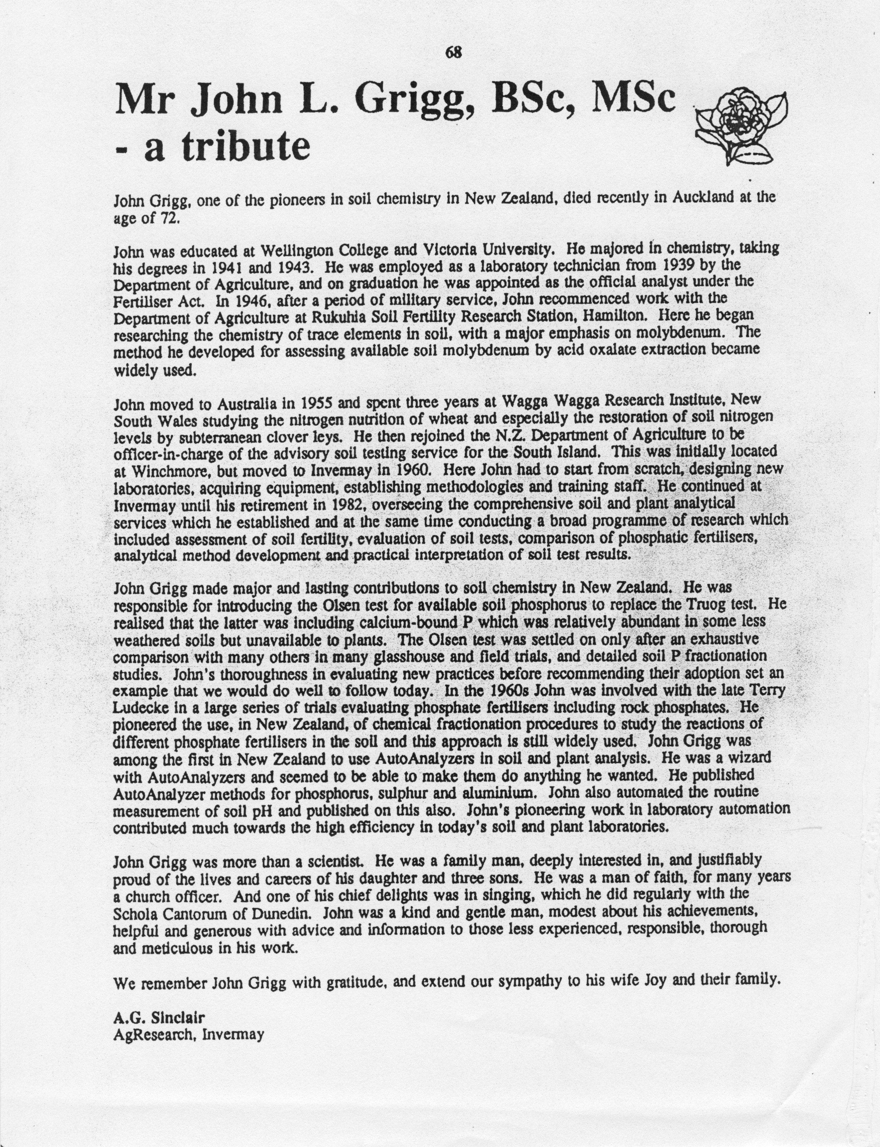

Appendix 1: Genetic survey reveals hidden Celts of England, by JOHN ELLIOTT AND TOM ROBBINS, The Sunday Times (UK) 12-02-2001
THE Celts of Scotland and Wales are not as unique as some of them like to think. New research has revealed that the majority of Britons living in the south of England share the same DNA as their Celtic counterparts.
The findings, based on the DNA analysis of more than 2,000 people, poses the strongest challenge yet to the conventional historical view that the ancient Britons were forced out of most of England by hordes of Anglo-Saxon invaders.
It suggests that far from being purged and forced to retreat into Wales, Cornwall and Scotland when the AngloSaxons invaded in the 5th century, many ancient Britons remained in England.
The study, conducted by geneticists at University College London, found that as many as three-quarters of the men tested in some parts of the south of England have the same Y-chromosome as the ancient Britons or Celts, rather than that of the Anglo-Saxons.
Overall, the scientists found that between 50% and 75% of those tested in parts of southern England were directly descended from Celts, implying that they had survived the Anglo-Saxon invasion. In Scotland the proportion of those with Celtic ancestry was found to be little different from the population of southern England.
"The evidence is quite strong that there is a substantial indigenous component remaining in England," said Professor David Goldstein, who led the study. "Genetics has opened up a powerful window on the past. We can now trace the movements of peoples and address questions that have proved difficult to answer through history and archeology alone."
The study, commissioned by BBC2 for its current Blood of the Vikings series, was designed to assess the impact of Norwegian and Danish Vikings, as well as Anglo-Saxons, on the British population.
Researchers took swabs of saliva from 2,000 people in 30 locations around Britain, and from 400 people in Norway, Denmark and Schleswig- Holstein, the area in northern Germany identified by the team as a homeland of the AngloSaxons. Those taking part had to have lived in the area for at least two generations.
Scientists then examined the Y-chromosome, which is passed unchanged down the male line of a family and is thus not altered by intermarriage.
The analysis showed that 60% of the men tested on Orkney were descended from Norwegian Vikings, as well as 30% of those in the Hebrides. While the Viking influence in these areas has been well known, it had been suggested that they were simply a ruling elite who did little interbreeding with the local population.
On the mainland, the survey found that 70% of those tested in York were from the continental European groups rather than the indigenous population, suggesting that the Anglo-Saxons made more of an impact on the Celts in northern England.
Only 10% of those tested in Wales were of Anglo-Saxon origin, confirming that it has retained an almost exclusively Celtic population.
In recent years the fate of the Celts in England has become hotly debated. Many historians have come to doubt the traditional story about the flight of the Celts from southern England, which was based largely on the account of Gildas, the 6th-century historian.
"There are various schools of thought ranging from near genocide (of the Celts) to almost total survival," said Patrick Sims-Williams, professor of Celtic studies at the University of Wales. "There could have been mass flight as well — it’s partly a matter of scholarly fashion, coming and going from generation to generation."
The genetic data will be eagerly received by scholars. Many of the place names in southern England have Celtic origins. Among them are Leatherhead, in Surrey, which meant "the grey ford".
"If you believe Gildas, the Anglo-Saxons would have been chasing the ancient Britons, catching up with one who wasn’t fast enough and saying, ‘Look here, before I cut off your head, just tell me the name of this place’," said Dr Margaret Gelling, a leading authority on place names.

Appendix 2: Surname Distribution Maps for GRIGG
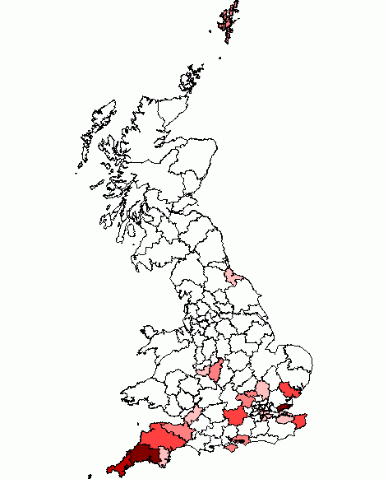
The maps shows the geographical spread of the surname in Great Britain in 1998 and 1881, using current postcode areas as the boundaries.
The areas are shown in one of six colours from white, lowest concentration of the name, to dark red, highest concentration. The maps show the relative probability of a person of that name being found in any specific postcode area (ie, someone called GRIGG is most likely to live in the dark red areas, and least likely to live in the white areas). The maps don't give any indication of the total number of people with that surname, it just shows where they are most likely to live. The more "white" a map is, the more localised the surname is.

http://www.britishsurnames.co.uk/surnames/GRIGG/maps

Surname Distribution Maps for GRIGGS
The maps shows the geographical spread of the surname in Great Britain in 1998 and 1881, using current postcode areas as the boundaries.
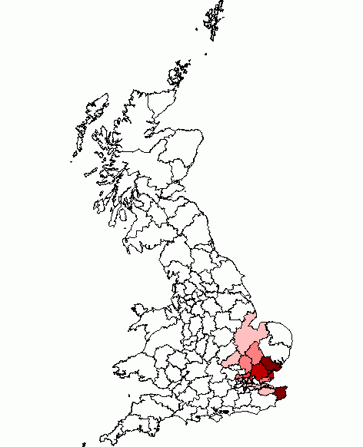
The areas are shown in one of six colours from white, lowest concentration of the name, to dark red, highest concentration. The maps show the relative probability of a person of that name being found in any specific postcode area (ie, someone called GRIGGS is most likely to live in the dark red areas, and least likely to live in the white areas). The maps don't give any indication of the total number of people with that surname, it just shows where they are most likely to live. The more "white" a map is, the more localised the surname is.
We know that William(0) Griggs son changed his name to William(1) Grigg, so we are of the Griggs clan in this region, and possibly all Grigg in the region are.
1881 GRIGGS

Surname Distribution Maps for GREGG
The maps shows the geographical spread of the surname in Great Britain in 1998 and 1881, using current postcode areas as the boundaries.
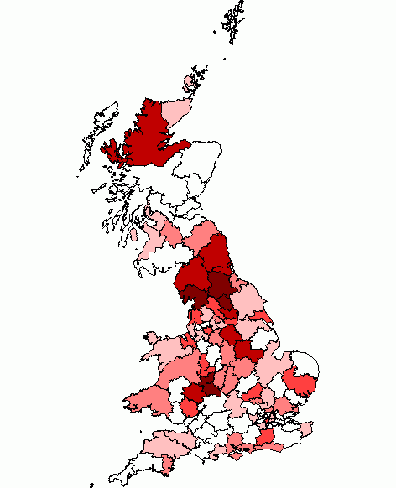
The areas are shown in one of six colours from white, lowest concentration of the name, to dark red, highest concentration. The maps show the relative probability of a person of that name being found in any specific postcode area (ie, someone called GREGG is most likely to live in the dark red areas, and least likely to live in the white areas). The maps don't give any indication of the total number of people with that surname, it just shows where they are most likely to live. The more "white" a map is, the more localised the surname is.

GREGG 1881
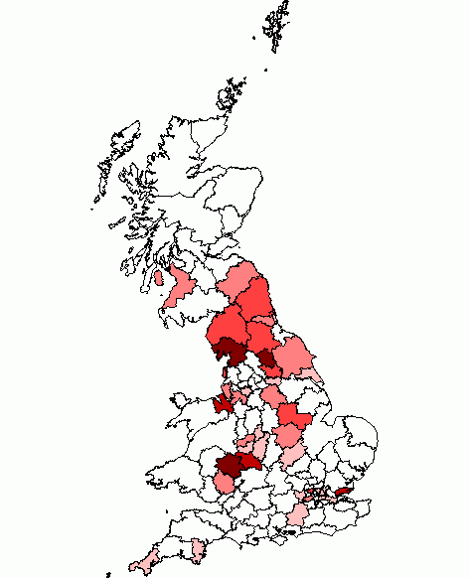
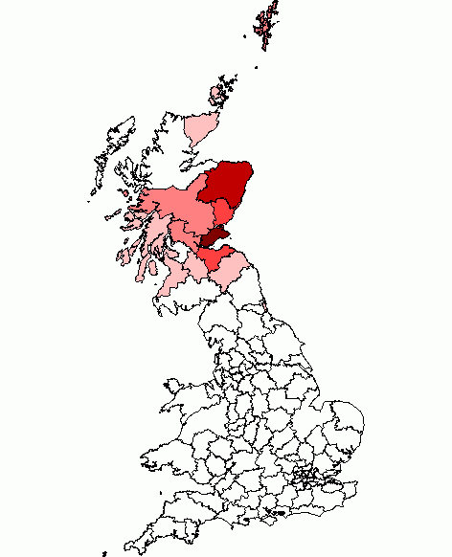
Greig, 1881

Given these variants, there is a pretty even spread, implying the name came from the earliest inhabitants. But surnames only evolved in the 12th century, so then all that can be said that it is Anglo-Saxon or Celtic, since there are many Grigg in Cornwall and in Kent…

Grigg, Griggs, Grix, Gricks; lists about ten from 1200’s and 1300’s Grig is short for Gregory, but also a nickname for a diminutive person, a dwarf. Given that no Griggs I know are short, the latter can be discounted.

Given that Grigg and Griggs occur in Cornwall and Kent, it would appear they come from earlier inhabitants rather than Roman and Norman subsequently. i.e. They were from Celtic, angle, British or Jute ancestry. Given that there is a spread in both Cornwall and Kent and up North, it would appear they were not Jute but from earlier i.e. Celtic.

Appendix 3: How We Gained and Lost the Mill
"suzannah.foad" suzannah.foad@btopenworld.com
Subject: Ebay Abstract of Title mentions Tomlin, Griggs Dixon, Clark, Mummery, Chapman Darby, Rowe and many more Date: Sat, 8 Jan 2005 19:39:04 -0000
Title of Tomlin to property in Birchington 1689-1782 Item number: 6503978817
Abstract of Title of Tomlin to 15 houses in Brunswick Place, Birchington, Isle of Thanet and a house & carpenter’s shop in Birchington Street. 1782.
Massive and detailed 30 page document, handwritten in ink on handmade paper watermarked J. Green & Son 1832. 16" x 13", folded. Cover a little dirty otherwise in excellent condition
Solicitors draft Abstract, commencing 1689. 17 & 18 July 1689, Indenture between Henry Sackett of St. John the Baptist, Thanet, yeoman, only son of Paul Sackett late of Buckland near Faversham, yeoman, by Susan his wife, only daughter & Heir of Henry Sackett of St. John the Baptist, yeoman deceased, and John Lee of Canterbury, grocer, and Sarah Laming of Chislet, sale of messuage with barn, outhouses, garden, etc., at Birchington Street with 3 parcels of land adjoining

3 & 4 January 1774 indenture. the Serats to William Grigg of the Vill of Wood in Birchington, miller; sale of the farm and land in the occupation of Henry Hills afterwards of Thomas Pittington since of John Coleman and late of William Row
11 December 1797 William Grigg, miller bequeaths farm to sons Samuel Grigg and John Grigg and wife Ann Grigg, occupied by Mrs. Rowe. will proved 28 may 1799
30 November 1810 indenture John Grigg of the Vill of Wood, miller, to Gilbert Stringer of birchington, schoolmaster, to James Paine of St. Peters, Isle of Thanet, bricklayer; sale of house with kitchen, yard and garden marked out with stumps at Birchington, part of property now divided into 3 parts occupied by John Grigg, James Grigg and Richard Darby plus a cow lodge and barn occupied by the Griggs
Indenture: James Raine, Frances Cobb & wife Charlotte Mary, Thomas Hubbard, John Hubbard, Thomas Roof, john grigg, william grigg and james grigg; sale of 7 houses, 6 stables, 6 gardens and 7 acres in Saint Peter the Apostle, St. john the Baptist and Birchington
5 December 1810 John Grigg to Thomas Chapman of Margate, gent. mortgage
14 & 15 April 1814 indenture. Grigg to William Grigg of Titchfield St., oxford road, Middlesex, plumber & glazier to Thomas Sidders of Acol, yeoman to Charles Dixon of Margate, baker, to Chapman to Richard Mummery of Margate, gent. sale to Sidders

(NOTE: Titchfield was a new housing area in London in the 1820’s).

Appendix 4: The Smugglers Leap
Close by Acol is the famous chalk pit where Exciseman Gill and Smuggler Bill met their deaths as told in the well-known poem, The Smuggler's Leap by Richard Barham. Exciseman Gill sold his soul for a demon horse that had the ability to catch Smuggler Bill. In the swirling mist on that night in Thanet, just as Exciseman Gill caught up to the Smuggler, he drove his horse off the top of the chalk pit as did the Riding Officer. The bodies of the two men and only one horse were found later and are still said to haunt the area.

Appendix 5:The Search for Ancestors of Thomas Griggs (b c 1650)

Some Early Wills (probably irrelevant, but they do show the variant spellings):
Grigg Grigge Elizabeth Sandwich 1510 PRC17/11/104
Grigg Grigge Geoffrey Hothfield 1505 PRC17/10/31
Grigg James Sandwich 1546 PRC32/21/34
Grigg Grygg John Alkham 1476 PRC17/3/52
Grigg Grigge John Northbourne 1484 PRC32/3/6 Finglesham Northbourne
Grigg Oliver Minster in Sheppey 1535 PRC17/20/128
Grigg Grygye Roger Headcorn 1541 PRC17/22/231
Grigg Grygge Thomas Ivychurch 1509 PRC32/9/154
Grigg Thomas Canterbury 1511 PRC3/2/152 AD
Grigg Thomas Elham 1518 PRC3/4/114 AD
Grigg Grygge William Headcorn 1473 PRC17/2/254
Grigg William Great Mongeham 1497 PRC17/6/336
Grigg William Minster in Sheppey 1526 PRC17/17/101 PRC3 Eastchurch
Grigg see also Grege and Gregg

(http://www.kentarchaeology.ac/ekwills_a/series/pl1/pl1_go.htm)
GRIGGE William, glover and Anne GREGORYE, widow, of the City of London, relict of William GREGORYE, late of Chalton co. Kent, glover – at St Bennet, Paul’s Wharf. 26 Jan 1585/6 (http://www.janetandrichardsgenealogy.co.uk/london_marriage_licences_g.htm)
Grigg Mary Canterbury 1821 1828 69/248
Grigg Philip Canterbury, Upper Hardres 1780 1780 66/211
Griggs Henry Dover 1828 1851 72/27a
Griggs John Saltwood 1585 1585 35/197
Griggs Martha Herne 1847 1848 71/261c
Griggs Sarah Dover 1782 1782 66/281
Griggs William Dover 1765 1774 65/601a
Grigsbye Margaret Loose 1564 1564 30/123
Grigson Benjamin Maidstone 1718 1718 59/302
Grigson John Maidstone 1710 1711 58/303
Grigson Margaret Hythe 1607 1608 41/80

Consistory Court of Canterbury Will Index, Volumes 27-72, G, Source: DCb/PRC32/ Vol 27 – 72 Circa 1557 – 1857, Canterbury Cathedral Archives, © M. J. Cozens – March 2005 http://freepages.genealogy.rootsweb.ancestry.com/~mrawson/cc_g.html

http://www.rootsweb.ancestry.com/~engken/efgd.txt

There is a migration from Middlesex to Kent early 1700’s.
In memory of / Alexander GRIGG of Newington / in the County of Middlesex. He died / August ye 13th 1761 aged 40 years / Also in memory of / Sarah wife of / Alexander Grigg and daughter / of William JOHNSON of this Parish. She / also died ye 13th of August 1761 / aged 41 years. Inscriptions in the Churchyard of Ridley, Kent Taken September 1890 (http://www.kentarchaeology.org.uk/Research/Libr/MIs/MIsRidley/MIsRidley.htm)

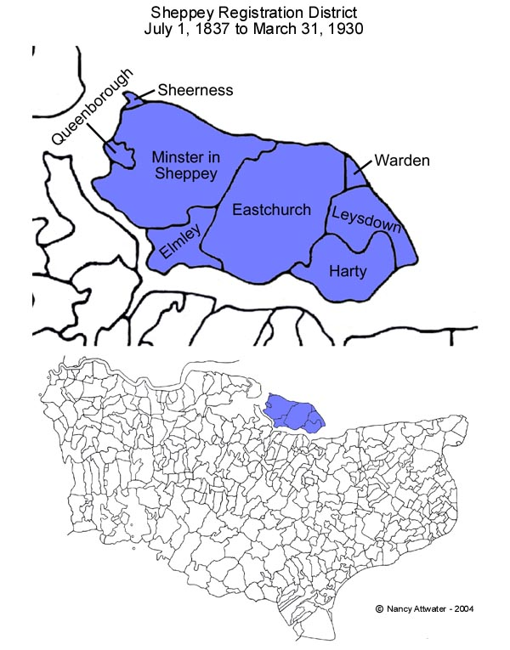

Appendix 6: Devon/Suffolk/London Griggs (probably not related)
The earliest reference to this family is recorded in a will of Thomas Grege,12 baker of
Exeter, Devon in 1558. In that will he mentioned his four sons and two daughters, five of
whom are under age.
The youngest son, Michael, married Rechord Prouse, the daughter of a prominent family of tailors/drapers of Tiverton, Devon in London in 1581.13 In London he established himself as a tailor14 and raised a family of eight children at a house at St Pauls Churchyard, in St Gregorys parish, next to the old St Pauls Cathedral. In 1623 he died in London and his funeral was attended by a College of Arms herald who recorded that he is the son of Thomas Grigg of Exeter.15

His will,16 some 13 pages long, records his successful move from Devon to that of a
London gentleman. He remembered the poor of Doddiscombleigh, Devon, where he was
“nursed” and left to his eldest son and heir, Michael, properties in Exeter which he had
purchased on his marriage. He left his wife £1000 and to his children numerous
properties in London and in various counties. In particular he left to his eldest son,
Michael, properties in Dunstable and Maulden, Bedfordshire and the bulk of his substantial property holdings.

To his second son, Robert, he left the Manor of Becklings, in Snape, Suffolk and as an inducement to complete his academic studies, £750 if he graduated in divinity, medicine or law; he did so as a “minister of God”.17

There appears to be a strong family connection with Dunstable in Bedfordshire. Michael
who died at London in 1623 certainly bought property there and a family of Grigg is living in the Dunstable region between the 1560s and the 1660s.18 One of the Dunstable Grigg family can be traced to the same London parish of St Gregory, where Michael and his family lived, in 1618.19 This Bedfordshire family also has the same naming patterns of the other families, in that Michael and Robert seem to be consistent names for the first born males. How this family links with Michael’s origins in Devon I am uncertain but clearly Bedfordshire has a link with the London family of Michael.

Michael’s wife and children were well cared for by his will in 1623 and were moving up
the social scale. His widow married Sir Richard Deane, Alderman of London and a
daughter, Mary, married Sir John Miller.20 His eldest son Michael, born 1591, however
surpassed them all in financial, if not social, status. It is this Michael and his younger brother, Robert, as heads of the two branches of his family which may have possible connections with Virginia.

Michael, the son and heir born 1591,21 followed his father in the family trade and is
recorded in 1628 as selling cloth for the King’s funeral to the value of £1530.22 He was a
master of the Guild of Merchant Taylors23 and obviously very successful. He became in
1630 High Sheriff of Bedfordshire24 and took a prominent interest in civic affairs in
London. He was the paymaster for the refurbishment of St Pauls Cathedral in the 1630s25
and assisted the King by collecting outstanding fines imposed by the Star Chamber.26
It is Michael’s support of the King against Cromwell and Parliament during the 1640s
which landed him in grave trouble. He was identified as a delinquent in not supporting
Parliament and was heavily fined. Refusing to pay he was imprisoned but on a
commitment to make good the payment he was released.27 Between 1646 and 1650 he is
recorded as selling a number of properties,28 possibly to pay the fine and in the final
administration of his father’s will in 1657 it is noted that he had died, the administration
being taken over by his own son, Benjamin.29 No trace of that branch of the family can be traced after 1657. Of 17 children none can be fully traced. The eldest, Michael, borne 1618, is recorded as dying “beyond the sea” by 1645.30 Amongst the sons possibly surviving childhood are Abraham, born 1620, John, 1626, Benjamin, 1627, Christopher, 1628, Ralfe, 1632, Robert, 1633, William, 1635 and Charles, 1637. Despite the status and wealth of the family, they seemed to have disappeared from the records.

The head of the other branch, Robert, born 1598, became a cleric,31 married Margaret
Reeve of Suffolk, settled at Houghton Conquest, Bedfordshire and had six children.32
Both he and his wife were dead by 1645 leaving the children orphans.33 His sons are
Michael, born 1630 and Robert, 1634.34

Michael, Robert’s son, married Dorothy Gosnold of Otley,35 Suffolk, daughter of a family
of Gosnolds prominent in the early exploration of Virginia.36 They settled at Bealings
Parva, Suffolk and had 11 children, and again Robert, born 166237, and Michael, born
1660, feature as the names of the earliest born sons. Michael, the father died at Little
Bealings, Suffolk in 1669.38 Michael, his son, went on to take his Doctorate in Divinity at
Cambridge,39 married Barbara Williams in 168840 and became the rector of Upwell,
Norfolk in 1691.41 He died in that parish in 1698.42 The only sibling of this generation of
the family to leave any trace is Frances, born 1656. She died a spinster in 1720 at
Foulsham, Norfolk and left to her nieces Rechord Grigg and Dorothy, her estate.43

From Finding the Origins of William Grigg, Immigrant to Virginia
Terry Grigg Email: Thegriggs@Bigpond.com
9 Jason Court, 12 North Balwyn, Victoria 3104, Australia

Appendix 7: Other Links not Explored Yet

From: "suzannah.foad" <suzannah.foad@btopenworld.com>
Subject: [IoT] Griggs and Tilbe Thanet Directory 1929
Date: Sat, 28 Feb 2004 17:44:49 -0000
References: <002201c3fdd6$0f2f69a0$125889d9@AMD1800>
Griggs - Margate - Private
Charles, Rose Lawn Canterbury Road, Westbrook
H, 1 Garden Row
Harold, 20 Hawley Street
John, 124 Byron Road
Sidney W, 12 Invicta Road, Cliftonville
William, 18 Church Street
William, 2 Edward's Place
Griggs Commercial Margate
Clifford H, Chimney Sweep, 5 Westbrook Avenue, Westbrook
W Griggs and Son, Chimney Cleaners, 74 Trinity Square.
Broadstairs - Private - Grigg
William Grigg, 10 Howard Road
Ramsgate - Griggs Private
John GRIGG, 17 Trinity Place
Charles, 21 Hill brow Road
Ernest, 33 Bloomsbury Road
Frederick William, 202 Herson Road
George, 42 Dane Park Road
John, 101 Southwood Road
John Edmund, 81 Chapel Road St Lawrence
Mrs, a, 193 Crescent Road
Richard A, 8 Claremont Gardens, St Lawrence
Thomas, 28 Flora Road
Thomas William, 1 Myrtle Cottages, Forge Lane, St Lawrence.
Tom, 10 Roseberry Avenue
William, 6 Ayton Road
William, 19 Claremont Gardens, St Lawrence
William Edmund, 71 Chapel Road, St Lawrence.
Minster - Griggs- Private
Rev Sydney Richard, L.th, The Vicarage, St Nicholas
George, Sarre
Mrs, 3 St Helier's, Augustine Road, Minster
Broadstairs & St Peters - private residents -1936
Grigg Wm Sea View North Foreland rd North Foreland Broadstairs

Note 22
· ID: I09738
· Name: Edward GRIGGS
·Marriage 1 Spouse Unknown
Children
Jane GRIGGS b: 1840 in Stourmouth , Kent
(http://wc.rootsweb.ancestry.com/cgi-bin/igm.cgi?op=GET&db=pinkvamp&id=I09737)
------------------------------
Note 25
There is a George Griggs who was the registrar at Ramsgate in the mid 1800’s
Note 26
There is in the 1891 census an Emely Griggs Visitor 30 Female Sandwick, Kent Kent Birchington She is the only Grigg.

Note 27 Maybe another one of them, as there was a Brockman born in Acol as well
Sarah GRIGGS1 was born in 1854 in St. Nicholas at Wade, Kent, England.
Spouse: Thomas BROCKMAN. Thomas BROCKMAN and Sarah GRIGGS were married on November 10, 1876 in Monkton, Kent, England.
Note 30
For further research call the C of E in BIRCHINGTON and find out where barry’s website went to, then check out membership of the Baptist Church.
Baptist Crescent Road 845400
Church of England All Saints the Square 841117
Church of England St. Thomas - Minnis Bay 841117
Methodist Canterbury Road 832475
Roman Catholic Our Lady & St Benedict’s - Minnis Road 841549

Note 37
Grigg Oliver Minster in Sheppey 1535 PRC17/20/128
Grigg William Minster in Sheppey 1526 PRC17/17/101 PRC3 Eastchurch
(Calendar of Wills and Administrations 1396-1558. Source: Original Volume by Henry R. Plomer Pub.1920, Canterbury Cathedral Library. Transcribed by M. J. & D. G. Cozens – June 2005-2006)

3. Re: [Isle-of-Thanet] GRIGG/EMPTAGE [0.947235]
Hi michael. Eliza Grigg comes up in the 1851 census 1851 census: St Nicholas at Wade. Registration District: Thanet Thomas Grigg: Head, Widow, 44, Ag lab, born St Nicholas Jane, Daughter 12 Eliza, Daughter 10 Louisa, Daughter 8 Martha, Daughter 4 William Brice, Son in Law, 21 born Canterbury, Shepherd Sarah
http://archiver.rootsweb.ancestry.com/th/read/isle-of-thanet/2007-05/1179482814
Date: Fri, 18 May 2007 06:06:54 EDT
From:

Note 49
Grigg, Henry KEN 1820 Birchington 1851 Paglesham ESS (Watch Vessell Beagle) Wife: Edith, 1824, IOW. Children: Josiah Joseph, 1844, IOW; Henry Samuel, 1850, Paglesham, ESS. K

Appendix 8: Search for Nash Connection
Archdeaconry Court of Canterbury Will Index
Source: DCb/PRC17/ Vol 30 – 113, Circa 1557 – 1858, Canterbury Cathedral Archives
© M.J.& D.G. Cozens June 2006 - September 2007

Nash Agnes Harrietsham 1601 1602 PRC17/52/260b
Nash Ann Boughton Monchelsea 1749 1755 PRC17/95/69
Nash Anthony Whitstable 1606 PRC17/59/21a
Nash Cornelius Ramsgate 1800 1801 PRC17/103/402b
Nash Elizabeth Whitstable 1608 1608 PRC17/58/188
Nash Elizabeth Folkestone 1789 1792 PRC17/102/208
Nash Elizabeth Chislet 1797 1801 PRC17/103/403a
Nash Foster Ramsgate 1733 1734 PRC17/89/41c
Nash George Boughton Monchelsea 1746 1747 PRC17/93/13j
Nash James Bapchild 1632 PRC17/68/365a
Nash Joane Murston 1634 1635 PRC17/69/52
Nash John Marden 1621 1621 PRC17/63/423
Nash John Woodnesborough 1697 1700 PRC17/79/422c
Nash John Marden 1719 1719 PRC17/85/3d
Nash John Chilham 1719 1719 PRC17/85/10c
Nash John Kennington 1775 1777 PRC17/99/559
Nash John Langley 1851 1852 PRC17/112/347b
Nash Mark Chislet 1720 1720 PRC17/85/19b
Nash Roger Newenden 1676 1681 PRC17/75/298
Nash Samuel Borden 1678 1678 PRC17/74/242
Nash Sarah Newington n Hythe 1764 1776 PRC17/99/438
Nash Thomas Tonge 1601 1601 PRC17/52/257a
Nash Thomas Woodnesborough 1624 1624 PRC17/66/449
Nash Thomas Cranbrook 1710 1711 PRC17/81/438b
Nash Thomas Staplehurst 1800 1800 PRC17/103/319
Nash Thomas Canterbury 1831 1833 PRC17/109/161a
Nash William Shoulden 1699 1700 PRC17/79/422b
Nash William Cant. Longport 1788 1789 PRC17/101/409b
Nashe Anthony Rolvenden 1616 PRC17/62/10b
Nashe Christopher Cant. St Mildred 1570 1572 PRC17/42/44
Nashe Johan wid. Fordwich 1558 1559 PRC17/31/36
Nashe John Marden 1585 1585 PRC17/46/354a
Nashe John Barham 1587 1587 PRC17/47/64
Nashe Margaret Sturry 1597 1598 PRC17/51/70
Nashe Nicholas Sturry 1566 1567 PRC17/40/133
Nashe Nicholas Little Chart 1616 1617 PRC17/62/17a
Nashe Robert Monks Horton 1610 1610 PRC17/56/400b
Nashe Simon Rolvenden 1592 1593 PRC17/49/209a
Nashe Thomas Goudhurst 1565 1565 PRC17/39/117a
Nashe Walter Bethersden 1558 1558 PRC17/33/100a
Nashe William Cant. St George 1560 1565 PRC17/39/227b
Nashe William Shoulden 1625 1625 PRC17/65/261b

Appendix 9: Wills at Canterbury

Archdeaconry Court of Canterbury Will Index
Source: DCb/PRC17/ Vol 30 – 113, Circa 1557 – 1858, Canterbury Cathedral Archives
© M.J.& D.G. Cozens June 2006 - September 2007

Grig Phillip Stelling 1712 1712 PRC17/82/19
Grigg Edward St Peter in Thanet 1767 1767 PRC17/97/460
Grigg James Goodnestone n Faversham 1745 1745 PRC17/92/70c
Grigg Johan Cheriton 1627 PRC17/64/422
Grigg John Stelling 1640 1640 PRC17/70/662
Grigg John St Peter in Thanet 1758 1775 PRC17/99/278a
Grigg Richard Milton n Sitt,bne 1638 PRC17/70/587b
Grigg Troward Upper Hardres 1797 1800 PRC17/103/287b
Grigg William Chartham 1592 1593 PRC17/49/431a
Grigge Edmund Headcorn 1559 1560 PRC17/32/40a
Grigge John Headcorn 1563 1564 PRC17/38/108a
Grigges Abraham Chartham 1666 1666 PRC17/72/235
Grigges Thomas Northbourne 1590 1591 PRC17/48/160a
Griggs Christiane Barham 1661 1665 PRC17/72/149a
Griggs Henry Bridge 1633 1633 PRC17/68/469a
Griggs James Northbourne 1619 PRC17/63/163a
Griggs Richard Folkestone 1675 1688 PRC17/77/228b
Griggs Richard Queenborough 1717 1718 PRC17/83/36a
Griggs Sibilla Barfrestone 1787 1789 PRC17/101/386
Griggs Susanna Petham 1762 1763 PRC17/96/559
Griggs Thomas Selling 1744 1744 PRC17/92/69d
Griggs Trevanion Ramsgate 1841 1842 PRC17/110/644
Griggs William Petham 1766 1772 PRC17/98/519
Griggs William Margate 1851 1850 PRC17/112/239a

Consistory Court of Canterbury Will Index
Source: DCb/PRC32/ Vol 27 – 72 Circa 1557 – 1857, Canterbury Cathedral Archives
© M.J. Cozens – March 2005

Grigg Mary Canterbury 1821 1828 PRC32/69/248
Grigg Philip Cant., Upper Hardres 1780 1780 PRC32/66/211
Griggs Henry Dover 1828 1851 PRC32/72/27a
Griggs John Saltwood 1585 1585 PRC32/35/197
Griggs Martha Herne 1847 1848 PRC32/71/261c
Griggs Sarah Dover 1782 1782 PRC32/66/281
Griggs William Dover 1765 1774 PRC32/65/601a

Nash Charles Dover 1841 1852 PRC32/72/52a
Nash Dorothy Pluckley 1734 1735 PRC32/61/822
Nash Howson Dover 1773 1774 PRC32/65/608
Nash Jane Adisham 1716 1720 PRC32/59/431
Nash John Sandwich St Mary 1567 1568 PRC32/30/535
Nash John Goodnestone n Wingham 1752 1760 PRC32/64/335
Nash John Dover St James 1749 1768 PRC32/65/266a
Nash Martha Goodnestone 1760 1763 PRC32/64/528
Nash Samuel Nonington 1817 1818 PRC32/68/320a
Nash Susanna Dover 1825 1830 PRC32/69/316
Nash Thomas Nonington 1844 1844 PRC32/71/73
Nash William Adisham 1721 1722 PRC32/59/549b
Nash William Canterbury 1842 1846 PRC32/71/183a
Nashe Nicholas Woodchurch 1568 1569 PRC32/31/91b
Nashe Richard Goodnestone n Wingham 1605 1605 PRC32/39/301
Nashe Richard Goodnestone 1615 1615 PRC32/43/203a
Nashe Robert Egerton 1612 1613 PRC32/42/317
Nashe Stephen Maidstone 1616 1617 PRC32/44/361a
Nashe Symon Goudhurst 1631 1631 PRC32/50/31b

Consistory Court of Canterbury Will Index
Source: DCb/PRC32/ Vol 27 – 72 Circa 1557 – 1857, Canterbury Cathedral Archives
© M.J. Cozens – March 2005
No Griggs in Acol
Derricke Thomas Acol Birchington 1586 1587 PRC32/36/26
Hallaway John Acol Birchington 1774 1775 PRC32/66/36b

No Griggs in Woodchurch
Gathafoord Geoffrey Woodchurch 1573 1573 PRC32/32/38b
George James Woodchurch 1687 1688 PRC32/55/353b
George John Woodchurch 1722 1728 PRC32/60/349a
George John Woodchurch 1837 1847 PRC32/71/224
George Mary Woodchurch 1733 1736 PRC32/61/868
George Peter Woodchurch 1768 1768 PRC32/65/238
Gibson Elizabeth Woodchurch 1605 PRC32/41/133b
Gilham Thomas Woodchurch 1718 1722 PRC32/59/557
Glover Edward Woodchurch 1617 1617 PRC32/44/252a
Glover John Woodchurch 1590 1590 PRC32/36/264
Glover John Woodchurch 1600 1600 PRC32/38/262b
Goble Matthew Woodchurch 1690 1690 PRC32/56/22
Goble Phoebe Woodchurch 1692 1692 PRC32/56/240
Godfrey John Woodchurch 1781 1782 PRC32/66/282b
Goodwin Sarah Woodchurch 1818 1818 PRC32/68/314b
Gower Thomas Woodchurch 1839 1840 PRC32/70/392
Gyrdler John Woodchurch 1556 1558 PRC32/27/281

No Griggs in Birchington
Garrett Mary Birchington 1721 1721 PRC32/59/516
Gibson Thomas Birchington 1743 1759 PRC32/64/238
Gilbert Richard Birchington 1665 1665 PRC32/53/284
Goare James Birchington 1669 1669 PRC32/53/458a
Goare John Birchington 1753 1754 PRC32/63/550
Gooson Ismail Birchington 1626 1626 PRC32/47/20a
Gooson Leonard Birchington

Surnames Forenames Places Made Prob Reference Continued, Notes etc
Griggs Henry Dover 1828 1851 PRC32/72/27a
Griggs Sarah Dover 1782 1782 PRC32/66/281
Griggs William Dover 1765 1774 PRC32/65/601a

No Nash, Hubert or Grigg in Monkton only a Nash above in Woodchuch

Will of Cornelius Nash of Ramsgate, Kent. Proved in the Court of Canterbury. ( August 22 1801 http://www.nationalarchives.gov.uk/documentsonline/details-result.asp?Edoc_Id=7403950&queryType=1&resultcount=3115).

1891 census
Civil parish: Birchington
Ecclesiastical parish: All Saints
Town: Birchington
County/Island: Kent
Country: England
Registration district: Thanet
Sub registration district: Minster
ED, institution, or vessel: 6
Address: CanterburyRoad, Ivy House
William E Austin Head M 56 Plumber & Decorator Employer Kent Margate
Esther Austin Wife M 46 Kent Deal
William J Austin Son S 10 Scholar Kent Birchington
Esther R Austin Daur 9 Scholar Kent Birchington
Lilian H Austin Daur 7 Scholar Kent Birchington
Rose Searle Visitor W 65 Livong on her own means Kent Rochester
Emily Griggs Visitor Single 30 Dressmaker Neither employer or employed Kent Sandwich
Clarisse Nicholls Serv Single 22 Gen Dom Serv Worker Kent St Nicholas
PRO Ref: RG 12 Piece 725 Folio 69 Page 4 Schedule 41

Consistory Court of Canterbury Will Index, Volumes 27-72. G.
Source: DCb/PRC32/ Vol 27 – 72 Circa 1557 – 1857, Canterbury Cathedral Archives
© M. J. Cozens – March 2005

Grigg Mary Canterbury 1821 1828 69/248
Grigg Philip Canterbury, Upper Hardres 1780 1780 66/211
Griggs Henry Dover 1828 1851 72/27a
Griggs John Saltwood 1585 1585 35/197
Griggs Martha Herne 1847 1848 71/261c
Griggs Sarah Dover 1782 1782 66/281
Griggs William Dover 1765 1774 65/601a

Grig Phillip Stelling 1712 1712 PRC17/82/19
Grigg Edward St Peter in Thanet 1767 1767 PRC17/97/460
Grigg James Goodnestone n Faversham 1745 1745 PRC17/92/70c
Grigg Johan Cheriton 1627 PRC17/64/422
Grigg John Stelling 1640 1640 PRC17/70/662
Grigg John St Peter in Thanet 1758 1775 PRC17/99/278a
Grigg Richard 8Milton n Sitt,bne 1638 PRC17/70/587b
Grigg Troward Upper Hardres 1797 1800 PRC17/103/287b
Grigg William Chartham 1592 1593 PRC17/49/431a
Grigge Edmund Headcorn 1559 1560 PRC17/32/40a
Grigge John Headcorn 1563 1564 PRC17/38/108a
Grigges Abraham Chartham 1666 1666 PRC17/72/235
Grigges Thomas Northbourne 1590 1591 PRC17/48/160a
Griggs Christiane Barham 1661 1665 PRC17/72/149a
Griggs Henry Bridge 1633 1633 PRC17/68/469a
Griggs James Northbourne 1619 PRC17/63/163a
Griggs Richard Folkestone 1675 1688 PRC17/77/228b
Griggs Richard Queenborough 1717 1718 PRC17/83/36a
Griggs Sibilla Barfrestone 1787 1789 PRC17/101/386
Griggs Susanna Petham 1762 1763 PRC17/96/559
Griggs Thomas Selling 1744 1744 PRC17/92/69d
Griggs Trevanion Ramsgate 1841 1842 PRC17/110/644
Griggs William Petham 1766 1772 PRC17/98/519
Griggs William Margate 1851 1850 PRC17/112/239a
(Archdeaconry Court of Canterbury Will Index, Source: DCb/PRC17/ Vol 30 – 113, Circa 1557 – 1858, Canterbury Cathedral Archives, © M.J.& D.G. Cozens June 2006 - September 2007)

The yere 1523. RICHARD FISSHER of Maidstone. To be buried within the church of Saint Faith of Maidstone. To the light of Saint Petir of Milton next vnto Gravesend 3s. 4d. Also the goodes which my wife hath in Syoo [sic] I freely geve to hir owne propre use. I bequeth to John my brother thelder £100. Rest to Elizabeth Fissher my moder, sole executrice.
Witness: Sir Wm. Barett, curat, John Fisher, Thomas Dennam, Henry Gryg.

Tudor P.C.C. Will Transcription by L. L. Duncan - Books 47 & 48 page 61, RICHARD FISSHER, Will 1523.
shawn mccrea (View posts) | Posted: 15 Nov 2000 5:11PM GMT

i have traced my mccrea family tree to the griggs
great gr. gr. gr. gr. gr. grandparents
phillip grigg
elizabeth randall married in oct. 18. 1770 in st. nicholas at wade, kent, england
kids: john grigg sr. 1772 - 1837
mrd: sarah wooten grigg 1771 - 1843 on july 6, 1793 in st. nicholas at wade, kent eng.
kids:
john grigg jr. 1795 - dec 18, 1876 married susanna holmes grigg 1787 - 1875
john was born in minister in Thanet, kent england
mrd on oct 14, 1820 in minister in Thanet, kent england buried in durham county england
Kids unknown except sarah grigg (great gr. grandmother)

Appendix 10: Earliest Scottish Grig (no connection)
However, this marriage led to disputes over succession of the Pictish Crown and in the struggle that followed, ALPIN, son of AYCHA II, who ruled over Scotland Picts from A.D. 833 to 836, was slain in a battle with the Picts on 20 July 836. The whole matter was finally decided by the victory of ALPIN's son, Kenneth MC ALPIN, who urged his rights of inheritance by defeating WRAD, the last of the Pictish monarchs, who died at Fortivet in A.D. 842, in defense of his kingdom. Eight years later, Kenneth MC ALPIN succeeded to the throne, thus uniting Scotland into one kingdom. He had married CINAITH, daughter of ANICUM of the Isles. He was succeeded by his brother, Donald, who died in A.D. 863.
HANNA provides the following commentary on the next few kings:

On Donald's death, CONSTANTINE, the son of KENNETH, came to the throne. After a reign of some 15 years, he was killed in battle with the Norsesmen, who fought the Scots at Inverdufatha (Inverdovet) near the Firth of Forth, in 877. CONSTANTINE was succeeded by his brother, AEDH, or HUGH, who reigned as King of the Picts for one year, when he was killed by his own people. While under the Law of Tanistry, which governed the descent of the crown among the Scots, DONALD, son of CONSTANTINE, was entitled to rule, yet by the Pictish law (Oadh) EACHA (son of CONSTANTINE's sister and of RUN, King of the Britons of Strathclyde) was the next heir, and as the Pictish party at this time seems to have been in the ascendancy, EACHA was made king.

Being too young to reign, however, another king was associated with him as governor. This governor, or regent, was GRIG, or CIRIC, son of DUNGAILE. While the earlier "Pictish Chronicle" gives no account of this reign beyond the statement that after a period of 11 years, EACHA and GRIG were both expelled from the kingdom, the later writers have made a popular hero of GRIG, and his virtues and achievements are magnified to most gigantic proportions. GRIG, having been forced to abdicate, was succeeded in 889 by DONALD (IV), son of CONSTANTINE, who reigned for 11 years. DONALD was also chosen as King of Strathclyde, which henceforth continued to receive its princes from the reigning Scottish family until it was finally merged into the Scottish kingdom.

Appendix11: Distribution of Grigg Listings across the United States
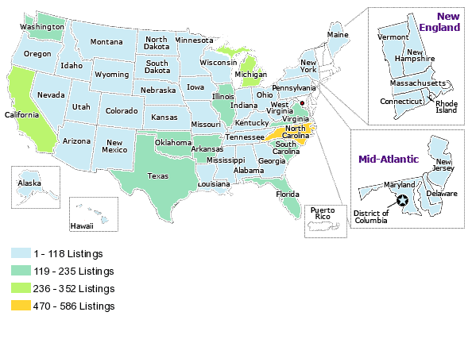

Appendix 12: Some unknowns, source from Genealogical Index of the Mormons
Margaret Gryg 02 MAY 1619, Tonbridge, Kent, England dau Thomas Gryg, Son of Thomas Gryg

ADRYAN GRYGGE Gender: Female Marriage: 31 JUL 1550 Saint Mary Woolnoth, London, London, England Spouse was Edward Cage

EDWARD GRYGGE Gender: Male Christening: 06 JAN 1613 Saint Mary Somerset, London, London, England Son of William Grygge

ANNE GRYGGE Gender: Female Christening: 08 MAY 1598 Holy Trinity The Less, London, London, England.

Appendix 13: Contention
A brief comment on the musical context in which JOHN Grigg F.R.A.S worked.

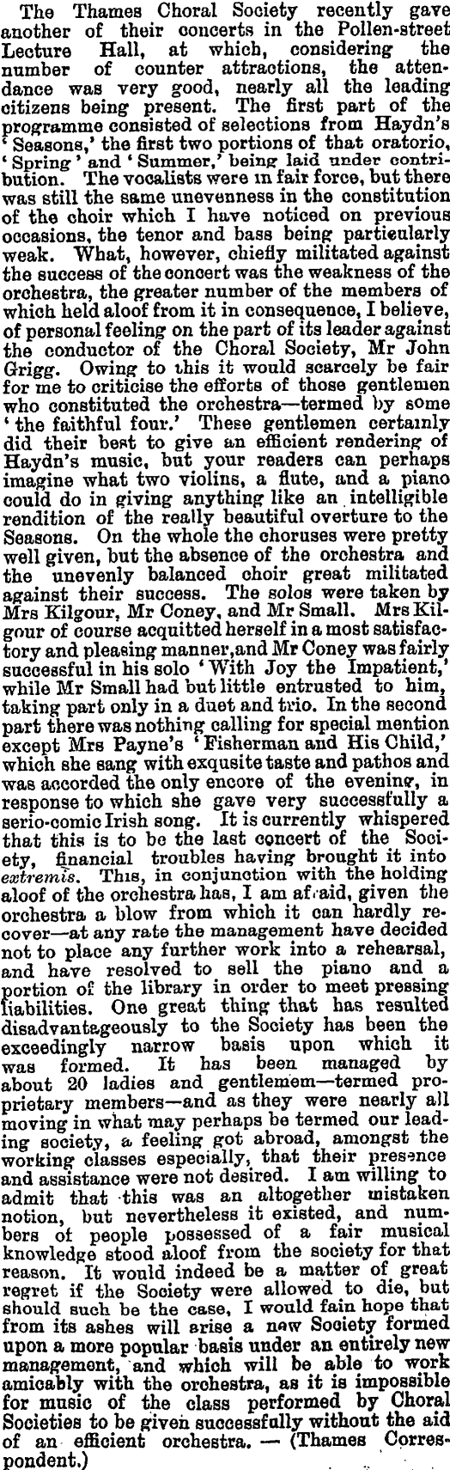

An expansion of The Ancestors and Descendants of the Pioneer Settler, John Grigg, F.R.A.S. of Thames, New Zealand. (1836-1920) compiled by his oldest great-grandson, John Lawrence Grigg., Auckland 1991.
There are three main Grigg clans in New Zealand, the religious Grigg, our family; the racehorse Grigg of Ashburton from Devon, and the West Coast Grigg from Cornwall. A note from Tony Grigg notes connections: Sir Percy James Grigg, Parliamentary Under Secretary of War who was Governor of Kenya amd Sir Edward William Macleay Grigg, also Parliamentary Under Secretary of War. He became Lord Altrincham after WWII. They were not related. The former was from a Devon family and the latter was from Cornwall, whose remote family included John Grigg of Ashburton, New Zealand.
Sir Henry Brett, 1842-1927, Albertlanders: Brave Pioneers of the Sixties. Published 1927 by Brett. 436 pages. Reprinted by Caper Press 1979. - Brookes, Edwin Stanley, (1995). Bachelor Block: A Story of Albertland, 1840 - 1904. - Articles on the Albertland Settlement, Auckland Star early 1925. - Mabbet, H. (1977). The Rock and the Sky: The Story of Rodney County, Wilson & Horton Ltd, 449pp. Index. - (197?). Passenger Lists of Ships Which Brought the Albertlanders to New Zealand. D.B.Reid, Auckland, New Zealand.
Descendants of Simon Burlingham, be Shelley Green, http://members.aol.com/sdgreen715/burlingham.htm.
American Surnames, by Elsdon Coles Smith.
What's in a Name ? GREGORY http://www.genuki.org.uk/big/eng/DBY/NamesPersonal/Gregory.html
Another book, oft repeated, speaks of Grig as a common name for small people. The difficulty with that is I have never met a small Grigg, have you?
This means should you see a Grigg Coat of Arms it is spurious, being invented by some scurrilous hoakster to rake in some money. There is no Grigg royalty or tribe!! We are noble but not nobles.
http://ralphwaite.com/weedram/Kent_isle_of_thanet2.htm
From Wikipedia, the free encyclopedia.
Finglesham has a long and interesting history, with records dating back at least as far as the 7th Century AD. In 1964, excavations at the site of the Anglo-Saxon Finglesham cemetery revealed a find of great archaeological importance - a rare gilt bronze buckle, found in the grave of a male skeleton accompanied by a small collection of other artefacts. Quite different from other Kentish buckles of its time, the Finglesham buckle is believed to be unique amongst Anglo-Saxon archaeology. Understood to have Swedish origins, the buckle comprises the figure of a man (probably a warrior) holding two spears and wearing only a belt and two-horned helmet. 'The 'Finglesham Man’ is today depicted in the village sign, which can be seen opposite The Crown’s garden in The Street.
Æthelberht of Kent, From Wikipedia, the free encyclopedia
Ibid, p4
Canterbury Cathedral Archives, DEAN AND CHAPTER ARCHIVE [CCA-DCc-ChAnt/P - CCA-DCc-ChAnt/S], Grant CCA-DCc-ChAnt/S/202 27 Sep 1307 Former reference: CCA-DCc-ChAnt/S/202 1 document Parchment, 1m, seal, slightly stained Related information: Registered version: CCA-DCc-Register/B, f87r Contents: From: Ralph Bourt, rector of Southchurch To: 'Dominus' Peter of Southchurch, knight; Joan, wife of 'Dominus' Peter of Southchurch, knight All lands and tenements which Ralph has of the gift and feoffment of Peter and Joan in the hamlet of Horseham ('Hersham') in Helion Bumpstead parish ('Bomstede Helioun et Bomstede Comitis'). Given at Horesham ('Hersham') [in Helion Bumpstead, Essex]. Witnesses: 'Dominus' John de Watevile, knight; 'Dominus' William Pontyn, knight; 'Dominus' Adam de Neuton', knight; 'Dominus' Robert de Ros, knight; Henry Grigge; Roger de Balliol; Simon de Henham; Geoffrey de Caples; William Longhals; Walter le Mayster Endorsed with description and 'Souch'' in 14th cent hands.
In like manner, Robert Griggs of Martham was brought before the bishop, the seventeenth day of February, in the year aforesaid, for holding and affirming the aforesaid articles, but specially these hereafter following: "That the sacrament of confirmation, ministered by the bishop, did avail nothing to salvation. "That it was no sin to withstand the ordinances of the Church of Rome. "That holy bread and holy water were but trifles, and that the bread and the water were the worse for the conjurations and characters which the priests made over them." Upon which articles he being convicted was forced to abjure, and received penance in manner and form as the other had done before him. ( http://www.exclassics.com/foxe/foxe113.htm).
Records of Early English Drama of Canterbury 1218 TRANSLATIONS (http://www.archive.org/stream/kentcanterburyREED03gibsuoft/kentcanterburyREED03gibsuoft_djvu.txt). f 8v . On wine spent on St John s Day by Richard Grigge, Mathew Hygon, John Cole, and others at John Cole s house lOd Likewise paid to players playing before the mayor and his fellows 12d
A Temporary Preface to the Six-text Edition of Chaucer's Canterbury Tales, By Frederick James Furnivall, Geoffrey Chaucer, Chaucer Society, Published for the Chaucer Society by N. Trübner, 1868, Original from Oxford University, Digitized Aug 7, 2007. London: Robert Grygge, Saddler and Alan Grygge, a chandler on a Tuesday in 1371 under Edward III he heard a certain esquire of our Lord the Prince telling the same in the shop of John his master before mentioned. And afterwards being diligently examined hereupon as to whether he had any knowledge of this esquire he said that he had no knowledge of his person nor did he hear such esquire relate the said news as he had before alleged. But he said that he heard one Alan Grygge chaundeler relating the said news in manner aforesaid by the shop of the said John his master at Le Oldeiwherye. Therefore precept was given to the Sheriffs to have the said Alan here on the Tuesday following. And the said Nicholas was committed to prison in the meantime until etc Upon which day namely Tuesday next before the Feast of St Barnabas the Apostle ii June came here as well the said as Alan aforesaid And the said Nicholas alleged as before that heard the same Alan relate the matters aforesaid at the shop of said master at Le 2 Holdiwerye and this he was ready to prove far as the Court etc And the said Alan said that he did not or say as the aforesaid Nicholas imputed to him and asked inquisition might be made by the country thereon and the Nicholas in like manner Therefore a jury was to be thereon upon the Wednesday following etc and the said was in the meantime committed to prison etc And the Alan was mainprised by William atte Castelle armourer Horkesle tailour Henry Chaucer vyntner and Robert Saddler such persons to have them here on the said day at peril Upon which Wednesday namely the Feast of St came here Nicholas and Alan aforesaid And the jury by assent the parties chosen by John Rygge and eleven others said their oath that the said Alan Grygge did not utter the words or say as the said Nicholas above imputed to him it was adjudged that the same Alan should go acquitted and that the said Nicholas for the lie of which he was so and by him maliciously invented should have the punishment the pillory to stand thereon http://books.google.co.nz/books?id=grDRAAAAMAAJ&pg=PA353&img=1&zoom=3&hl=en&sig=ACfU3U0ZLbRpfDx4Rh3xyN0XebFsSpV0yA&ci=39%2C131%2C775%2C1180&edge=0
Nov. 15, 1389. Licence, for 80£. paid to the king by lioger de Boys, knight, John Westminster. Ulneston, knight, Robert Asshefeld, Robert Grygge clerk, and Richard Cratfeld, clerk, for the alienation in mortmain by them to the prior and…
Petitioners: Geoffrey Grygg, merchant of London; John Burwelle, merchant of London; Andrew Preston, merchant of London; William Reynewell, ... Name(s): Grygg; Burwelle; Preston; Reynewell; Stanerton; Lyncolne (Lincoln); Gedeneye; de York, Geoffrey; John; Andrew; William; Robert; John; John; James Nature of Request: Grygg, Burwelle, Preston, Reynewell, Stanerton, Lyncolne, Gedeneye and York, who recently freighted Lane's ship called 'James' ... (National Archives:Family History: Ancient Petitions, Henry III - James I)
Quoted in Persons Involved in the Sale of Knelle Manor:Batesford. http://www.telefonica.net/web2/kenello/batesford.htm accessed Oct 27, 2008 Not sure what this DYK reference is.
Quitclaim DYK/8 3 Jun 1398 Contents: Richard, son of Thomas Grygge of Frant, to William Brenchesle, Nicholas Potyn and Thomas Wallere and their heirs Lands and tenements formerly held by Robert de Bromfelde in Frant or elsewhere or by Thomas Grygge Robert de Bromfelde married Joan, daughter of John Isle Dated: the morrow of the Holy Trinity 21 Ric.II Seal: on tag, red wax; a bird Endorsed as enrolled in the first roll of charters and protections in the Bench [Court of Common Pleas], Trinity 22 Ric. (Archive of the Dyke family of Frant, Waldron and Kent and the Penkherst family of Mayfield and Buxted).
The House of Commons, 1422-1504; Biographies completed include Richard Grygge. From Note in the History of Parliament Annual Review.2006 http://www.histparl.ac.uk/downloads/doc/review2005.doc
Richard Bacon may have been given the sryle to distinguish him from his ...... yeve armigerum, Willelmum Applyard armigerum, Thomam Grygges armigerum, ... An Election Dispute of 1483 by Roger Vigoe Historical Research in Volume 60 Issue 141, Pages 24 – 44, Published Online: 12 Oct 2007, © 2008 Institute of Historical Research.
See appendix 5.
Villat' de Middelborg. £ s .d. Nicho Grygg' 4 5¼ From: 'Sussex subsidy of 1332: The rape of Lewes', The three earliest subsidies for the county of Sussex: 1296, 1327, 1332 (1910), pp. 282-297. URL: http://www.british-history.ac.uk/report.aspx?compid=65860 Date accessed: 14 July 2009. Likely named after Middelborg, Nøtterøy, Vestfold, Norway, thus likely a Norse settlement in Sussex. Villat' de Sontyng. Nicho Grygg 1 6½ Rado Grygg 2 3¾ From: 'Sussex subsidy of 1296: The rape of Bramber', The three earliest subsidies for the county of Sussex: 1296, 1327, 1332 (1910), pp. 53-68. URL: http://www.british-history.ac.uk/report.aspx?compid=65847 Date accessed: 14 July 2009. Thus Rado b 1250 c likely father of Nicho b in Sontyng 1275
Three Gryg are recorded in the 1332 taxation of Sussex In the Hundr' de la Manewod., Villat' de Sidlesham, Johe Gryg 4 9s Villat' de Seleseye, Walto Gryg 10s In the Hundr' de Boseham, Villat' de Chudeham. Rico Gryg 9s From: 'Sussex subsidy of 1332: The rape of Chichester', The three earliest subsidies for the county of Sussex: 1296, 1327, 1332 (1910), pp. 231-253. URL: https://www.british-history.ac.uk/report.aspx?compid=65857 Date accessed: 28 January 2009.
In 1405, the Pallingham Rent Roll, lists: Ric.Marshall p.twelfpenylond 12d, Ricu. Marshall p.1 cott 2/- and ter. gryg. 6d Text of part 1 of 'Threads in a Tapestry' compiled by Margaret Major pub. 1996 Isbn 0473-04231-2 November 1996. Chapter: The Downer Family of Marshalls Farm, Kirdford, Sussex
Quitclaim DUN 2/7 20 Jul 1428 The Sussex Connection: Related information: for a quitclaim of 2½a called The Marling, John Bereworth the elder to Roger Grygg, 6 Apr 1429, see DUN 40/1 below Contents: Geoffrey Keneworth, Alan Waterman and John Baker of Ticehurst to Robert Baker of Ticehurst A messuage, buildings and land as DUN 2/3 above Grant of a right of way DUN 2/8 Christmas week Dec 1430 Contents: Roger Gryg of Ticehurst to Gabriel Bereworth of Ticehurst A reasonable way from the highway at Dalehill to a piece of land of GB and his wife Agnes called Eastfelde, which way begins at the gate between the house of RG and the house of John Makerel W: John Bereworte, John Makerel, Richard atte Lege; at Ticehurst Counterpart grant for 7 instalments of 13s 4d DUN 2/9 12 Jul 1433 Contents: Henry Copyn of Ripe, Thomas Copyn, Robert Burdon and William Praty to Richard Burdon of Hadlow [in Kent] A piece of land called Crouchelond, a pond and a place for a smithy (loco pro fabrica), which once belonged to Simon Payn, with all the other freehold lands and tenements which HC, TC, RB and WP had by the feoffment of RB, and which formerly belonged to Nicholas Fryston and Henry atte Hamme, in Ticehurst The money to be paid at Ripe W: Thomas Warde, John Joos, John Harlesey, John Bereworth, tanner, John Grygge; at Ticehurst http://www.nationalarchives.gov.uk/a2a/records.aspx?cat=179-dun&cid=-1#-1 3023. Roger Ponde of Bedford, William Ryngden and Roger Grygge of Tysherst v. John Makerell and Maud his wife; a messuage and 16 acres in Tysherst; to Roger, William, Roger and heirs of Roger Ponde. (File 88. No. 5.) From: 'Sussex Fines: 16-20 Henry VI', An abstract of Feet of Fines for the County of Sussex: vol. 3: 1308-1509 (1916), pp. 250-255. URL: http://www.british-history.ac.uk/report.aspx?compid=65823 Date accessed: 21 July 2009.
Griggs-L archives: Re John Griggs, a part of the May 1998 "Saints and Sinners" newsletter: The Sussex Griggs probably deviate from this point on, so here is one snippet related to them: One of the first records of a GRIGGS was John GRIGGS who was born c 1436 in Somerton, Suffolk County, England. The first legal record of the GRIGGS name in England is found in Muskett's Suffolk Memorial Families. John is the first listed in this book showing d.27 April 1497, Suffolk County. He had a son, William GRIGGS, b.c.1471, Stansfield England, Suffolk County. We find GRIGGES and GRIGGS being used in a will by Richard GRIGGES with his name being spelled both ways and his spouse's name spelled GRIGGS. Richard had four brothers, William, Robert, Edmund and Thomas. Later, Michael went to London, married and began raising a family. Here we find the GRIGG spelling. As we all know, George GRIGGS, b1593 in England, d.23 June 1660 in Boston. His will was made in 1655. In 1535, George came to the US with his wife and children on the "Hopewell." This we can document from ships logs.
In I595,Philip Henslow, a London businessman, apprenuced his neice to John Grygs of London, "to learne all manner of workes, to make bone lace and to knit. ''Henslow's Diary, ed. W. W. Greg, I, ;964, p. Igz.
23 March, 1560, Richard Maunsell was seised of 9 messuages lying in the parish of Newyngton, in the tenure of Thomas Dixson; 1 messuage and 1 large garden in the tenure of Philip Innys; 12 messuages in Pursers Alley, in the parish of St. Olave in Southwarke, late in the tenure of Robert Grygg, deceased; From: 'Inquisitions: 2 Elizabeth I (1559-60)', Abstracts of Inquisitiones Post Mortem for the City of London: Part 1 (1896), pp. 191-211. URL: https://www.british-history.ac.uk/report.aspx?compid=65879. Date accessed: 04 November 2008.
R. G. Lang, Two Tudor Subsidy Assessment Rolls for the City of London: 1541 and 1582, London Record Society Publications 29 (1993).
Liber Albus, By Corporation of London (England), City of London (England). Corporation, John Carpenter, Henry Thomas Riley p414, prior to 1452.
GRIGGES/GRIGGS 03-11-1657, bap. Mary, dau. of Willyam Greeges Committee for Advance of Money: 06-05-1650: said to have ridden in the King’s army in the late rising in Kent. (http://www.snodlandhistory.org.uk/genealogy/17FG.HTM).
London Subsidy Rolls 1593-1600: Indexes Grige Henry 3 L369f22 Grigge Henry 3 L394b6 Grigge Michael 12 L372d15 Grigge Michael 10 L386 3 Grigge Michael 10 L399b8 Grigge Richard 3 M234 9 Grigges John 3 M234 8 Grigges John 3 M239 8v Griggz Henry 3 L260 2 http://socrates.berkeley.edu/~ahnelson/SUBSIDY/indexr.html
LXVI.—SITE OF "THE ROOKERY" (BAINBRIDGE STREET, LAWRENCE STREET, MAYNARD STREET, ARTHUR STREET and BUCKNALL STREET). Included in that part of the Hospital property which fell to Lord Lisle's share was "one close lyinge before the greate gate there conteyninge by estimacion 16 acres, with appurtenances, nowe or late in the occupacion of Maister Magnus." (fn. 1) From this description Parton had some justification in assuming that the ground covered the site of Baynbridge Street, Arthur Street, etc. If this is correct, however, the close must have been split up by the early part of Elizabeth's reign, and that part which covered the sites of the streets in question was, in 1583, in the possession of George Harrison. On his death in that year it was found (fn. 2) that he was seized inter alia of "a close … called Le Church Close in the parish of St. Giles, containing by estimation five acres of pasture." He also owned 13 messuages with gardens on the north side of High Street, stretching westward from The Maidenhead, (fn. 3) which he had purchased from Lord Mountjoy, (fn. 4) but no record has been found which might enable the previous owners of Church Close to be traced. In 1632 John Barbor alias Grigge bought (fn. 5) a number of the houses, together with "all that close of meadow or pasture … called … Church Close alias Williamsfeild … conteyning 5 acres," and in 1649 the property was further transferred to Henry Bainbridge. (fn. 6) From: 'Site of the Rookery', Survey of London: volume 5: St Giles-in-the-Fields, pt II (1914), pp. 145-146. URL: http://www.british-history.ac.uk/report.aspx?compid=74297. Date accessed: 04 August 2008. Close Roll, 8 Charles I. (2946). 6 Close Roll, 1649 (31). Indenture, dated 20th March, 1648–9, between John Barber als Grigg and Henry Baynbrigge. From: 'Site of the Rookery', Survey of London: volume 5: St Giles-in-the-Fields, pt II (1914), pp. 145-146. URL: http://www.british-history.ac.uk/report.aspx?compid=74297. Date accessed: 04 August 2008.
Based on Tony Grigg’s extensive analysis of the Kentish Grigg’s – in East Kent, i.e. West of the Men of Kent in Thanet. http://www.tonygriggs.btinternet.co.uk/early.html. copyrighted, so permission is needed if this is published.
Robert Grygg paid 2s 0d in the Hundred of Folkestone Documents Illustrative of Medieval Kentish Society. By F. R. H. Du Boulay, Kent Archaeological Society, 1964. Records Publication Committee, p124; Kent Lay Subsidy Roll for 1334-5 by H.A. Hanley.
Grant CCA-DCc-ChAnt/L/385 6 Jun 1365 Former reference: CCA-DCc-ChAnt/L/385 1 document :Parchment, 1m, indented at top, 8 seals on 2 seal tongues, wrapping tie, dirty, creased, several small rust stains Contents: From: Simon Islip, archbishop of Canterbury To: John Edward, archbishop's tenant; William mongeham, archbishop's tenant; William Chesman, archbishop's tenant; Augustine martyn, archbishop's tenant; John Grygg, archbishop's tenant; William Grygg, archbishop's tenant; William Herman, archbishop's tenant; William Chesman senior, archbishop's tenant Evidence shows that the archbishop's predecessors leased their estate ('fundu') in the denn of Sponden [in Sandhurst] for fealty, suit of court of their manor of Lyminge, an annual payment of ½ a mark and 5s for 'honygavel'? Reserving to the archbishops all the wood of the estate, pannage and 12d 'dangerium' when it occurred. The present tenants ('tenentes moderni') and other intruders ('invasores') have been infringing the archbishop's timber rights. The archbishop grants John, William, William, Augustine, John, William, William and William timber rights as specified. For a new ('novus') annual rent of assize of 6s 8d, payable as specified at the manor of Lyminge. Right of distraint if payment in arrears. Reserving to the archbishop fealty, suit of court, rents, 5s for 'honygavel' and other customs and services owed from the denn as of old ('ab antiquo'), except pannage and 'dangerium' of 12d which are owed when they occur. The archbishop grants that reliefs should be paid according to the old rent and that nothing more shall be demanded because of the new rent. Archbishop's part of indenture. Given at Charing [Kent]. Endorsed 'on' in' comp' martini Frensh de anno xxxix' and 'Spondenne' and 'Lymynge' in 14th cent hands. http://www.nationalarchives.gov.uk/A2A/records.aspx?cat=054-cadchant_5&cid=-1&Gsm=2008-06-18#-1
The above from http://www.tonygriggs.btinternet.co.uk /early.html
We are not descended from the Grigg of Cornwall, as DNA testing shows no connection. “In sorting out the origins of William the Immigrant, we now have the opportunity to look further at what the DNA tells us. We need to add more markers to the Thomas of Suffolk lineage, and ideally, get more 25 marker results from other descendants of this colonial Griggs family. Also, more recently we obtained 12 marker results from a lineage that has deep roots in Kent, England (possibly to 13th Century) that is also a close match to the William the Immigrant line and the Suffolk line. As Terry notes, we have no DNA evidence that there is a connection to the Cornwall Grigg lines. If anyone interested in helping with the upgrades to 25 markers on the Suffolk and Kent lines, please contact me anytime.” (http://genforum.genealogy.com/grigg/messages/709.html Posted by: Dan Wharton (ID *****7744), Date: September 21, 2006 at 18:59:23.
Canterbury Cathedral Archives, CCA-DCc-Shadwell/42. Quoted in Tony Griggs’ Early History??
Where is Cottingham? Is it the nearby Cottington Lakes, Sandwich Road, Sholden, Deal, Kent CT14 0AR. There is also mention on the web by a fisherman of a Cottingham Alder Lake in Kent. Cottingham, (or Cottenham), appears to be the name of a borough in Ickham Parish. Lies the next adjoining parish to Wickham eastward, being called in the survey of Domesday both Hickham and Gecham, and in other antient records Yeckham, taking its name from the Saxon word yeok, a yoke of arable land, and ham, a village. The whole parish consisting for the most part of arable land. There are three boroughs in this parish, viz. of Cottenham, Seaton, and Bramling. (Hasted's Survey of Kent, 1797-1803).
To give an example, two women with bracteates were buried in Finglesham. The place-name means ‘home of a prince’, and it is close to Eastry. This place-name is one of the earliest Germanic place-names, denoting the centre of an early administrative area of Kent, as does Lyminge, where another grave with a bracteate was found. http://www.bbc.co.uk/legacies/immig_emig/england/kent/article_3.shtml
Tony Griggs, ibid, chart 2. presumably from the tombstone in Northborne.
Edward Hasted. (1799). The History and Topographical Survey of the County of Kent. Vol IV., p. 153., footnote f.
A William Grygg was appointed as chaplain to the rectory of Kyngesdown, Kent in July 1457 as listed in the Registers of Thomas Bourghier (Archbishop of Canterbury 1454-1486)). The same source records that he resigned in 1463, and must have been appointed to the rectory of Murston as it is in that location that an entry is made concerning the vacancy at Murston caused by the death of William Grygg in 1472 (Tony Grigg’s note, reference unclear).
Lease CCA-DCc-ChAnt/L/373A/5 24 Sep 1445 Former reference: CCA-DCc-ChAnt/L/373A/5 1 document Parchment, 1m, indented at top, remains of 3 seal tags, dirty, creased Contents: From: John Salisbury, I, prior of Canterbury Cathedral Priory; the convent of Canterbury Cathedral Priory To: William Grygge of Mongeham; William mersh' of East Langdon, yeoman; Thomas Page of East Langdon, yeoman Lydden and £40 for stock and dead stock as specified. For a term of 3 years. For an annual payment of £32 13s 4d, payable as specified in the priory's treasury at Canterbury. Reserving certain rights and dues. The lessees shall have wreck of the sea when it occurs, provided the value is not 20s or more a year. Conditions on repairs. Right of distraint and re-entry if payment in arrears. The lessees have made a bond in £100 to observe the terms of the lease. Priory's part of indenture. Given at the chapter house of Canterbury Cathedral Priory.
Tony Griggs sheet 2
Grant CCA-DCc-ChAnt/D/106A 10 Mar 1448 Former reference: CCA-DCc-ChAnt/D/106A Parchment, 1m, seal tag with traces of red wax, dirty, faded in parts Contents: From: Nicholas Rolf' of Dover To: William Fysshare of Canterbury; John Nordenne of Dover A tenement and 1 acre of land, lying within the port and liberty of Dover, the tenement lying in Biggin Ward ('Bykenwarde') with the king's highway to north east, the tenement of Robert Maister to east, the garden of the heirs of Walter Stratton' to south west and the tenement of Henry Reypost to north west and the acre of land lying at 'Wynterhelde', with the land of the prior and convent of Dover Priory to north east, the land of Richard Schortstrete to south east and the land of Alice Bonere to south west and north west. Given at Dover [Kent]. Witnesses: Ralph Toke, mayor [of Dover]; Walter Nesham, bailiff [of Dover]; John Warde; Thomas Gore; Walter Pope; Richard Grygge; William Hamond
Tony Griggs, ibid
A Hasted's Survey of Kent, 1797-1803): 1432-1955, By Royal Commission on Historical Manuscripts, Great Britain, p19. Richard Grygg is mentioned as mayor on p18, 29.
IV. There are likewise payments for gunpowder, for "scout wache," while many an item of expense is incurred in connection with the "Gret Gune." "Tom Grygg and Tom Day pd. 1/6 for dressyng of the gret gonne above Wall." Boys, Collection for a History of Sandwich, p. 676.
Tony Griggs, chart 2.
Tony Griggs, sheet 2
Tony Griggs has researched this in contrast with Fred Grigg’s earlier research: There seem to be a couple of queries, the first being if Hubbeard fits into the family.....Fred seems to completely have ignored Hubbeard's existence. I do grant that it is a rather unusual forename, but there are three records that name him and one of these indicates that he is a member of the family. The first, major piece of evidence is the will of Thomas Grigg/s of Northbourne proved in 1590 (CKS:PRC17/48/160a) "...If my said sonne James Grigges do die before his full age of one and twenty years, then I will my said tenement unto Hubbeard Grigge my brother and to his heirs of his bodie lawfully begotten provided always that my said brother shall not be deceased before Elizabeth my wife..." This shows that Thomas had a brother called Hubbeard and a son called James (born sometime after 1569) and a wife called Elizabeth. We however do not know what the father’s name was! James remained in Northbourne and parish records and his own will would suggest he did not father our Thomas (who married Dorothy). It would be just about be plausible that Thomas (died 1591) could have fathered our Thomas, but again no provision is made for him in his father’s will. Hubbeard also appears in a marriage in 1579 at Great Mongeham and of course the burial at Whitfield in 1601. There can be no doubt that however foreign sounding the forename, Hubbeard is related to the Grigg’s family of interest. From this, we do know that Hubbeard survived to adulthood, and over 20 years of marriage! Ample to have spawned offspring. The next query is over the imbalance of wealth between Hubbeard and subsequent generations. I think the assumption that Hubbeard was very poor is a little unfair. 'servant' would have meant little more than 'employee' in modern terms. I am assuming that the fact his employer was mentioned may be justification for why Hubbeard was buried in Whitfield, maybe the burial being paid for by him? Fred seems to have concluded that some of the subsequent generation were particularly wealthy, and while this may be the case several generations later, I would question whether Thomas Griggs (m. Dorothy) or James Griggs (moved to Birchington) were wealthy at all. There are certainly no wills or administration grants for them (suggesting there was no legacy to pass on). Fred points to the fact James appeared as a payee of the Hearth Tax is 1662 was a pointer to wealth, that is not exactly the case. Hearth Tax was charged on all houses based on the number of fires (or Hearths) in them. A household with a single hearth was considered "modest" (Kent Hearth Tax Returns, Duncan Harrington). More hearths would have indicated wealth. The only people generally exempt were those actually in receipt of parish relief (i.e. the VERY poor). In fact, the comment accompanying John Griggs who was buried at Ham in 1639 (one of James who moved to Birchington's brothers) was "a poor servant". The wealth seems to start to accumulate with the adoption of the trade of blacksmith by James's son, Thomas. Fred suggests that the Blacksmith link comes from the Cook family and actually fits in nicely here. We are not overun with possibilities for the father of Thomas Grigg/s (m. Dorothy). The possibilit of Hubbeard as the father is based purely on the following.... - He was born about the right time. - He had a brother called Thomas (so possibly would name his own son that) - We know he survived till adulthood and married. - No other candidates (the others can be disproved). - No firm evidence to prove he did not! Not the best of proofs - hence the dotted line!
From KFHS fiche no 321 SHEPHERDSWELL, Kent Marriages 1686-1754 Computerised by Anne STOPHER 69 1609 08/06 GRIGGE Henry GROTT Merrye 281 1747 05/07 GRIGGS John St.Peters, Thanet, DIXON Sibella Barfreston.
There is a reference copy of the book by Fred Griggs at the Centre for Kentish Studies, Maidstone, Kent. The Family History of Fred Griggs, A Man of Kent. Last Name First Name Birth Date Birth Place Death Date Gen -7 Griggs John ca 1430 Finglesham Ken. Gen -6 Griggs William ca 1450 Great Mongham Ken. Gen -5 Griggs Richard ca 1480 Sholden Ken. Gen -5 Griggs Thomas ca 1480 Sholden Ken. Gen -4 Griggs James ca 1500 Sholden Ken. Gen -4 Griggs Thomas ca 1500 Sholden Ken. Gen -3 Griggs Thomas ca 1550 Sholden Ken. Gen -3 Griggs Richard ca 1560 Sholden Ken. Gen -3 Griggs James ca 1570 Sholden Ken. Gen -2 Griggs James ca 1591 Birchington Ken. Griggs Thomas ca 1589 Sholden Ken. 1632 Griggs Thomas or Richard ca 1530 Sholden Ken.
NORTHBOURNE and LITTLE MONGEHAM, Kent. Ashley Grange, formerly of St. Augustine's abbey, Canterbury, acquired by exchange in 1542. NORTHBOURNE and LITTLE MONGEHAM (cont): Northbourne almonry, with Betteshanger and Finglesham tithes, formerly of St. Augustine's abbey, Canterbury, acquired by exchange in 1540. Sholden, Kent. Hull manor, formerly of St. Augustine's abbey, Canterbury, acquired by exchange in 1542. Sholden rectory, as above. (http://www.nationalarchives.gov.uk/a2a/records.aspx?cat=109-aa_1-1_2&cid=3-1&kw=Lambeth%20Palace%20Library#3-1). TEMPORALITIES AA/EDT/T [n.d.] These documents are held at Lambeth Palace Library Need to read: Davis, A.H., 1934, William Thorne’s Chronicle of Saint Augustine’s Abbey, Canterbury. (Oxford, Blackwell). A chronicle of the history of St. Augustine's Abbey by the 14th century monk William Thorne including details of its Saxon origins and charters.
Griggs (Gryggs), Robert, Headcorn 1465 (PRC17/1/309) (http://www.kentarchaeology.ac/ekwills_a/series/pl1/pl1p_ga.htm). Grigg Grigge Elizabeth Sandwich 1510 PRC17/11/104 Grigg Grigge Geoffrey Hothfield 1505 PRC17/10/31 Grigg James Sandwich 1546 PRC32/21/34 Grigg Grygg John Alkham 1476 PRC17/3/52 Grigg Grigge John FingleshamNorthbourne 1484 PRC32/3/6 Grigg Oliver Minster in Sheppey 1535 PRC17/20/128 Grigg Grygye Roger Headcorn 1541 PRC17/22/231 Grigg Grygge Thomas Ivychurch 1509 PRC32/9/154 Grigg Thomas Canterbury 1511 PRC3/2/152 AD Grigg Thomas Elham 1518 PRC3/4/114 AD Grigg Grygge William Headcorn 1473 PRC17/2/254 Grigg William Great Mongeham 1497 PRC17/6/336 Grigg William Minster in Sheppey 1526 PRC17/17/101 PRC3 Eastchurch Grigg see also Grege and Gregg Griggs Gryggs Robert Headcorn 1465 PRC17/1/309 Griggs Griggis Thomas Sandwich 1541 PRC3/10/10 AD (Calendar of Wills and Administrations 1396-1558, Source: Original Volume by Henry R. Plomer Pub.1920, Canterbury Cathedral Library, Transcribed by M. J. & D. G. Cozens – June 2005-2006)
A Biographical Register of the University of Oxford, A.D. 1501 to 1540. Alfred Brotherston Emden p 249.
Two Tudor Subsidy Assessment Rolls for the City of London: 1541 and 1582, By Great Britain Exchequer, R. G. Lang, Great Britain Public Record Office; Contributor R. G. Lang, Published by London Record Society, 1993, Original from the University of Michigan, Digitized Jun 16, 2008.
Grigge, William, glover and Anne Gregory’s, widow, of the City of London, relict of William Gegorye, late of Chalton co. Kent, glover – at St Bennet, Paul’s Wharf. 26 Jan 1585/6. (London Marriage Licences for Kent (http://www.janetandrichardsgenealogy.co.uk/london_marriage_licences.htm) A licence was issued by the Bishop, which gave a couple permission to marry either: In a church in a parish where neither of them lived In a hurry - as there was no need to wait for 3 weeks. Occasionally a marriage in church may take place with a certificate issued by the civil Superintendent Registrar.
Between Poplar High Street and East India Dock Road: Bazely, Wells, Woolmore, Cotton and Ashton Streets', Survey of London: volumes 43 and 44: Poplar, Blackwall and Isle of Dogs (1994), pp. 188-199. URL: http://www.british-history.ac.uk/report.aspx?compid=46486. Date accessed: 05 November 2008.
f.230v 1459-60 [38 Hen. 6] List of burgesses in time of John Swalman, mayor: [-] Northwode, esq. [added], John Swalman, maior, William Bret sen. [mort. added], William Bret. jun., John Bret [struck through], Geoff. Benet [mortuus est added], Alan Jacob, John Ledys [struck through], John Lowye [struck through], John Wyllys, John Clerk, John Grygges [struck through], Lawrence Herte [struck through], William Baker [struck through]. Johannes Gryggs is mentioned in Archaeologia cantiana (Volume v. 22) → online text (page 22 of 45) . http://ebooksread.samaragbi.ru/authors-eng/kent-archaeological-society/archaeologia-cantiana-volume-v-22-tne/page-22-archaeologia-cantiana-volume-v-22-tne.shtml
The History of the Castle, Town, and Port of Dover - Page 87, by Samuel Percy Hammond Statham - Dover (England) - 1899
www.books.google.com/books?id=vK8UAAAAQAAJ&dq=Grygge&lr=&pg=PA418&ci=214,467,691,361&source=bookclip">Issues of the Exchequer Being a Collection of Payments Made Out of His Majesty's Revenue, from King Henry III. to King Henry VI. Inclusive ; with an Appendix, Extracted and Translated from the Original Rolls of the Ancient Pell Office, Now Remaining in the Custody of the Right Honourable Sir John Newport, Bart., Controller-General of His Majesty's Exchequer By Frederick Devon, John Newport, Exchequer, England Exchequer, England Exchequer, England
http://www.tonygriggs.btinternet.co.uk/early.html.
Dover clan or cousins? There is a John buried in Dover (5th of December 1761 aged 85, so date is five years out as he would have been born in 1686) who may be John(0). Ellie Mae sets father of John Griggs as another John Henry Griggs b Nov 1665 b Dover, m Anne, so father of the buried John is not our Thomas born in Brichington (was the John his brother or unrelated?). John (1) GRIGGS and Mary SCOALES married in St. Paul's in Canterbury, Kent, England on 7 Feb 1734 (Scriven above) confirmed Mary Scoales (Ellie-mae tree, Margaret Higgens). Their son, Robert GRIGGS and Susanna PASCALL were married in St. Mary's in Dover, Kent, England 27 Apr 1763.
Return to N side of churchyard. Tombstones placed against the wall. 7. Here lieth interred the body of Elizabeth wife of John GRIGGS she died September the 8th 1747 aged 59 years. Also John Griggs son of the above he died May ye 8th 1754 aged 42 years. Also Mary wife of (sunk). Here lieth interred the body of John Griggs father of the aforesaid John Griggs he departed this life the 5th of December 1761 aged 85 years. Dover, St Mary's. 9th August 1835 William GRIGG widower and Ann Martha SMITH spinster both this parish by Banns, witnessed by William and Mary Ann INGRAM, all signed (x) (Dover Parish Register)
"GRIGG, HENRY","JANE SCOALES","4 Oct 1727","ST.MARTINS, Canterbury, KENT, ENGLAND" "GRIGG, JAMES","MARGARET WYLD","21 Sep 1705","ST.ANDREWS, Canterbury, KENT, ENGLAND"
"GRIGGE, WILLIAM" "ELIZABETH CHIDDUCK" "12 Oct 1663" "ST.MARTINS Canterbury,KENT
Hubert, John, Physician, M.A. Diocesan Licentiate 1619 (Haggis, ‘Liber G’) A Directory of Medical Personnel Qualified and Practising in the Diocese of Canterbury, circa 1560-1730, Ian Mortimer, BA MA PhD FRHistS RMSA, www.kentarchaeology.ac.uk
A Genealogical and Heraldic History of the Commoners of Great Britain and … By John Burke.
PRC32/44/336a (needs researching). He stood surety for a court case in 1616: James Preston, [as in QM/SRc/1616/8], in £20, to appear and answer; sureties, John Wylverden, senior and Nathan Hubert, both of Woodchurch, yeomen QM/SRc/1616/9 3 April 1616. Canterbury Quarter Sessional Division, c 1350-1797; Maidstone Quarter Sessional Division, c 1350-1797; Kent Court of Quarter Sessions, 1797-1814; Kent Court of Annual General Session, 1814-1971, National Archives. Also William Poynet of Staplehurst, victualler, at the sign of the Bell; sureties, Nathan Hubert, victualler and Thomas Warrey, kersey maker, both of the same QM/RLv/244 4 May 1612
Manor and mansion of Nash Court R-U1063/T39A 1791-1820 16 docs Contents: With land (415a.) in SS. J. & P. Cullis Court (42a.) in St. P., marsh (15a.) near river Stour in Chislet; also Vincent farm (165a.) in SS. J. & P., Jolly Sailor and George, in Ramsgate, Old Hough and High Elms farm (31a.) in Hough, Herne, 4 messuages, 9-12, Union Crescent, Margate (http://www.nationalarchives.gov.uk/A2A/records.aspx?cat=2006-r-u1063&cid=-1&Gsm=2008-06-18).(needs researching)
Nash Charles Dover 1841 1852 PRC32/72/52a Nash Dorothy Pluckley 1734 1735 PRC32/61/822 Nash Howson Dover 1773 1774 PRC32/65/608 Nash Jane Adisham 1716 1720 PRC32/59/431 Nash John Sandwich St Mary 1567 1568 PRC32/30/535 Nash John Goodnestone n Wingham 1752 1760 PRC32/64/335 Nash John Dover St James 1749 1768 PRC32/65/266a Nash Martha Goodnestone 1760 1763 PRC32/64/528 Nash Samuel Nonington 1817 1818 PRC32/68/320a Nash Susanna Dover 1825 1830 PRC32/69/316 Nash Thomas Nonington 1844 1844 PRC32/71/73 Nash William Adisham 1721 1722 PRC32/59/549b Nash William Canterbury 1842 1846 PRC32/71/183a Nashe Nicholas Woodchurch 1568 1569 PRC32/31/91b Nashe Richard Goodnestone n Wingham 1605 1605 PRC32/39/301 Nashe Richard Goodnestone 1615 1615 PRC32/43/203a Nashe Robert Egerton 1612 1613 PRC32/42/317 Nashe Stephen Maidstone 1616 1617 PRC32/44/361a Nashe Symon Goudhurst 1631 1631 (PRC32/50/31b)
There is a will of Nashe, Nicholas at Woodchurch in 1568, 1569 (PRC32/31/91b needs researching)
The Family History of Fred Griggs, A Man of Kent.
I am definitely a descendant of Robert Griggs and Susanna Pascall who were married in St. Mary's in Dover, Kent, England, 27 Apr 1763. They are my 4g grandparents. If we have made the right connections going back from there my 5g grandparents are John Griggs and Mary Scoates married in St. Paul's in Canterbury, Kent, England on 7 Feb 1734. My 6g grandparents would be John Griggs and Elizabeth Hager, who were married 5 Jan 1712 in St. Margaret's in Canterbury, Kent, England. My 7g grandparents would be Thomas Griggs and Martha Cook, married 23 Dec 1677, in Birchington in Thanet, Kent, England. (Edward A Scrivener eascriv@msn.com Check his sources) From Ed Scrivener, 6 Aug 08: Robert GRIGGS, christened 29 Aug 1742 in St. Mary's in Dover. His parents are given as John and his wife, Mary. This John was likely the one christened in St. Mary's on 8 Jun 1712, the son of John and Elizabeth. Since John and Mary married in St. Paul's in Canterbury on 7 Feb 1734 and are listed as "of this parish" it is hard to accurately make other connections. We have always been "comfortable" with Mary being Mary SCOATES, christened 24 Nov 1706 in St. John's, Margate, the daughter of Wm and Eliz SCOATES. I haven't found a death or marriage in Thanet for Mary SCOATES, so I think it is still a possibility she married John GRIGGS in St. Paul's. It is perhaps "convenient" for us to think John (b. 1712) was the son of John Griggs and Elizabeth HAGER, who were married in St. Margaret's in Canterbury on 5 Jan 1712, and that this John is the one christened in Birchington 4 Feb 1683, the son of Thomas and Martha Griggs. I just can't prove it. It would seem possible they would have migrated down to Dover, but not absolutely proven. In Dover, the Griggs family became mostly ship captains and pilots. (Edward A Scrivener eascriv@msn.com Check his sources).
Perhaps John Grigg married Elizabeth Hagar? on 5 Jan 1712, in St Margarets in Canterbury(Scrivener) or Elizabeth Hixon b 1693 in Dover, d Sept 8, 1747 in Dover (Margaret Higgens on Ellie Mae website). She has his death as Dec 5, 1761 in Dover (but as there a death recorded in Birchington with different dates it is more likely there are two John Griggs at this time, and that our clan was not the Dover clan). - perhaps but unlikely leading to the development of the Dover family of John (3)Griggs (b 1712 in Dover) d May 8,1754 in Dover, m Mary Scoates (b 1713), Mary Griggs (b 1713 in Dover, d 1760 dover), Ann Griggs(b 1714 in Dover) (Margaret Higgens) - Children of John (3) Griggs of Dover: Elizabeth(b 1734 d 1813 Dover), Mary , John , William, Robert, Esther, Thomasine etc. (Margaret Higgens site develops this) (also find the marriages at Lyminge about 10 miles West of Dover).
• ID: I03900 • Name: George Griggs • Sex: M • Birth: 1735 in Birchington, Kent, England Father: William Griggs b: 1695 in Kent, U.K Mother: Mary Strode b: in Kent, U.K Marriage 1 Elizabeth Bartlet b: in Kent, U.K. Children - Elizabeth Griggs b: 24 SEP 1774 in St Lawrence, Kent, U.K - William Griggs b: 1775 - Ann Griggs b: 1777 in Kent, U.K.
There are a number of William Griggs in the line William Griggs ca1695 Birchington Ken. William Griggs ca1720 Birchington Ken. 1784 William Griggs ca1742 Birchington Ken. 1798 William Griggs ca1777 Birchington Ken. 1779 William Griggs ca1784 Birchington Ken. William Griggs ca1802 Birchington,Ken. ( http://www.jenforum.org/griggs/messages/1385.html )
There are wills that don’t match at Dover, 21.5 miles south through Ramsgate. Likely there are two clans, one in Dover/Deal as there is a spread of Griggs to all the villages around Dover, and the other in Thanet from Birchington, as there is a similar spread from the 1600’s on. Griggs, Sarah, Dover, 1782 1782 66/281 Griggs, William, Dover, 1765 1774 65/601a (Source: DCb/PRC32/ Vol 27 – 72 Circa 1557 – 1857, Canterbury Cathedral Archives © M. J. Cozens – March 2005).
This is one link back from what Matthew Grigg could find, perhaps because he was searching Birchington for Grigg, not Griggs.
3 & 4 January 1774 indenture. the Serats to William Grigg of the Vill of Wood in Birchington, miller; sale of the farm and land in the occupation of Henry Hills afterwards of Thomas Pittington since of John Coleman and late of William Row 11 December 1797 William Grigg, miller bequeaths farm to sons Samuel Grigg and John Grigg and wife Ann Grigg, occupied by Mrs. Rowe. will proved 28 may 1799 (see appendix 3)
Date based on the following news story from the Daily Universal Register (London, Middlesex and England), 30th November 1786. Also published in the Ipswich Journal of December 2nd, 1786
St Nicholas at Wade People There is a Phillip Grigg married Hester Booker on 23 July 1740, - Esther Grigg was born 20 Oct , 1750, likely daughter.[she was in fact daughter from the record] - John Grigg Sr. brn: 1772 death: 1837 m Sarah Wooten brn: 1771 death: 1843 married: july 6, 1793 in St. Nicholas at Wade, Kent, England - Phillip Grigg m Elizabeth Randall, October 18, 1770 in St. Nicholas at Wade, Kent, England (was this a second wife, or son of Phillip and Hester?) - John Grigg jr. brn: 1795 death: dec 18, 1876 m Susanna (susane) Holmes brn: feb 1787 death: jan 1875. John was born in Minister in Thanet. They were both buried in Durham County - James Grigg brn: march 4, 1827 death: 1906 m Jemiah Brown brn: 1823 death: 1906 (shawn2@vianet.on.ca)
117. Jane, wife of John GRIGG, of Manston, died 6th April 1792 aged 50 years. Also John Grigg died December 1819 aged 86 years. St Lawrence (Laurence), Ramsgate, Thanet http://www.kentarchaeology.org.uk/Research/Libr/MIs/MIsRamsgate/01.htm
Grigg, Edward, St Peter in Thanet 1767 1767 (PRC17/97/460) “GRIGG,SARAH” ”4 May 1735””ST.NICHOLAS AT W””EDWARD GRIGGS””ANN “
“GRIGG” ”9 Feb 1752””ST.NICHOLAS AT W””PHILLIP GRIGG””HESTER BOOKEY” “GRIGG,SARAH””8 May 1757””ST.NICHOLAS AT W””PHILLIP GRIGG””HESTER BOOKEY” “GRIGG, STEPHEN”, ”9 Feb 1752”, ”ST.NICHOLAS AT W”, ”PHILLIP GRIGG”, ”HESTER BOOKEY” “GRIGG, RICHARD”,”2 Sep 1733”,”ST.NICHOLAS AT W”,”EDWARD GRIGGS”,”ANN “
GRIGG,William 1743 Birchington CCA-U3-76/13/H/1 William Grigg, a poor man, wife Mary and children Sarah 14, John 10, Thomas 9, George 7 and Catherine 4 were removed from Ramsgate to Vill a Wood or Acol. The court sitting at Canterbury Castle decided that this was a 'Vexatious Removal' and quashed it, at the same time ordering the Ramsgate overseers to pay one guinea for the costs of the Grigg family attending the court 11 January 1743.
"GRIGG, PHILLIP","HESTER BOOKEY","23 Jul 1740","ST.NICHOLAS AT W, KENT, ENGLAND" “GRIGG, PHILLIP”,”15 Aug 1742”,”ST.NICHOLAS AT W”,”PHILLIP GRIGG”,”HESTER BOOKEY” 1812 5 Jul GRIGG James John & Sarah 6 Jun (Barbara Stow, List of Baptisms at St Nicholas at Wade). Re: Grigg @ St Nicolas/Wade in Kent Posted by: Neville Grigg (ID *****5575) Date: June 21 The descendants of Phillip GRIGG (b 1727) are outlined as follows: Phillip GRIGG - born circa 1727: Married Hester BONKEY http://www.teanook.ca/family/tree/fam/fam00319.htm Phillip GRIGG - born 1742 Married Elizabeth RANDALL http://www.teanook.ca/family/tree/fam/fam00297.htm John GRIGGS – born 1771 (Note: GRIGGS is not a spelling mistake) Married Sarah WOOTON http://www.teanook.ca/family/tree/fam/fam00003.htm John GRIGG – born 1795 Married Susannah HOLMES http://www.teanook.ca/family/tree/fam/fam00004.htm James GRIGG – born 1827 Married Jamima BROWN http://www.teanook.ca/family/tree/fam/fam00023.htm Note that I also have a “fragment” family that is close, but still disconnected from the Grigg – Bonkey clan. I am reasonably certain that this group is related, but I cannot seem to connect the dots... Edward GRIGGS Married Ann 2 Sep 1733. Children - Richard GRIGG - Born 2 Sep 1733, St Nicholas at Wade, Thanet, Kent, England. - Sarah GRIGGS - Born 4 May 1735, St Nicholas at Wade, Thanet, Kent, England. - Edward GRIGGS - Born 13 Oct 1731, St Nicholas at Wade, Thanet, Kent, England. ( http://genforum.genealogy.com/cgi-bin/pageload.cgi?grigg,kent::grigg::700.html)
Margate clan In 1769 in Margate there is Griggs, Stephen, Shipwright (Margate Directory). Was he brother, cousin to William (0) Griggs? Son is likely Charles Grigg, Mariner, m Mary, Father of Sarah Ann (see Entry 2165 below) Likely the following are his children or grandchildren of Stephen Griggs through another son 1. Kentish Chronicle: Coastguard Samuel GRIGGS ca 1831 [0.654806] Hi, I have uncovered some intriguing information about my 3xG grandfather Samuel GRIGGS, who was a commisioned boatman in the coastguard, stationed from 13 April 1831 at Newgate coastguard station, which I understand is near Margate. The following article appeared in the Times newspaper: 13 July 1832 An inquest was held on Monday last, as stated in our last paper, before Matthew Kennett Esq., on the body of Daniel Churchman, who, it was supposed, was wilfully murdered by Samuel Griggs, of the Coast Guard http://archiver.rootsweb.ancestry.com/th/read/isle-of-thanet/2006-02/1139140739 Date: Sun, 5 Feb 2006 11:58:59 -0000 From: "Deborah Griggs" 2. Entry 2165 - November 13th (1823). Sarah Ann daughter of Charles & Mary GRIGGS of Margate. Charles is described as a Mariner. The officiating priest was W. Frederick Baylay, Vicar. Stan Weeks 4. Benjamin GRIGG (b c1820) and Mary PHILPOTT - Son, Walter GRIGG b.1850c at Margate, Kent. Walter Grigg married Louisa COOPER in Chepstow, she was the daughter of Edwin COOPER. Arrived New Zealand, 1874. Louisa died 1880 (Heather Walden, Pukekohe, NZ. email:heather-walden@xtra.co.nz)
Sheppey Clan: Grigg, William, Minster in Sheppey (1526 PRC17/17/101 PRC3) Eastchurch Grigg, Oliver at Minster in Sheppey 1535 (PRC17/20/128) GIBBONS, JANE","WILLIAM GRIGG,"6 Feb 1798","MINSTER, SHEPPEY, KENT, ENGLAND" http://www.rootsweb.ancestry.com/%7Eengken/gm.txt
1851 census: St Nicholas at Wade. Registration District: Thanet Thomas Grigg: Head, Widow, 44, Ag lab, born St Nicholas Jane, Daughter 12 Eliza, Daughter 10 Louisa, Daughter 8 Martha, Daughter 4 William Brice, Son in Law, 21 born Canterbury, Shepherd Sarah Griggs,-Miss Eliza, milliner and dressmaker, Market place (1858 Margate directory). Eliza Griggs was baptised 1840 September 27th daughter of Thomas and Charlotte Grigg, there were 7 siblings all girls. (Switched from Grigg to Griggs!!!) http://archiver.rootsweb.ancestry.com/th/read/isle-of-thanet/2007-05/1179684194 Date: Sun, 20 May 2007 19:03:14 +0100 From: "barbara marsh"
“George Grigg walked out on his wife in September of 1846. Soon after Mary Ann Grigg became destitute and applied for poor law aid in the parish of St Martin in the Fields of London, where the family was living. Overseers took the family into the workhouse…. Five months later, when Grigg had not reappeared, guardians established that the legal settlement of the family was in Margate, Kent, and began to remove them (St Martin of the Fields, Board of Guardians, Sworn Examinations, 1840-1870. 2 March 1847 Greater London Record Office).
History, Gazetteer and Directory of Kent, Vol II, 1847, p143, http://www.historicaldirectories.org/hd/d.asp accessed July 20, 2009
Date based on news story from the Daily Universal Register (London, Middlesex and England), 30th November 1786.
Was this the same as: Griggs Sarah Dover Will Made 1782 Prob 1782 Ref: PRC32/66/281 Griggs, William Dover 1765 Prob 1774 (Consistory Court of Canterbury Will Index, Source: DCb/PRC32/ Vol 27 – 72 Circa 1557 – 1857, Canterbury Cathedral Archives, © M.J. Cozens – March 2005) The different death date indicates this may have been a different person, in fact a different couple.
Ebay Abstract of Title mentions Tomlin, Griggs Dixon, Clark, Mummery, Chapman Darby, Rowe and many more [0.585767] Title of Tomlin to property in Birchington 1689-1782 Item number: 6503978817 Abstract of Title of William Tomlin to 15 houses in Brunswick Place, Birchington, Isle of Thanet and a house & carpenters shop in Birchington Street. 1782. Massive and detailed 30 page document, handwritten in ink on handmade paper watermarked J. Green & Son 1832. 16" x 13", folded. Cover a little dirty otherwise in excellent condition Solicitors draft Abstract, commencing 1689. 17 & 18 July 1689, (See Appendix 3) http://archiver.rootsweb.ancestry.com/th/read/isle-of-thanet/2005-01/1105213079 Date: Sat, 8 Jan 2005 19:39:04 -0000 From: "suzannah.foad"
Matthew Henderson Grigg, John Grigg, F.R.A.S. of Thames, N.Z. c1971.
Manston, Ramsgate http://www.kentarchives.org/DServeEKA/dserve.exe?&dsqIni=Dserve.ini&dsqApp=ArchivePub&dsqDb=Catalog&dsqCmd=NaviTree.tcl&dsqField=RefNo&dsqItem=EK-U1453/8/3/15/830#HERE has bank accounts details of a Samuel Grigg at Margate c 1817 Grigg, Samuel of St. Nicholas at Wade EK-U1453/B3/15/830 [n.d.]3 docs Contents: Bank account and insurance, Around 1821 (East Kent Archives Centre, Cobb of Margate, Family and Business Papers [EK-U1453/B3]) 117. Jane, wife of John GRIGG, of Manston, died 6th April 1792 aged 50 years. Also John Grigg died December 1819 aged 86 years. http://www.kentarchaeology.org.uk/Research/Libr/MIs/MIsRamsgate/01.htm
(http://wc.rootsweb.ancestry.com/cgi-bin/igm.cgi?op=GET&db=pinkvamp&id=I02187) • Name: John GRIGG • Birth: ABT 1780 in Acol Kent Marriage 1 Mary ANDREWS b: ABT 1780 in Minster Thanet Children Eliza GRIGG b: 1811 in Birchington Kent c: 30 JUN 1811 in Birchington Kent
Or, William Grigg (3) b 1813 m 1835 Ann Martha Smith (not likely).
From 1851 Census of Birchington Staplegate CSG 012 GRIGG William Head M 48 Butcher KEN Birchington 18 Staplegate CSG 012 GRIGG Emma Wife M 42 - KEN Hothfield 18 Staplegate CSG 012 GRIGG William S. Son U 17 Butcher KEN Canterbury 18 (I am not sure what this Staplegate is?)
There is a Henry Griggs in Dover died 1851 (Griggs, Henry Dover, 1828 Prob 1851 PRC32/72/27a)
Is this? 1812 5 Jul GRIGG James John & Sarah 6 Jun (Barbara Stow list of Baptisms at St Nicholas at Wade).
GIBBONS, JANE,WILLIAM GRIGG,6 Feb 1798,MINSTER, SHEPPEY, KENT, ENGLAND Might have a match here, where she married William (2) Needs research http://www.rootsweb.ancestry.com/%7Eengken/gm.txt
Jane Griggs witnessed the baptism of one of the sons, and a daughter is called Jane, so this is the most likely name of the wife.
Louisa Ann Grigg of Acol was baptised 5th April 1829 at All Saints Birchington Kent to Edward a Labourer and Mary of Acol. Siblings Ann b.16th Feb 1823, John Edward 15th May 1831, Sarah Anne 12th Sep 1824, William Smith 12th Nov 1826. William Miller and Louisa Ann Grigg married 10 Feb 1849 at St Lawrence. Both of full age, William a Labourer and son of William also a labourer. Father of Louisa was Edward Griggs a Labourer. Witnessed by John Cogers and Jane Griggs Baptism Full Name Emily Louisa Miller By 1858 there were no Grigg(s) in Minster, Acol, Birchington, one in Margate, St Peter in Thanet, Sarre, Monkton, St Lawrence, just 5 in Ramsgate; Griggs, Robert, post-house master, Council House street Griggs, Miss Elizabeth, apartments, Esplanade, both in Dover, William Grigg, Butcher in Staplegate, Canterbury. They had all migrated to London or the colonies.
From: Tom and/or Lesley Huppert Date: 09/13/06 10:33:07 To: isle-of-thanet-d@rootsweb.com Subject: [ISLE-OF-THANET] SAYER, Birchington Jane SAYERShe was born c1829 in Birchington, (according to five sets of census records) and married John GRIGGS (b. 1824 to Patty IMPETT and Edmund GRIGGS) at some point before the 1851 census. Does anyone know who her parents were? She had a sister Called Caroline, if that helps. (Lesley, Constance Bay, Ontario).
There are Frederick H Mitchells born in Lambeth, Surrey (part of London, near Kennington Lane). In the 1841 Census there are two Gloucestor born Emma Mitchells aged 4. One was the daughter of George and Maria, the other of Thomas and Hannah. George and Maria had 4 other children at that time: George, 12; Ann, 10; Thomas, 8; and Sarah, 2. Thomas and Hannah had 3 others: Palina, 11; Kezie, 9; and George, 7 (names as shown on the census form). From Descendants of John Grigg, by Graeme Osborne, 202 Cormorant Crt, Southern River, WA6110, Australia. graszzaoz@primusonline.com.au. I presume the family account of Thomas Legge Mitchell is more accurate, but John Grigg lived near Kennington.
H. H. Driver in Pioneer Baptists in Auckland, the New Zealand Baptist Jubilee Issue, 1932.
Page 3 Advertisements Column 3, Te Aroha News, Putanga 6, 14 Hōngongoi 1883, Whārangi 3 http://www.paperspast.natlib.govt.nz/cgi-bin/paperspast?a=d&d=TAN18830714.2.13.3&e=-------mi--1----0-all
Thames Choral Society. Observer, Volume 9, Issue 572, 14 December 1889, Page 14. See Appendix.
GRIGG, WILLIAM ROBERT, Saddler and Harness-maker, Kaitaia. Mr. Grigg was born at the Thames in 1872 and is the son of Mr. John Grigg, a well-known resident of that town. He was educated at the Kauearanga Boys' School and Thames High School, and was first employed in the jewellery trade, then as a saddler with Mr. George Allen for four years and with Mr. Jones for nineteen months, in order to gain more experience he went to Christchurch and entered the employ of Mr. Howell, and later, to still further increase his knowledge of the trade, he visited Melbourne, where he was in the employ of Mr. Bragg, of Elizabeth Street. On his return to New Zealand. Mr. Grigg travelled the Auckland province for awhile and finally settled at Kaitaia, where he started his present business in 1896. To meet the requirements of the district he has recently added a boot and shoe department to his business. He is essentially a cash trader, pays cash and insists on being paid in current coin, claiming that by so doing he can turn out better work at less price than if he followed the credit system. Mr. Grigg has been connected with a number of debating and musical societies. (Auckland Provincial District, Kaitaia, In The Encyclopedia of New Zealand. p. 588.
Grigg (crater). From Wikipedia: Coordinates 12.9° N, 129.4° W, Diameter 36 km, Depth Unknown, Colongitude: 130° at sunrise Eponym John Grigg: Grigg is a lunar crater that is located on the far side of the Moon. It lies in the northern outskirts of the huge Hertzsprung walled-plain, to the southwest of Fersman crater and southeast of Poynting crater. The rim of this crater is generally circular, with a small impact crater intruding into the eastern edge. A small crater fills the northwestern part of the interior floor.
Edward Hasted, 'Parishes: Wood, alias Woodchurch', The History and Topographical Survey of the County of Kent: Volume 10 (1800), pp. 310-311. URL: http://www.british-history.ac.uk/report.aspx?compid=63625. Date accessed: 18 July 2008.
“Zechariah set James, his sixth son, up in a mill at Birchington, Kent. This was believed to be a mill belonging to the Griggs family, who were millers there in 1666. The greatest triumph of all came when I obtained a photo of the old Birchington Mill, which everyone said I would never get. This photo can be seen on a later page. It is, in fact, a photo of a sketch, taken between 1870-80” He has 5 pages about the Griggs mil in Birchington (L.G. Grey, From Wind to Power, 2007).
From the October, 1895, Century Magazine.
John H. Lienhard. http://www.uh.edu/admin/engines/jhlbio.htm
Kealey, E., Harvesting the Air: Windmill Pioneers in Twelfth Century England. Berkeley: University of California Press, 1987, Chapter 7. (http://www.uh.edu/admin/engines/epi607.htm).
TITLE DEEDS [no ref. or date] Birchington, St. John, St. Laurence, St. Peter, St. Nicholas at Wade, Minster, Monkton and Acol, all in Thanet [no ref. or date] Quex, Dandelion and Kingsgate estates [no ref. or date] Capital messuage called Quex with farmhouse and land (611a.) R-U1063/T1 1770-1777 14 docs. Contents: Cottage and windmill (2a.), cottages called smith's forge and Shepard's house, mess. and 3a.; capital mess. called Dent de Lion and land (420a.) in St. J.,B. Minster and W.; mess. and 97a. at Reading Street, mess. and 26a. at R.S. 2 mess's., one recently demolished and land (9a.) at the Nord, Noble Captain, land (19a.) at Two Trees, (5a.) at Kingsgate, (5a.) at Lady Robins, building called Convent, capital mess. and 15a. on site of sundry houses, all in St. P.; mess. and 15a. called Mutherix in St. J.; land (8a.) on site of Humber's windmill, St. L.; mess. and 47a. at the Fleet in S.S. J. & L. reciting that Lord Holland erected certain buildings near Noble Captain in St. P., namely Arx Ronchin, Temple of Neptune and pillar to Mr. Harley; docs. including conveyance by Lord Holland to Charles James Fox 1770, and by C.J.F. to John Powell of Fulham, Middlesex 1777, signature of C.J.F., and copy deposition in Exchequer, J.P. versus Lady H., C.J.F. and others c.1775 Original bundle. http://www.nationalarchives.gov.uk/A2A/records.aspx?cat=2006-r-u1063&cid=-1&Gsm=2008-06-18.
http://www.nationmaster.com/encyclopedia/Swing-Riots
http://www.aucklandcity.govt.nz/dbtw-wpd/exec/dbtwpub.dll?BU=http%3A%2F%2Fwww.aucklandcity.govt.nz%2Fdbtw-wpd%2Fnzcardindex%2Fsearch.htm&AC=QBE_QUERY&TN=NZcardindex&QF0=unique_record_id&NP=4&RF=Display+card+info&QI0=NZCI000148256. Retrieved March 13, 2013.
Possibly, William Guest, aged 42, a gas stoker, who arrived in Wellington, New Zealand aboard the ship "Ionic" in 1884 (https://www.houseofnames.com/Guest-family-crest/French).
The surname Guest was first found in Savoy (French: Savoie) in the Rhône-Alpes region of the French Alps, where this eminent family held a family seat since ancient times.
http://paperspast.natlib.govt.nz/cgi-bin/paperspast?a=d&cl=search&d=EP19160120.2.74
A Dictionary of English Surnames By Percy Hide Reaney, Richard Middlewood Wilson, p 206

